Areas of Overlapping Parts
Estimate the size of overlap when various shapes are laid on top of each other

Potential GCSE content covered
- Angle facts related to parallel lines
- Sequences and nth term
- Algebraic reasoning
In the classroom

Give the students some time to look at the first problem and attempt to find the missing angle. You may wish to prompt them to recall any angle facts which they have covered in class. Some students may notice the intersecting parallel lines formed by the sides of the rectangle. This should help them to tackle the problem.

The second task involves investigating the connection between the overlap as a fraction of the total shaded area, and as a fraction of each rectangle. The students can use the GeoGebra file to help them with this (note the fractions have not been cancelled). Encourage them to start simple by beginning with rectangles with a width of 1. Ask them to think about organising the data, possibly in a table, then look for patterns. This can later be extended into trying to prove why their rule works (see answers).

Problem Solving

Students will need to work out a way to find the missing angle in task 1. They need to recognise which lines are parallel and then use their understanding of angle facts to find the angle.

In the second task the students will need to organise the information into a table and look for a pattern. The GeoGebra file “Overlapping Parts” will help the students gather data more quickly.

The students can then be encouraged to explain why/how their pattern works.

Discussion Points

Compare the different approaches used to tackle the problems, discuss what was helpful, unhelpful, and why.

It would be nice to show how algebra can help to explain why the pattern works.

Extending the problem

Give the students some other number patterns which can be obtained from growing shapes or geometric patterns and allow them to develop/consolidate their skills.

Answers

Task 1 (x=128⁰) there are several approaches.

The angle I have marked a is corresponding to 52⁰ and x and a are on a straight line so x = 180⁰ – 52⁰ =128⁰

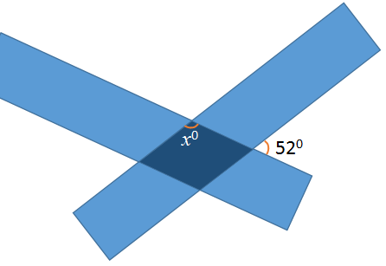
a

Task 2
For rectangles 1 unit wide, the overlap will be 1 square.
If each rectangle has n squares then the fraction of each rectangle is 1/n.
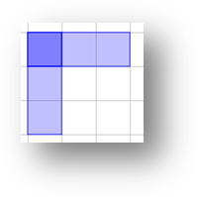
There are two rectangles in the pattern but one square is the overlap so it is counted twice.
There are 2n-1 squares in the pattern so the fraction of the pattern is 1/2n-1.

For rectangles with a width greater than 1

The overlap = width² = w²
If each rectangle has n squares then the fraction of each rectangle is w²/nw = .
There are two rectangles in the pattern but one square is the overlap so it is counted twice
There are 2nw-w² squares in the pattern so the fraction of the pattern is w²/(2nw-w²) = .

Additional Materials
The GeoGebra file ‘Overlapping Parts” can be used to help the students to gather data.

Curriculum links

England | Northern Ireland
> GM3. Apply the properties of angles at a point, angles at a point on a straight line, vertically opposite angles; understand and use alternate and corresponding angles on parallel lines; derive and use the sum of angles in a triangle (e.g. to deduce and use the angle sum in any polygon, and to derive properties of regular polygons)  > A1. Use and interpret algebraic notation  > A5. Understand and use standard mathematical formulae; rearrange formulae to change the subject | > T1 - Recall the properties and definitions of special types of quadrilaterals, including square, rectangle, parallelogram, trapezium, kite and rhombus  > T2 - Set up and solve simple equations  > T2 - Understand and use the angle properties of parallel and intersecting lines
Scotland | Wales
> MNU 3-11a I can solve practical problems by applying my knowledge of measure, choosing the appropriate units and degree of accuracy for the task and using a formula to calculate area or volume when required  > MTH 3-17a I can name angles and find their sizes using my knowledge of the properties of a range of 2D shapes and the angle properties associated with intersecting and parallel lines  > MTH 3-13a Having explored number sequences, I can establish the set of numbers generated by a given rule and determine a rule for a given sequence, expressing it using appropriate notation  > MTH 4-13a Having explored how real-life situations can be modelled by number patterns, I can establish a number sequence to represent a physical or pictorial pattern, determine a general formula to describe the sequence, then use it to make evaluations and solve related problems | Using Algebra Skills  > Y9 - Construct and solve equations that include brackets ( ) and a( ) + b( )  > Y9 - Construct and solve equations where the variable appears on both sides of the equals sign

