Hydrogen Fuel Cell Resource Sheet

What is a Hydrogen Fuel Cell?

Hydrogen (H₂) is one of the most common chemical elements in the universe. Although the air that we breathe contains only a very small amount of hydrogen gas, it is one of the two elements that make up water (H₂O). Hydrogen can be obtained from water, but energy is required to separate it from the oxygen (O₂).

A hydrogen fuel cell uses hydrogen obtained from water and oxygen to make electricity. The hydrogen fuel cell is different to an electrochemical battery, in that the fuel in the cell needs to be constantly replaced with more hydrogen and oxygen. These fuel cells have the potential to provide a sustainable and clean energy for the future: clean because the by-product of a hydrogen fuel cell is water, and sustainable because the fuel starts and ends as water.

Why do we need Hydrogen Fuel Cells?

Sources of Energy

Most of the energy we currently use comes from fossil fuels, such as oil, gas and coal. These can provide energy very quickly when it is required. However, these are non-renewable fuels. This means that as we use them, they are slowly used up and eventually we will run out of them.

As global reserves of fossil fuels run low, scientists are developing sustainable energy sources fuel for the future. These include solar power and wind power. One of the challenges with these sources is that they are not as easy to turn on and off as fossil fuels. For example, a wind turbine can only make electricity when it is windy. This means that you have to make the energy when you can and then store it until it is needed.

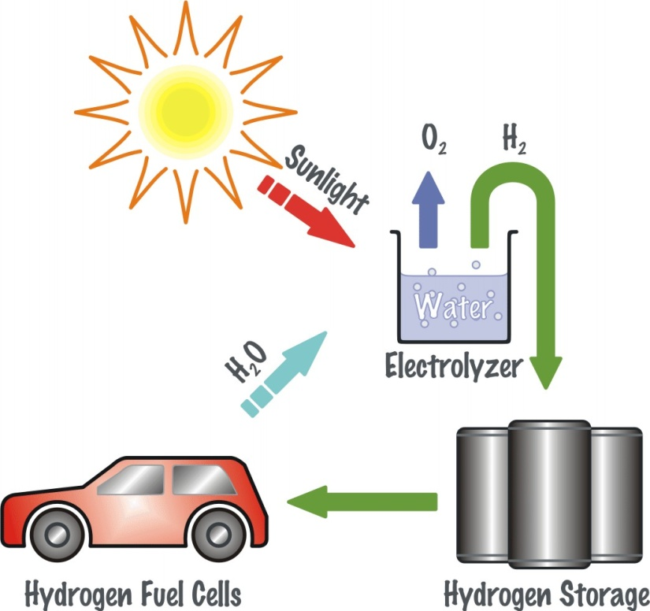
Storing Energy

One way of storing energy this is to use rechargeable batteries. However, batteries use a lot of chemicals and materials when they are made, some of which are very bad for the environment. They would also need to be very large and heavy to capture all of the energy that we need!

An alternative way of storing this energy is to use it to make hydrogen gas from water. This can be stored and then used in hydrogen fuel cells, to make power when it is needed.

How do Hydrogen Fuel Cells Work?
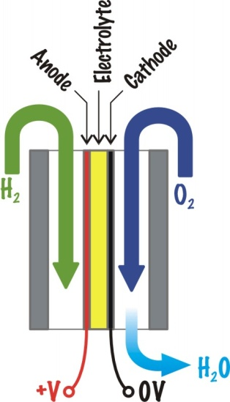
Hydrogen can be burnt together with oxygen to produce heat, in the same way as fuel gases (e.g. town gas, propane, butane, etc.), with water as a by-product. However, this is not how a hydrogen fuel cell works – there is no burning or combustion.

A hydrogen fuel cell consists of an electrolyte, sandwiched between two electrodes, called an anode and a cathode. Hydrogen gas flows over the anode and oxygen gas flows over the cathode. The anode takes the electrons from the hydrogen, forcing them through a circuit, and thus producing an electrical current that goes round the circuit to the cathode. The electron-less hydrogen moves through the electrolyte, meets with the oxygen and reacts to make water.

To help the process happen, a catalyst is used. This is a material which does not react with the hydrogen or oxygen itself, but helps the process to take place. The catalyst is not used up during the reaction. Unfortunately, very few materials are good catalysts. One of the best found so far is a platinum-based alloy, but this costs more than gold so it is very expensive!

Typically a hydrogen fuel cell will produce about 0.7 Volts. Cells can be lined up together (in series) to increase the voltage, or side-by-side (in parallel) to increase the current.

Uses of Hydrogen Fuel Cells

Hydrogen cells are still being developed and improved. However, they are already starting to be used in products.

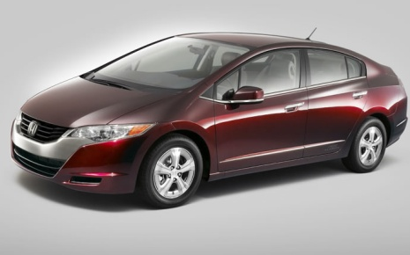
Honda have been developing the hydrogen fuel cell to power cars. In November 2008, they introduced the FCX Clarity in Southern California, where hydrogen can be purchased from fuel stations. The Clarity is one of the first successful vehicles to be powered by hydrogen fuel cells. For more information visit
http://automobiles.honda.com/fcx-clarity/.


Another example of the use of hydrogen fuel cells is in the home of Michael Strizki in New Jersey, USA. He spent $500,000 converting his house to produce and use hydrogen to provide for all his family’s energy needs. For more information visit http://www.scientificamerican.com/article.cfm?id=hydrogen-house or http://www.youtube.com/watch?v=xEdQRVQtffw

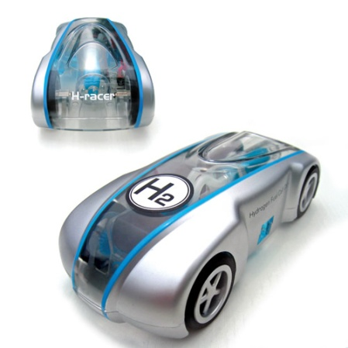
The H2 Racer is a miniature model car that is powered by a hydrogen fuel cell. It costs under £60. For more information, including videos showing how it works, go to http://www.hydro-car.co.uk/

Some Further Sources of Information
- http://auto.howstuffworks.com/fuel-efficiency/alternative-fuels/fuel-cell.htm
- http://www.hydrogen.energy.gov/pdfs/doe_h2_fuelcell_factsheet.pdf
- http://inventors.about.com/od/sstartinventions/ss/Physics_Illustr_2.htm
- http://www.youtube.com/watch?v=oy8dzOB-Ykg

Things to Find Out About Hydrogen Fuel Cells…
- What are the properties of hydrogen that make a potential energy source of the future?
- What are the challenges to using hydrogen as an energy source?
- What are the advantages and disadvantages of hydrogen fuel cells?
- What existing products use hydrogen fuel cells?

