

Explore engineering careers at www.tomorrowsengineers.org.uk
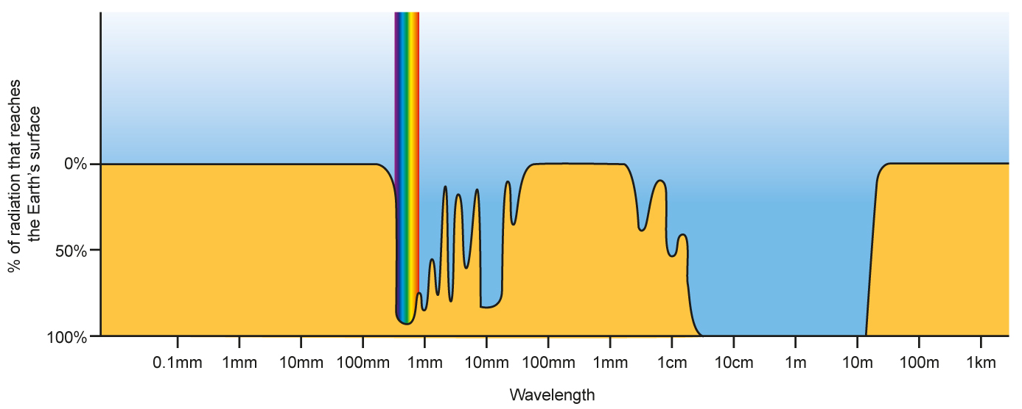
In the earthquake story, the person was trapped in a basement. There was no light getting in (one form of electromagnetic radiation). There was no mobile phone signal (another form of electromagnetic radiation). So how was the Wi-Fi signal still getting through?

About electromagnetic radiation
There is a very big range of different frequencies that we refer to as electromagnetic radiation. Look at the ‘Electromagnetic radiation and the atmosphere’ diagram above.

Electromagnetic radiation and the atmosphere

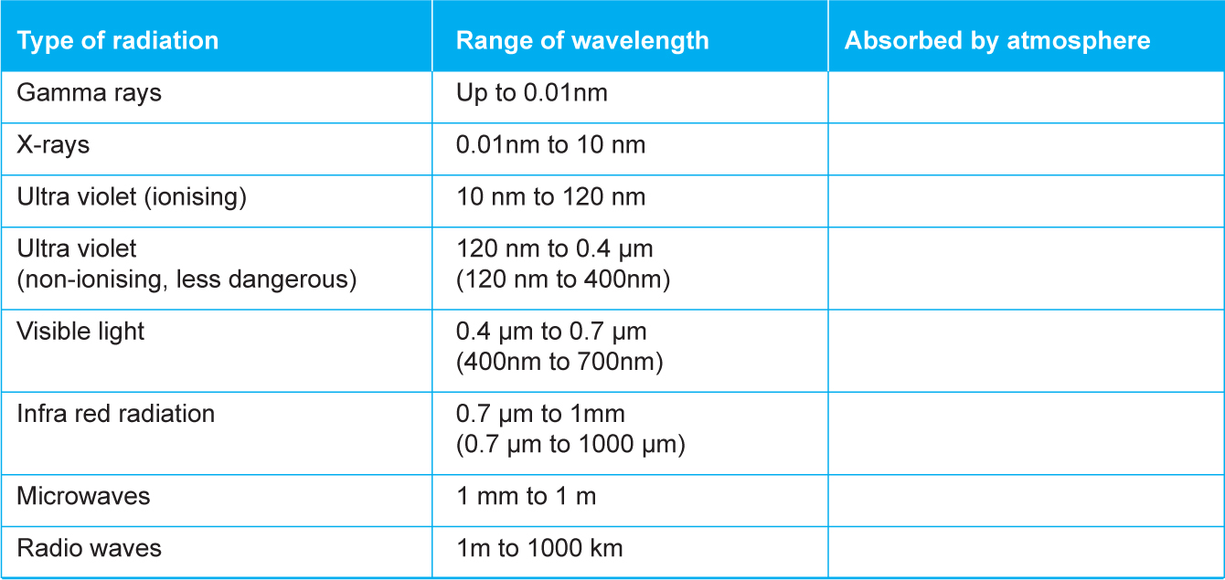
Explore engineering careers at www.tomorrowsengineers.org.uk
Tasks:
1. On the ‘Electromagnetic radiation and atmosphere’ diagram, divide the range of electromagnetic radiation
frequencies into gamma rays, x-rays, ionising ultraviolet radiation, non-ionising ultraviolet radiation, visible
light, infrared radiation, microwaves and radio waves.

Use vertical lines to separate the different radiations

Table 1:

Note about units
1000 nm = 1 μmm 1000 mm = 1 μmm 1000 mm = 1m
1000 m = 1 km

2. Copy the table above and complete the last column. Use the information on the annotated ‘Electromagnetic
radiation and the atmosphere’ diagram that you have produced.

3. Describe the effect of the atmosphere on the ‘dangerous’ gamma rays, x-rays and ionising ultraviolet rays.

- 4. Describe the effect of the atmosphere on the non-ionising ultraviolet rays (these are the ones that give you
a suntan).
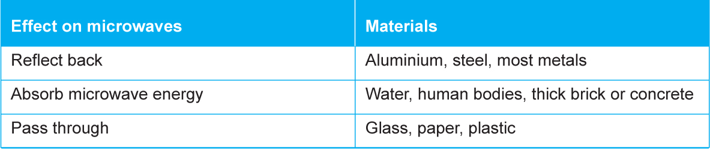
Explore engineering careers at www.tomorrowsengineers.org.uk
Tasks continued:
Why is the visible light range of frequencies shown as different colours?

5. Describe the effect of the atmosphere on the infrared range of frequencies (Some of these we feel as the
sun heating our skin).

6. Describe the effect of the atmosphere on microwaves and radio waves.

7. What would be a suitable ‘window’ in the range of wavelengths for sending messages to satellites in orbit
above the atmosphere?

8. A Wi-Fi signal uses a frequency of 5GHz (5,000,000,000Hz). Calculate the wavelength of a 5GHz radio signal.

Use the equation: Velocity of radiation = Frequency x wavelength
Velocity of electromagnetic radiation = 300,000,000 metres per second
Final note: Other materials than air
Computer and mobile phone systems use frequencies in the ‘window’ where they can pass through the atmosphere without being absorbed. But other materials such as brick and concrete will absorb these frequencies (see Table 2).

Table 2:

