

Explore engineering careers at www.tomorrowsengineers.org.uk

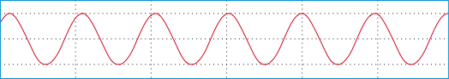
This picture shows the type of visual representation you would get from a 200Hz sound wave, made by a signal generator that sounds like a musical note.

1. On this representation of a sound wave, mark the amplitude of the wave and the wavelength or period of the wave.
Note: Amplitude is related to LOUDNESS of the sound and wavelength or period is related to PITCH of the sound.

2. The signal generator is turned down to a frequency that you can’t hear any more.
Draw a representation of a sound wave that is shown on the oscilloscope screen when you can’t hear the wave
any more.

Write down the lowest frequency of the sound that you can hear.

Hz

Explore engineering careers at www.tomorrowsengineers.org.uk
Write down the highest frequency of the sound that you can hear.

4. Compare your frequency range of hearing with the hearing range of a typical pet dog. This is 40Hz to 60,000Hz.

3. The signal generator is turned up to a frequency that you can’t hear any more.
Draw a representation of a sound wave that is shown on the oscilloscope screen when you can’t hear the wave
any more.

Hz

