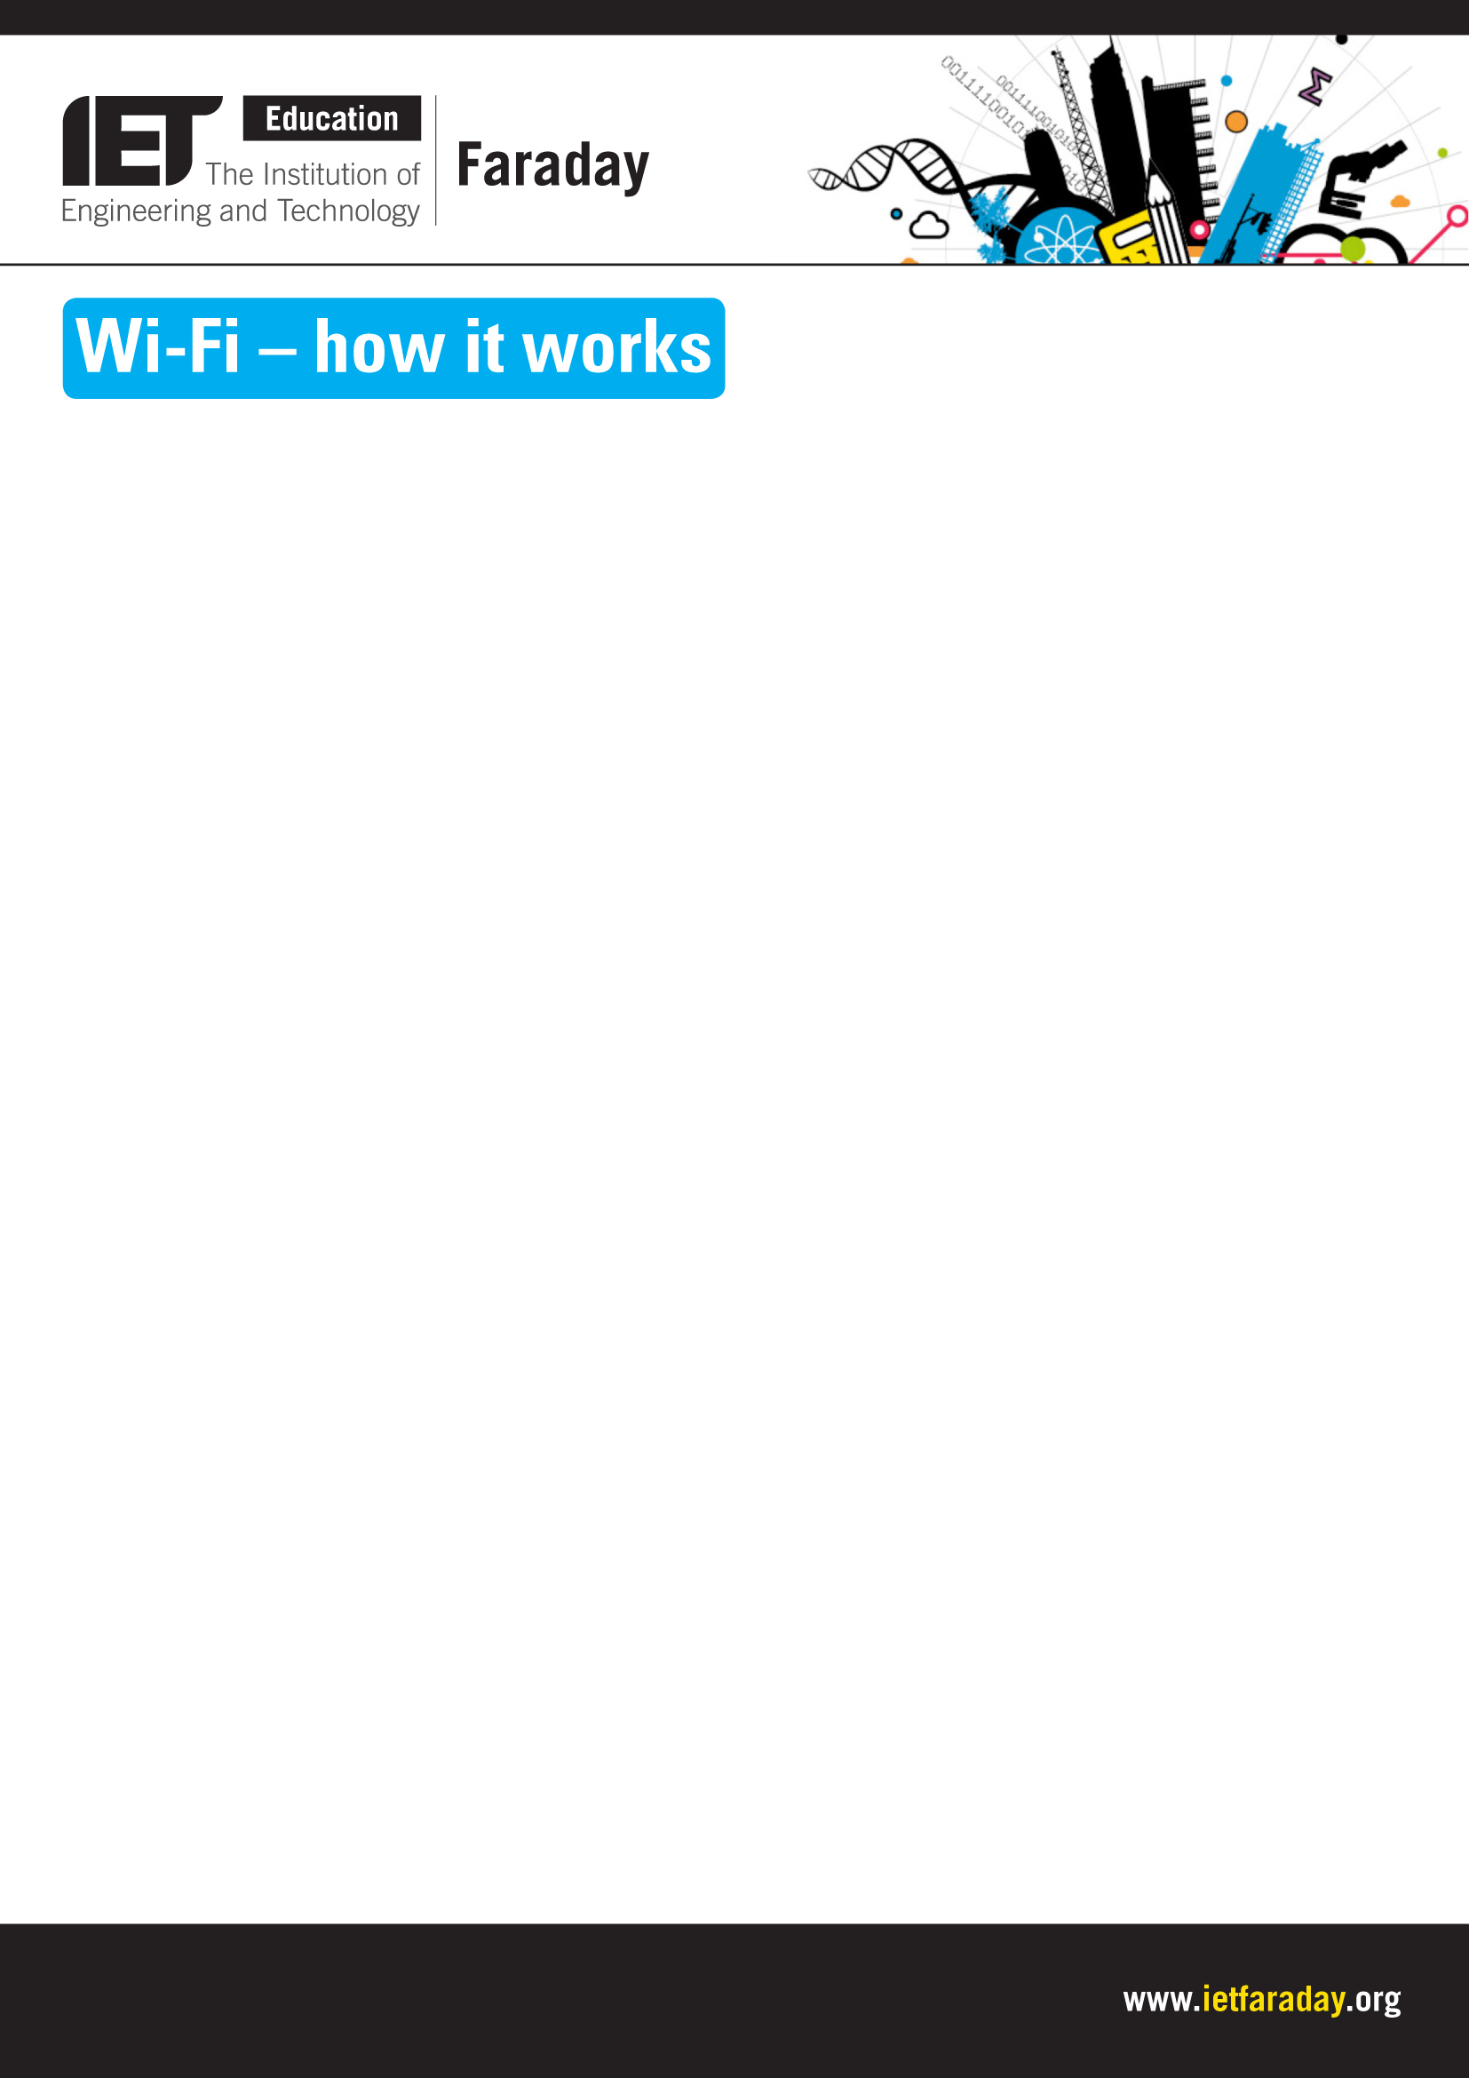
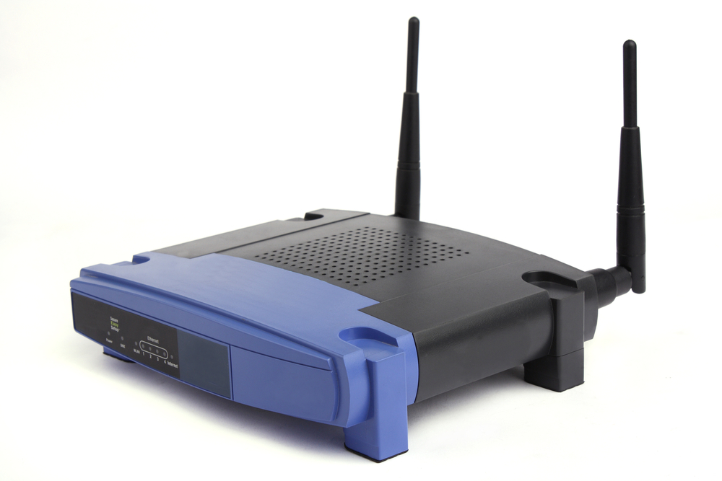

Explore engineering careers at www.tomorrowsengineers.org.uk
Wi-Fi (Wireless Fidelity) is a way of connecting your computer
into a network without plugging a cable into the back. This is
often referred to as WLAN (wireless local area network) and it
has become widespread. You can get connected to the internet
almost anywhere; at home, at school, even in many coffee bars.

A Wi-Fi network uses radio waves to transmit information like a
mobile phone does. But Wi-Fi uses a signal with a lot less power
than a phone. The Wi-Fi transmitters in buildings have to be low-
energy to be safe and usually only have a range of 30 metres
indoors and 100 metres out of doors.

The signal does not go all the way by radio, it just goes to a “router”
nearby. This receives the radio signal using an antenna and turns it
into a digital signal in a cable. The cable connects to a “modem” that
connects to the telephone system and via the phone network to the internet.

The router is called an ATM router. ATM stands for Asynchronous Transfer Mode — this refers to the way that the signal is sent between the router and the computer. The wireless network will work for two-way traffic, so the data from the internet will pass through the router to be coded into a radio signal. This is received by the laptop, tablet or smart phone that is being used.

A wireless network will transmit at a frequency of 5GHz. But a complex piece of electronics divides the radio signals into smaller packets of signals before reaching the router.

The term “hotspot” is used for an area where Wi-Fi access is available. It can either be through a closed wireless network at home, or in public places like coffee bars.

Activity
Draw a simple diagram of a Wi-Fi system in a school classroom. Annotate the diagram to show how the Wi-Fi connects a laptop to the internet.

Include:
- the Wi-Fi enabled computer
- the router
- the modem
- telephone network
- internet server.
Show how the signal is carried at each stage.

