The IET

Coding the Future
Student Booklet

Could you be our engineer….?

Contents

- The Context ……………………………………………………………………………… 3
- The Scenario …………………………………………………………………………… 3
- The Brief ………………………………………………………………………………… 4
- Schedule for the day ………………………………………………………………… 5
- Materials resource sheet ……………………………………………………………… 6
- Assessment information and criteria ………………………………………………… 8

The Context

Coding is part of the world for all of us; from gaming to working our mobile phones, our computers, even our washing machines. Coding enables us to provide instructions in a form which computers can understand. This means that computers can help us to do things which otherwise may be much more difficult.

The Scenario

As computers become more common in our everyday lives engineers are using coding more frequently to solve everyday problems. Today your challenge is to code your BBC micro:bit for a real-life application. You will work in teams of engineers to solve a problem or to change or improve people’s experience in an area of our everyday lives. You will experience what engineers do as they work together to develop a new product. You will need to use all your STEM skills as well as skills in teamwork, perseverance, creativity and innovation. You will need to be brave – engineering is not for the faint hearted!

Today is your chance to make a difference, could you be our engineer..........?
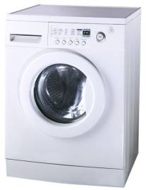
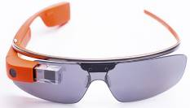
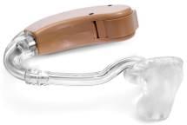
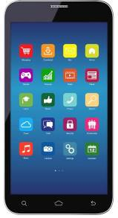

The Brief

You will need to choose one of the following four themes:

- Health
- Sport
- Travel
- Home and leisure

You will then need to develop two products for the real-world within the theme. Finally, you will pitch your product to the Coding the Future judges.

Divide your team to work on two ideas. These could be separate or linked together. Think about how your idea could solve a problem or change or improve someone’s life. How will they be used by people?

You will need to work effectively as a team. In order to do this your team will need some of you to take on a role in addition to being a Faraday Code Crew Software Engineer. These additional roles will give some of your team the responsibility for manging or marketing the project, budgeting and keeping to time.

You will need to develop a marketing pitch for your presentation to the Coding the Future judges. Your pitch will need to convince the judges that your products are the ones they should invest in.

Your team will need to:

- Identify a range of applications that your BBC micro:bit could be used for.
- Identify the two products that your team are going to put forward. Remember that these must both be from the same theme.
- Code your BBC micro:bit to bring your ideas to life.
- Construct any components you need to add to your BBC micro:bit to make it work effectively.
- Develop your marketing pitch.
- Demonstrate the capabilities of your two ideas by presenting them to the Coding the Future judges.

Considerations
Your BBC micro:bit products must:

- both be within one of the four themes
- have relevant and useful real-life applications
- demonstrate engineering skills and show creativity and innovation
- be effective and cost efficient.

4. Schedule for the day

09:15 | Register your team
09:30 | Introduction to coding
09:40 | Introduction to the Faraday Challenge
10:05 | STAGE 1: Identifying the problems and generating initial ideas  - Brainstorming of ideas  - Complete Stage 1 reflections
10.20 | Introduction to the BBC Micro:bit
10:25 | STAGE 2: Development  - Complete coding entry apprenticeship  - Agree on final product designs  - Complete Stage 2 reflections
10:40 | Allocation of roles
10:45 | Shop opens  - Create shopping list
11:10 | Break
11:20 | STAGE 3: Modifications  - Continue to design and code and modify where necessary
12:10 | Briefing for the pitch  - Project and/or marketing managers are briefed on the content of the pitch
12:30 | Lunch – Tools down
13:00 | STAGE 3 continued: Final preparations  - Finalise coding  - Prepare pitch with notes
13:30 | STAGE 4: Presentation  - Shop closes and coding finishes – laptops are removed  - Submit accounting sheet to the Shop keeper  - Practise pitch
14:00 | STAGE 5: Final test  - Teams pitch their designs to the judges
14:45 | Award ceremony  - Final feedback and evaluation of the day  - Winning team announced
15:00 | Finish - Engineering teams depart

5. Shop resource sheet
Below are the items available to buy in the shop. Choose carefully and keep within your budget.
Remember to keep track of all your purchases on your Accounts sheet.

Item | Description |  | Unit | Cost
Crocodile leads | 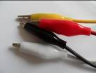 | Lead with crocodile clips at each end | Each | 5 Faradays
Piezo buzzer | 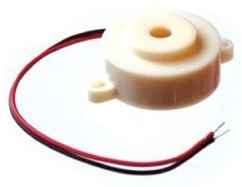 | Connect to the rings in a circuit to give a sound output | Each | 8 Faradays
LEDs – green + resistor | 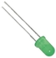 | LED which can be connected to the rings in circuit – green. Must be used with a resistor. | Each | 10 Faradays
LEDs – amber + resistor | 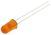 | LED which can be connected to the rings in a circuit – amber. Must be used with a resistor. | Each | 10 Faradays
Thermistor  + resistor | 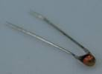 | Component that detects the ambient temperature and changes resistance to allow a current to flow through a circuit. Must be used with a resistor. | Each | 15 Faradays
Light Dependent Resistor + resistor | 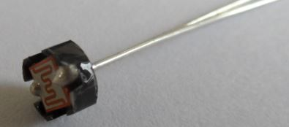 | Component that detects the light level and changes resistance to allow a current to flow through a circuit when it becomes dark. Must be used with a resistor. | Each | 15 Faradays
Resistor | 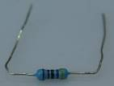 | Component used in a circuit to ensure that the correct current is supplied to other electrical components in the circuit. | Each | Comes free with LED, thermistor and LDR
Potentiometer | 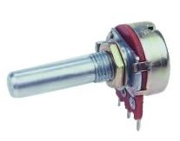 | Component used to adjust the sensitivity of a sensor in an electrical circuit. | Each | 10 Faradays
Polyfoam |  | A5 foam sheet – assorted colours | Each | 10 Faradays
Coloured card |  | A4 sheet of card – assorted colours | Each | 5 Faradays
Tin foil |  | A conductive material | 30cm strip | 5 Faradays
Masking tape |  | Can be used to secure parts in your design - do not stick anything to your BBC micro:bit or it may not work properly. | 30cm piece | 5 Faradays

Item | Description | Unit | Cost
Sticky tape | Can be used to secure parts in your design - do not stick anything to your BBC micro:bit or it may not work properly. | 30cm piece | 5 Faradays
Rectangular sponges | Can be used to make pressure switches or enhance your design. | Each | 5 Faradays
Cardboard tube | Can be used to reduce or focus light levels or enhance your design | Each | 5 Faradays
Cable ties | Can be used to hold your BBC micro:bit onto a background | Each | 5 Faradays
Scissors | Used for soft materials only – do not use to cut wires or any part of your BBC micro:bit. | Each | 5 Faradays
Stapler | Used to staple soft materials only – do not use to staple anything to your BBC micro:bit | Each | 5 Faradays
Hole punch | Used to make small holes in soft materials | Each | 5 Faradays
Rulers | Used to measure any part of your product or additional items | Each | 5 Faradays
String | Can be used as part of your product design | 30cm piece | 5 Faradays
Calculators | Can be used to calculate resistance and to help with accounting | Each | FREE
Codes to buy | Complete codes which your team can buy to copy or adapt – ask the shop keeper for information on the codes available for purchase | Each | 50 Faradays

6. Assessment information and criteria

Criteria | Marks
- Planning and research | 10 marks
- Development of product | 20 marks
- Use of budget | 8 marks
- Functionality of coding | 14 marks
- Functionality of product | 22 marks
- The pitch | 16 marks
- Teamwork | 10 marks
Total | 100 marks

- Planning and research (10 marks)
Using Stage 1 of the planning sheet provided, marks will be awarded for:
- Identifying at least two creative and innovative ideas for the BBC micro:bit in each of the four themes (6 marks).
- Identifying how your ideas could solve problems or change or improve our everyday lives
(4 marks).

- Development of BBC micro:bit products (20 marks)

Using Stage 2 and 3 of the planning sheet provided, marks will be awarded for:

- Identifying two ideas within the same theme which have real-life applications (6 marks).
- Identifying the advantages and disadvantages of your ideas (4 marks).
- Demonstrating a willingness and ability to adapt your designs or overcome problems where necessary (5 marks).
- Demonstrating an understanding of how effectively your chosen engineering roles worked both for the product design and for your team as a whole (5 marks).

- Use of budget (8 marks)
Use of the accountancy sheet to record all of the costs the team has incurred. Marks will be awarded for:
- Accuracy of expenses – maintains an accurate record of expenses (2 marks).
- Cost effectiveness – sensible use of budget for research and development of product
(6 marks).

4. Functionality of BBC micro:bit coding (14 marks)
Your BBC micro:bit products will be judged on:

- How appropriate is the code for the intended purpose? (4 marks)
- How well does the code work (6 marks)
- How effectively did your team work on the code? (4 marks)

5. Functionality of BBC micro:bit product (22 marks)
Your BBC micro:bit products will be judged on:

- Manufacture quality - how well your prototypes work, including any external components and packaging (6 marks).
- Creativity – how creative and innovative your prototypes are. (6 marks).
- Application – the extent to which your prototypes have a useful real life application (10 marks).

- The pitch (16 marks)
Your pitch to the judges will be marked on:

- Your reasons for choosing the theme and for the two ideas within your theme (3 marks).
- How effectively you used your STEM knowledge to produce your prototypes (3 marks).
- How effectively you demonstrate the ways in which your prototypes will work in the real world (this may involve you using resources to package or house your prototypes) (4 marks).
- What roles each team member chose and how effectively these enabled you to work together as a team and produce your prototypes (4 marks)
- How effectively you communicate your ideas to the BBC micro:bit Code Crew and remain within the time limit (2 marks).

- Teamwork (10 marks)
Marks are awarded for:
- How well you work as a team with all members working together effectively (4 marks).
- How well your team persevered in the development of the BBC micro:bit products (4 marks).
- How tidy, safe and organised your working area is kept (2 marks).

