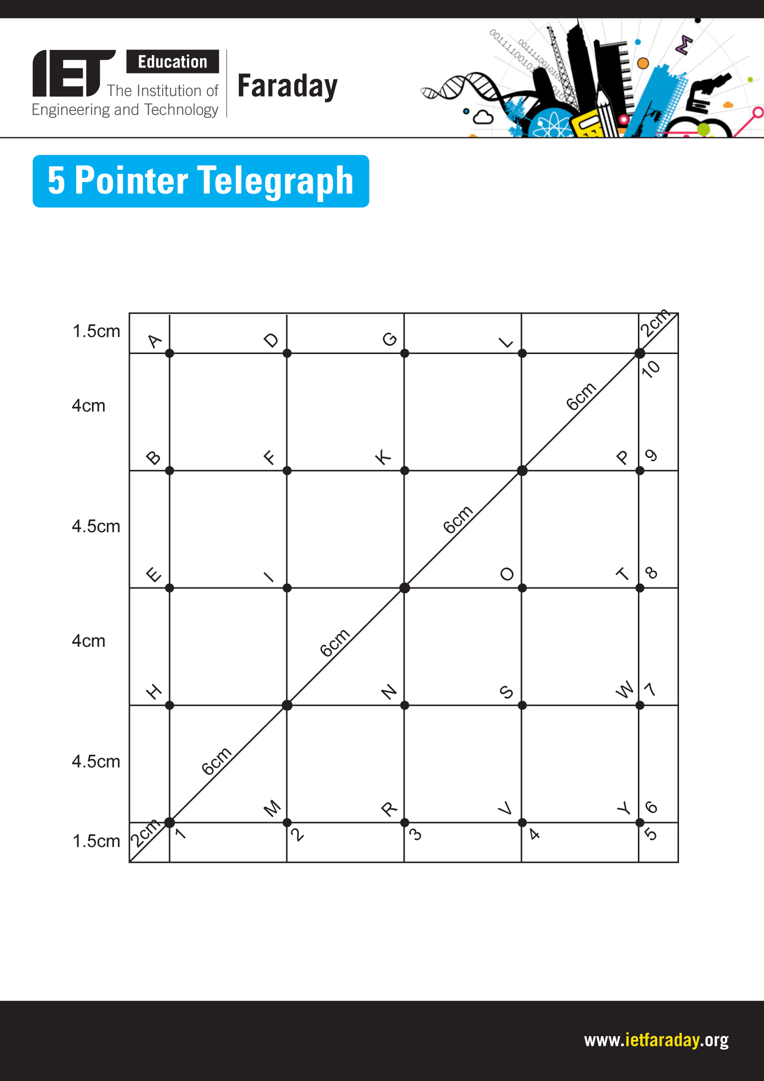

Explore engineering careers at www.tomorrowsengineers.org.uk
Grid for making a Model 5 pointer telegraph.

