
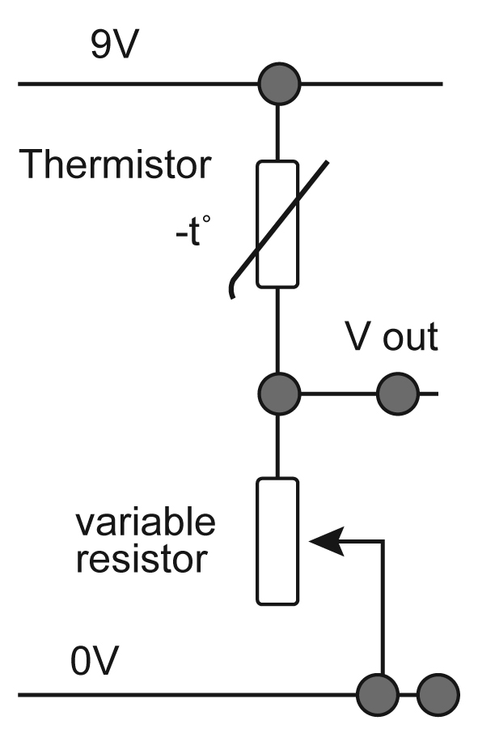
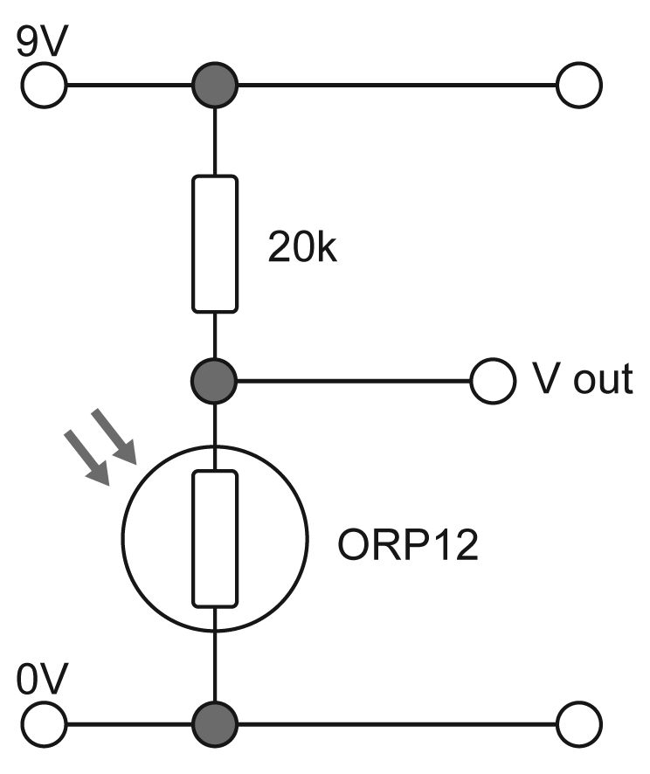
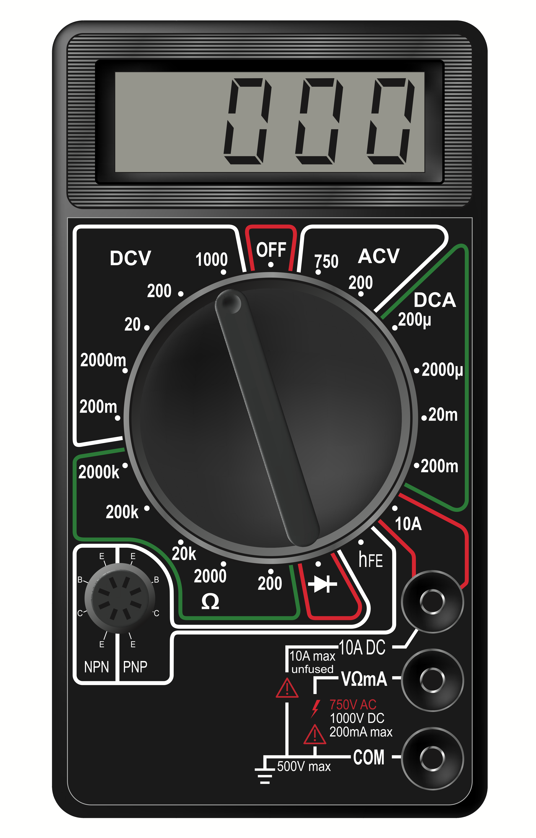

Explore engineering careers at www.tomorrowsengineers.org.uk
How to use a Multimeter
The diagram opposite shows a switched range multimeter.
You start by inserting the two probes. The black lead is connected to the socket marked COM, short for COMMON. The red lead is connected into the socket VmA.
The central knob has lots of positions. In any given range, it is a good idea to start with the highest position and work down until you obtain a reading.

Measuring Resistance
You will need to select the resistance range. Select the highest setting and work down. Place the probes at either end of your resistor and take a reading. Note the colours and order of the rings around the resistor. Change the resistor and repeat. Do this a number of times with different resistors.
Now use your Light Dependent Resistor (LDR) and place the probes at each end. Take a reading in the light and record it. Now place your hand over the LDR, take the new reading and record it. You may need to select a different range on your meter.
Repeat this with your thermistor. Record your reading. Instead of covering it hold it between two fingers to warm it up. You may need to select a different range on your meter to take the reading.

Measuring Voltage
We will be using the DC ranges indicated by on the meter.
The diagram top right shows a light sensor circuit. Set up this circuit on a breadboard or using another prototyping method.
What happens to the output voltage of the light sensor circuit when you cover the LDR with your hand? Record your findings on the recording sheet.
We are now going to use our thermistor. The diagram bottom right shows a temperature sensing circuit
What happens to the voltage when you rub the thermistor with your finger?
Record your findings on the recording sheet.
v =

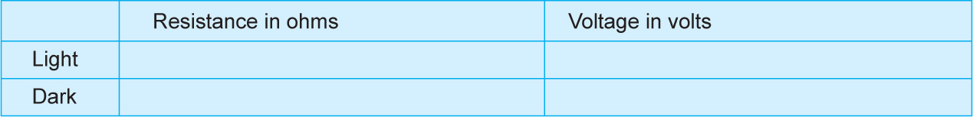
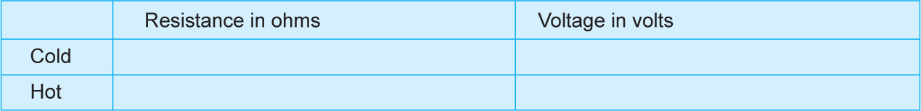
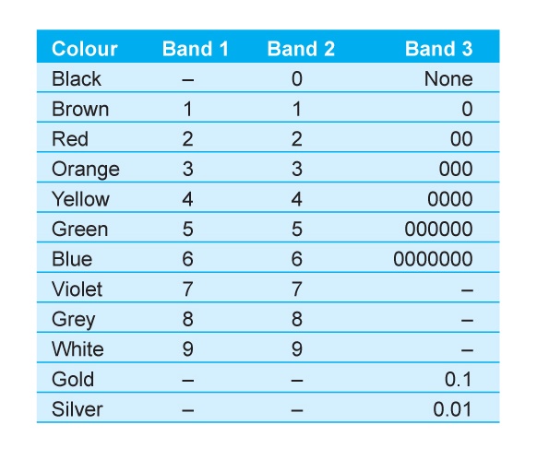
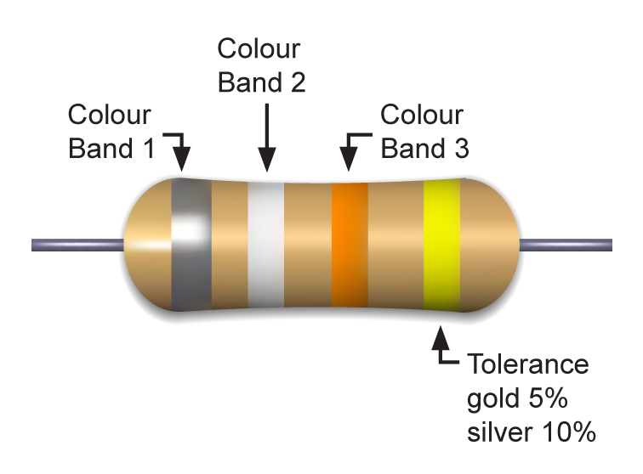
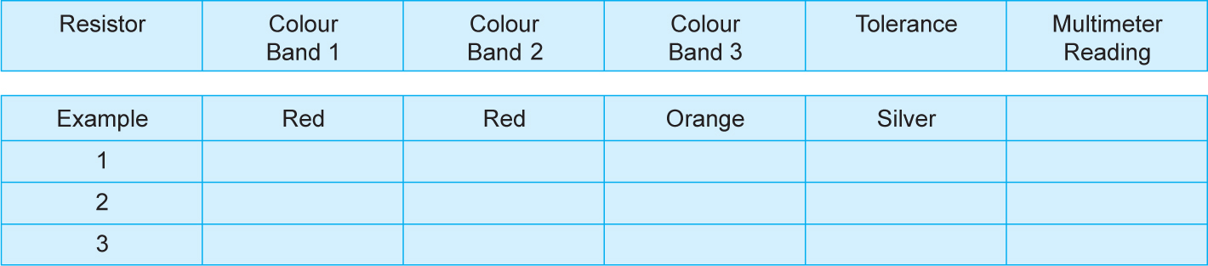
Explore engineering careers at www.tomorrowsengineers.org.uk
To work out the value of a resistor:
Band 1 is the first number
Band 2 is the second number
Band 3 is the number of zeroes
Band 4 is the tolerance. This is how much the resistance of the resistor might vary from its stated value.

In the example below we would calculate the value to be 22000 ohms with a tolerance of 10%. It can be written as 22kΩ (1000Ω=1kΩ).
Multimeter Recording Sheet

Light Dependent Resistor. Multimeter Readings

Thermistor. Multimeter Readings

