Recycling 2
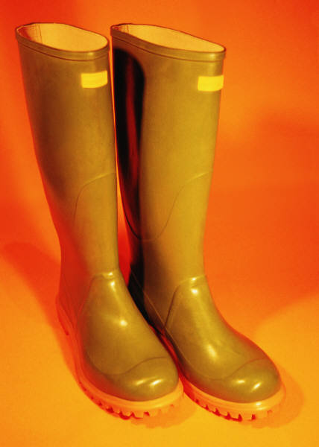

Wellington Boots

Each year, thousands of pairs of wellington boots are thrown away into landfill sites with the other garbage. However, they can be recycled. A combination of heat and up to 1000 tons of pressure can be used to squash them into 3mm thick sheets. The sheets are typically 1200 x 800mm in size.

Soft, rubbery and tactile, the sheets can be used for table coverings, bar and bar-stool tops, or even used as waterproof mats for bathrooms and kitchens.

Mobile phones

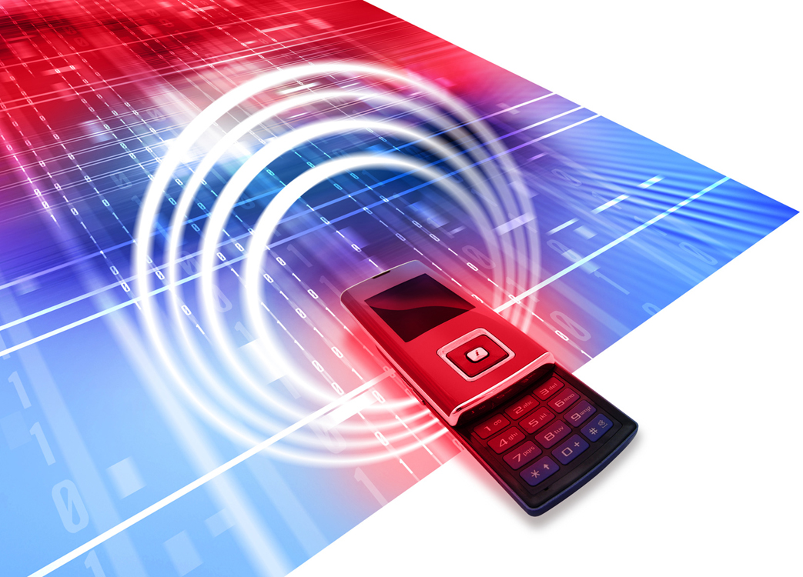
By 2008, there are just over 75 million mobiles in the UK. Every year about 25 million of them get discarded. Some are refurbished and sold again, but many of them often end up in landfill.

There are now EU regulations which force manufacturers and retailers of anything that runs on electricity to set up schemes for recycling equipment once customers have finished with it. Everything from washing machines and TV sets to MP3 players and torches are included in this. Some parts are used to make new products. Others are turned into recycled materials.

One example of recycling is the plastic cases of mobile phones. The batteries, SIM cards and electronics are removed from the phones. The cases can then be squashed and heated to convert them into plastic sheets. These can be used to make tabletops, display panels, or just hung on the wall as works of art. Each phone case can be seen in distorted, tortuous detail, compressed into two dimensions, but still clearly identifiable as someone’s personalised mobile, and preserved for ever as a table top or even as the latest style in coasters.

The sheets are made from nothing else but old mobiles, no additives, no resins, just plastic phone cases. They are available at 1200 x 800mm and approximately 6mm thick.

