In 1799 (CE) soldiers were building a fort in the village of Rosetta in
Egypt when they discovered a large stone tablet weighing 750kg. It was
obviously ancient, so probably valuable.
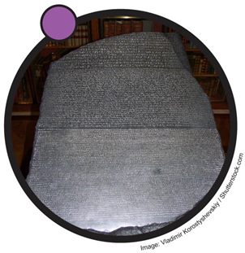
The stone, now called the Rosetta Stone, dated from 196 BCE. At
that time, the Ancient Greek civilisation ruled that part of the world.
The Ancient Greeks set great value by knowledge. The writing on
the stone records an announcement from King Ptolemy IV and was
carved by priests. The king got the priests to record all the good
things he did.
To ensure that everybody could read the Rosetta Stone, the priests
carved the same message in three different languages:
• Ancient Greek so the rulers could read it
• Ancient Egyptian, written in demotic script, read by the common people
• Hieroglyphs, the Ancient Egyptian text script, used by priests for religious work
Many other examples of hieroglyphs carved into stone have been found in excavations made of Ancient Egyptian sites, but the meaning of these symbols had been lost. The stone tablets were impossible to translate into modern languages.
A scholar in Paris called Champollion realised he could read the Ancient Greek part of the Stone. He used that to translate the Egyptian demotic characters, as they said the same thing. Finally, this gave enough clues to interpret what the individual hieroglyphs must represent. It sounds easy, but the work took 20 years. The hieroglyph code was broken and all the other writings in hieroglyphs could then be translated.
The Rosetta Stone is on display in the British Museum in London.
Questions
1. How old is the Rosetta Stone and where was it found?
2. What type of writing could not be translated before the discovery of the Rosetta Stone?
3. Why was there more than one language written on the Stone?
4. What was the writing on the Stone about and who made it?
5. What were the two different styles of writing used by Ancient Egyptians?
6. How did the Stone cause a breakthrough in translating certain languages?
7. Where can the Rosetta Stone be seen at the moment?

