Photovoltaic cells – Investigating Circuits
Manufacture a simple circuit and integrate it into a product

Subject(s): Science, Design & Technology, Mathematics  Approx time: 45-60 mins |  |  | Key words / Topics:  - photovoltaic cells  - solar energy  - renewable resource  - capacitor  - motor
Suggested Learning Outcomes
- To investigate how photovoltaic cells work and how they can be used in a circuit
Introduction
The ‘Photovoltaic cells’ scheme of work involves investigating how photovoltaic cells are used and then using this technology to make a series of electronic circuits of increasing complexity. This could form the basis of a design and make activity in Design and Technology (D&T), with cross-curricular links with Science.

Purpose
In this activity students will investigate the photovoltaic effect by manufacturing a simple circuit and integrating it into a product, in this case a version of the popular jitterbug project.

This could be used as a focussed practical task in Electronics or Product Design within Design & Technology, or as part of an investigation into the use of solar power in Science.
Activity |  |  | Teacher notes
Students should be divided into teams of 2-4. Each team should be given the component parts for the jitterbug, a circuit diagram and a drawing or picture of a finished example, e.g.:  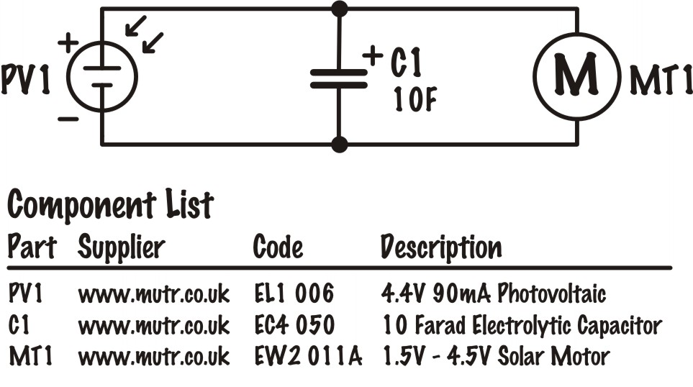  When the diagram above is redrawn the supplier column should be removed (mutr is now trading under the name mindsets) and the parts could be sourced from several different suppliers.  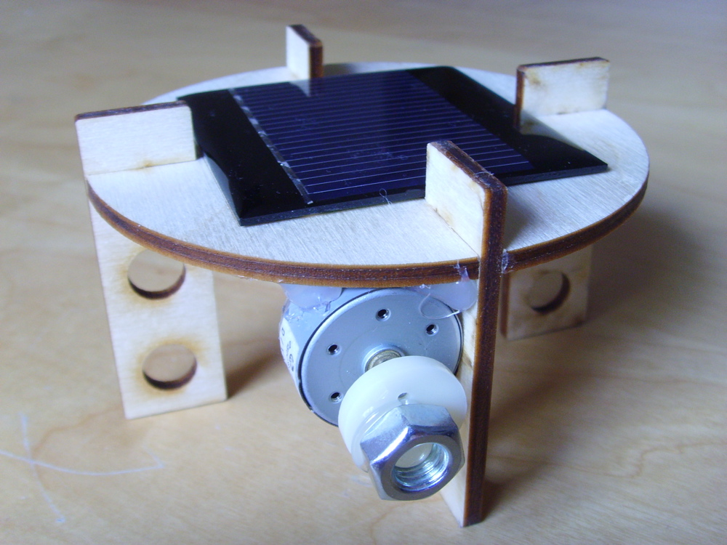  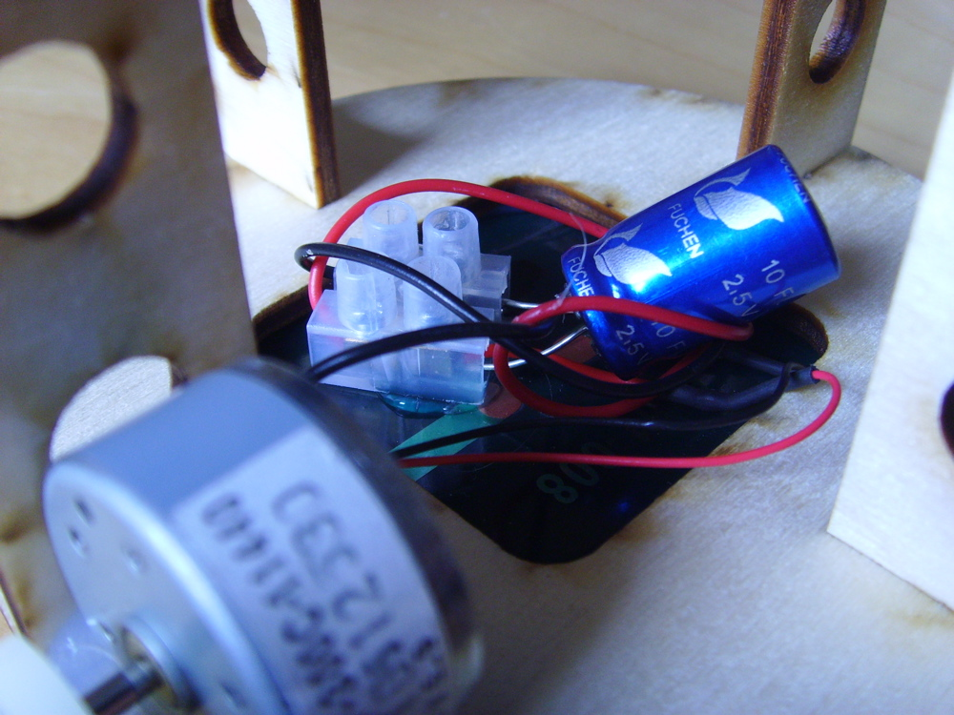  On completion, they should use a light source to charge up their capacitor and then observe the product in action! |  |  | The jitterbug uses a motor with an off-centred mass fixed to the driveshaft of the motor. When the driveshaft rotates at speed the off-centred mass causes it to vibrate, which in turn causes the jitterbug to jitter and move. By connecting the motor to a PV cell the motor will energise and spin when placed in sunlight. The 10 Farad ‘super’ capacitor, placed in parallel with the PV and motor, will charge when the PV is placed in sunlight. The motor will not work until the capacitor has fully charged, and will continue to move until it has discharged.  The cost of the three electronic components for this activity is over£7, so you might choose to put together a class set of construction kits which can be reused in future lessons. Alternatively, the solarbug could be used as a demonstration model to introduce the concepts of solar energy.  If available, multimeters could be used to check the electrical outputs of the PV cell.
Differentiation
Basic |  |  | Extension
A ‘step-by-step modelling’ approach could be used to build these jitterbugs. Connecting the motor etc. is not difficult, but the solar apparatus adds another dimension that could be a little confusing.  A completed example could be available for reference. If a series of pictures were taken during the construction of this example, these could be used to provide a step-by-step guide, either as a series of PowerPoint slides or in the form of a ‘storyboard’. |  |  | The solarbugs could be decorated and videos made of them in action. These could even be uploaded YouTube with an appropriate sound track. For an example (non-solar) go to: http://www.youtube.com/watch?v=eyUoQPikPkI  The students could redesign the body and legs using appropriate CAD software, and manufacture the components using a laser cutter. This would give a more personalised outcome.  Students could produce a ‘storyboard’ of pictures following the production process. This could be used with subsequent groups to provide differentiation, as noted in the easier column.  Students could be given a number of different offset weights to use, and have to chart the speed and movement of the jitterbug against the weight, size or offset.
Resources |  |  | Required files
- A suitable quantity of components to manufacture the circuit: 4.4 V 90 mA photovoltaic cells, 10F electrolytic capacitors, 1.5 - 4.5 V solar motors, circuit connectors, lengths of wire.
- Pre-cut component parts to make the jitterbug (one circular body, 4 legs, weight – a circle with an offset hole in it, that pushes on to the axle from the motor; the legs should slot tightly into the body. These could be made from any rigid sheet material; laser cutting could be used to minimise the work required and ensure consistent dimensions.
- Light sources to charge the capacitor.
- Multimeters.
Additional websites
- YouTube: Film clip ‘Solarbug’ by St Helens Engineering http://www.youtube.com/watch?v=LCagL44ifac
Related activities (to build a full lesson)
Starters (Options)  - ACTIVITY: Energy Efficiency starter  - ACTIVITY: Photovoltaic cells - Intro  Main (Options)  - ACTIVITY: Energy Efficiency main  - ACTIVITY: Photovoltaic cells – Investigating  Circuits  - ACTIVITY: Photovoltaic cells – Design & Make |  | Extension (Options)  - ACTIVITY: Photovoltaic cells - Modifications  Plenary  - Opportunities within activity for presentations, peer/self-assessment  - Reflection on Objectives and PLTS skills used

The Engineering Context 
- The story Green School
- How it works: Interseasonal Heat Transfer (IHT)
- Who makes it work? Chani Leahong

Curriculum links and PLTS
England  Science  - KS3 24c, 34e, 35a, 35b  Design & Technology  - KS3 2a, 2b, 3b, 4a, 4c | Northern Ireland  Technology & Design  (Objective 1) Developing pupils as Individuals  - Respond to a personal design challenge in relation to their own lifestyle  (Objective 2) Developing pupils as Contributors to Society  - Explore technical inventions and designs that have met a social need cost-effectively  - Ethical awareness  (Objective 3) Developing pupils as Contributors to the Economy and the Environment  - Pursue design solutions using environmental friendly materials and energy sources  - Education for Sustainable Development  Learning Outcomes  - Demonstrate practical skills in the safe use of a range of tools, machines and equipment  - Show deeper understanding by thinking critically and flexibly, solving problems and making informed decisions, using Mathematics and ICT where appropriate
Scotland  Technologies  - TCH 3-01a, TCH 2-12a / TCH 3-12a, TCH 3-13a | Wales  Design & Technology  - 1.1, 1.6, 5.3, 5.4
GCSE D&T  AQA D&T  - 3.1.2  Edexcel D&T  - 1.3  Eduqas D&T  - 2.1 Core: 3  OCR D&T  - 3.2 | GCSE Engineering  AQA Engineering  - 3.1.3
GCSE Science  AQA Combined Science Trilogy  - 6.1.3, 6.2.1.4  AQA Combined Science: Synergy  - 4.8.2.4, 4.7.2.4  Edexcel Combined Science  - Physics: 3.13, 10.2  Eduqas Combined Science  - 2.3: 1.2f, 7.2d  OCR Gateway Science: Combined Science A  - P.2b, P6.2a  OCR 21st Century Science: Combined Science B  - P2.2: 1, 2  - P3.1: 7 | GCSE Physics  AQA Physics  - 4.1.3, 4.2.1.1  Edexcel Physics  - 3.13, 10.2  Eduqas Physics  - 1.2f, 7.2d  OCR Gateway Science: Physics A  - P3.2b, P8.2a  OCR 21st Century Science: Physics B  - P2.2: 1, 2  - P3.2: 7

Personal, learning & thinking skills (PLTS)
- Team worker
- Self manager

