Photovoltaic cells - Modifications
Investigate some potential modifications to your solar powered night-light circuit

Subject(s): Science, Design & Technology, Mathematics  Approx time: 60 mins |  |  | Key words / Topics:  - photovoltaic cells  - variable resistor  - transistor  - Darlington pair
Suggested Learning Outcomes
- To be able to explain how a circuit can be modified to improve its functionality.
Introduction
The ‘Photovoltaic cells’ scheme of work involves investigating how photovoltaic cells are used and then using this technology to make a series of electronic circuits of increasing complexity. This could form the basis of a design and make activity in Design and Technology (D&T), with cross-curricular links with Science.

Purpose
In this activity students will investigate some potential modifications to the circuits they have designed and made in the ‘Photovoltaic cells – design and make (activity)’. This would then feed back into the ‘final’ make activity in ‘Photovoltaic cells – design and make (activity)’.

This was designed to be an extension to the design and make activity and needs to be preceded by the ‘Photovoltaic cells – design and make (activity)’. It could be used in Electronics or Product Design within Design & Technology, or to support an exploration on component functions within Science.
Activity |  |  | Teacher notes
The following objectives could either be chosen individually or sequentially. In each case, students will need to revise the design of the circuit made in the ‘Photovoltaic cells – Design and Make (activity)’ to satisfy the new objective, test their revised design and modify it if necessary.  1. Change the circuit so that the threshold can be adjusted – I.e. the circuit can be activated by different levels of light, as set by the user.  2a. Include an additional LED output in the circuit.  2b. Observant students will notice that multiple LED outputs might appear dimmer than a single LED. Increase the power provided by the circuit to the outputs. |  |  | The revised designs could be modelled using appropriate CAD software for circuit development or physically modelled using prototype boards, depending upon the available resources. This would then give greater confidence for the subsequent manufacture of the final circuit.  There are several ways of achieving this, such as the use of the analogue input port on a microcontroller. However, the simplest way is to use a variable resistor in the potential divider for the light sensor circuit.  This could look like the following circuit:  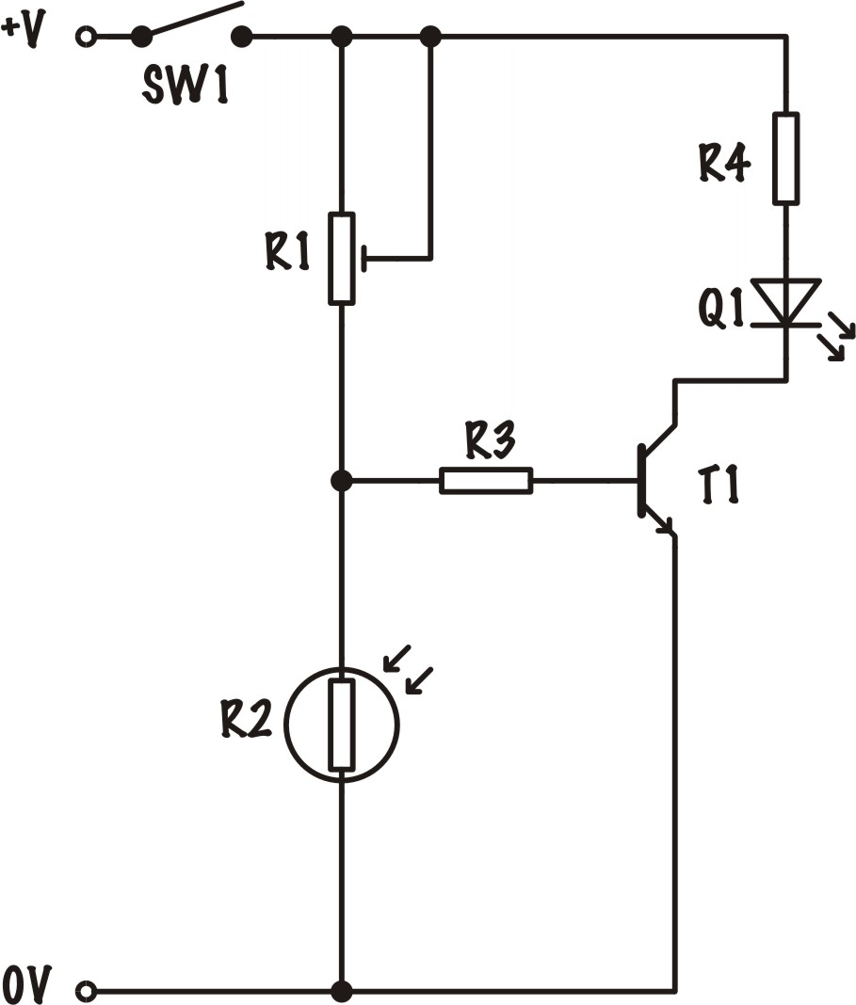  By replacing resistor R1 with a potentiometer (below), the threshold at which the LDR triggers the transistor can be adjusted.  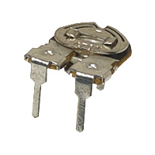  Additional LEDs can be connected in parallel, as shown in the example below.  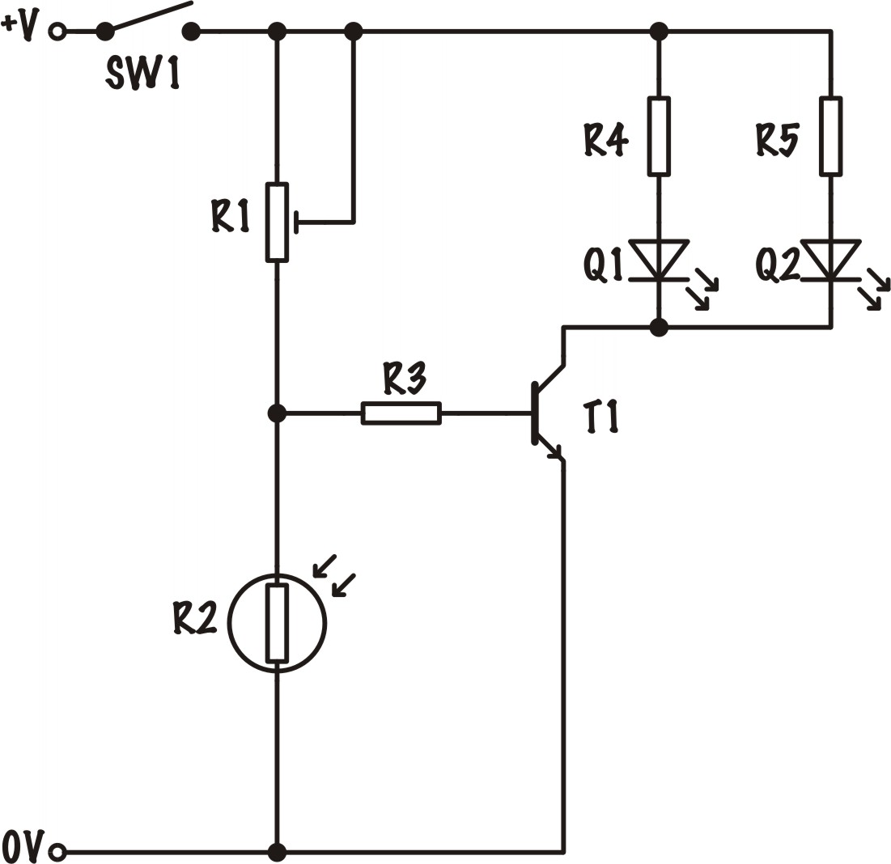  There are several ways of doing this – such as incorporating a relay (with a diode to protect against back emf) which operates high power outputs in a second circuit. However, the simplest method is to use a Darlington pair, as shown in the example below.  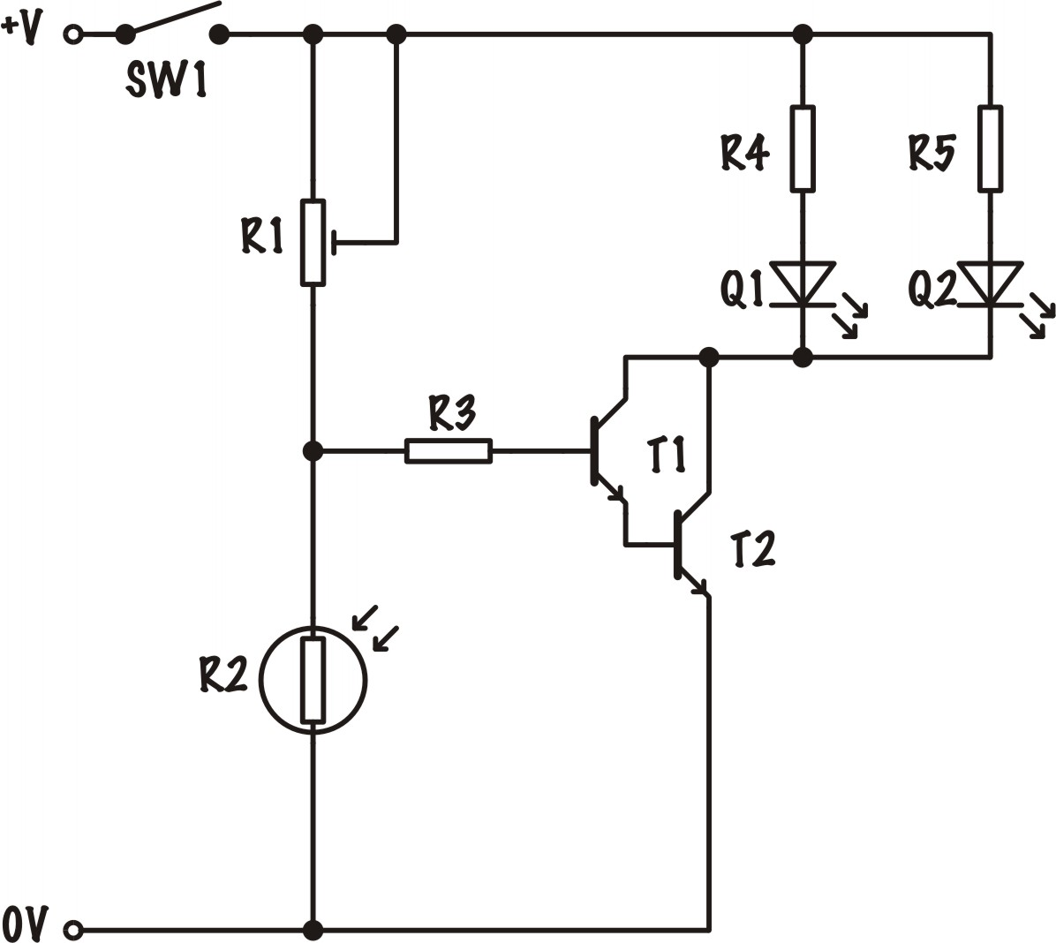  In the Darlington Pair circuit, the current that is amplified by transistor T1 is connected to the input pin (base) of transistor T2, which further amplifies the current. This circuit may be used to either make a more sensitive system or to drive more LEDs.
Differentiation
Basic |  |  | Extension
For task 1, students could be advised to use a potentiometer or variable resistor; if necessary, the example circuit layout shown in the teacher notes could even be shared with them.  The example circuit diagrams could also be shared for tasks 2a and 2b.  This could be treated as a step-by-step demonstration and make activity, with the teacher showing each step in the process, which is then copied by the students. |  |  | In task 1, students could be directed to use the analogue input of a microcontroller instead of the variable resistor. They would also need to produce a programme to operate the circuit. They could compare the use of the microcontroller with a variable resistor, listing its potential advantages and disadvantages.  Tasks 2a and 2b could be extended to include additional higher power outputs, such as a buzzer or a motor. These may necessitate that students redesign the circuit to include a relay, with a second circuit containing the output devices.
Resources |  |  | Required files
- Access to appropriate CAD software for circuit modelling and development
- Transistor sensor circuit help (Handout)
- A range of components to manufacture the circuits
- Prototype boards (breadboards), if appropriate
Related activities (to build a full lesson)
Starters (Options)  - ACTIVITY: Energy Efficiency starter  - ACTIVITY: Photovoltaic cells - Intro  Main (Options)  - ACTIVITY: Energy Efficiency main  - ACTIVITY: Photovoltaic cells – Investigating Circuits  - ACTIVITY: Photovoltaic cells – Make & Design |  | Extension (Options)  - ACTIVITY: Photovoltaic cells - Modifications  Plenary  - Opportunities within activity for presentations, peer/self-assessment  - Reflection on Objectives and PLTS skills used

The Engineering Context 
- The story Green School
- How it works? Interseasonal Heat Transfer (IHT)
- Who makes it work? Chani Leahong

Curriculum links and PLTS
England  Science  - KS3 24c, 34e, 35a, 35b, 35c  Design & Technology  - KS3 1d, 2a, 2b, 3b, 3c, 4c | Northern Ireland  Technology & Design  (Objective 1) Developing pupils as Individuals  - Respond to a personal design challenge in relation to their own lifestyle  (Objective 3) Developing pupils as Contributors to the Economy and the Environment  - Pursue design solutions using environmental friendly materials and energy sources  - Education for Sustainable Development  Learning Outcomes  - Demonstrate practical skills in the safe use of a range of tools, machines and equipment  - Show deeper understanding by thinking critically and flexibly, solving problems and making informed decisions, using Mathematics and ICT where appropriate  - Demonstrate creativity and initiative when developing ideas and following them through
Scotland  Technologies  - TCH 3-01a, TCH 2-12a / TCH 3-12a, TCH 3-13a, TCH 3-14a | Wales  Design & Technology  - 1.2, 1.6, 1.7, 4.1, 4.4, 4.5, 4.8, 5.3, 5.4
GCSE D&T  AQA D&T  - 3.1.1, 3.1.2, 3.1.4, 3.2.1, 3.2.5, 3.2.8, 3.3.4, 3.3.5, 3.3.6, 3.3.7, 3.3.10, 3.3.11  Edexcel D&T  - 1.3, 1.6, 1.16.1c, 1.17, 5.1.1, 5.2.1, 5.2.2, 5.2.3, 5.6.1, 5.7  Eduqas D&T  - 2.1 Core: 1, 3, 5  - 2.1 Systems: 1, 2, 6  - 2.2 Core: 5, 7, 8, 9, 10  - 2.2 Design and Make: 1, 3, 4  OCR D&T  - 3.2, 4.2a ii, 5.2, 6.4, 7.2a ii, 7.4 | GCSE Engineering  AQA Engineering  - 3.1.3, 3.3.2, 3.3.3, 3.4.1, 3.4.2, 3.6
GCSE Science  AQA Combined Science Trilogy  - 6.1.3, 6.2.1.1, 6.2.1.4  AQA Combined Science: Synergy  - 4.7.2.2, 4.7.2.4, 4.8.2.4  Edexcel Combined Science  - Physics: 3.13, 10.2, 10.19, 10.21  Eduqas Combined Science  - 2.3: 1.2f, 7.1f, 7.2d  OCR Gateway Science: Combined Science A  - P3.2b, P3.2e, P3.2f, P6.2a  OCR 21st Century Science: Combined Science B  - P2.2: 1, 2  - P3.1: 6b, 7  - P3.2: 5 | GCSE Physics  AQA Physics  - 4.1.3, 4.2.1.4, 4.2.1.1  Edexcel Physics  - 3.13, 10.2, 10.19, 10.21  Eduqas Physics  - 1.2f, 7.1f, 7.2d  OCR Gateway Science: Physics A  - P3.2b, P3.2e, P3.2f, 8.2a  OCR 21st Century Science: Physics B  - P2.2: 1, 2  - P3.2: 6b, 7  - P3.3: 5

Personal, learning & thinking skills (PLTS)
- Creative thinker
- Reflective learner
- Team worker
- Self manager

