Acoustic Engineering 1
What makes one set of headphones better than another?

Subject(s): Science, Design & Technology, Mathematics  Approx time: 20-30 mins |  |  | Key words / Topics:  - earphone design  - headphone design  - ergonomics  - aesthetics  - marketing
Suggested Learning Outcomes
- To understand how to analyse a product
- To be able to identify areas for development when analysing a product
- To be able to present their design considerations when deciding which areas and features to develop
Introduction
These starter activities have been inspired by the ‘Sound Design’ film and focuses upon the development of earphones and headphones. Students are provided with the opportunity to analyse earphones currently on the market in a structured, detailed, and creative way. They are then encouraged to investigate the potential development of this product.
Purpose
This unit will allow students to understand ergonomics and aesthetics in an authentic context and apply their findings in a creative and challenging way.
Activity |  |  | Teacher notes
Range of Starter activities  These activities are designed to be as flexible as you need them to be — they could form the basis of the lesson or be used as starters for a series of lessons.  - Watch the ‘Sound Design’ film and discuss  - Using the ‘Acoustic Engineering’ (Presentation), show Slide 2 and ask the students to identify the product and its function.  Ask the students, in pairs, to discuss the following questions  - Identify the target audience (age range, gender, lifestyle, demographic, etc.) for three of the earphones/headphones  - Why are there so many different types and styles of earphones and headphones, all providing a similar function?  - In relation to earphones and headphones, what is more important, form or function? (This may need some explaining.)  Ask the students to summarise these discussions for their group  - Using the ‘Acoustic Engineering’ (Presentation), show Slide 3 and ask the students to identify which of the earphones or headphones they believe to be the oldest, and to explain the reasoning behind their choice. Ask the students to sort the products in chronological order (from the oldest to the latest design).  Answers: D, B, C, E, F, A  - Use the responses of the students to stimulate a discussion about changes over the last 100 years in style, materials, aesthetics, and electronics. Relate these to key developments in society and technology.  Questions could include  - What did people do before headphones and earphones were invented?  - What do you think influenced the invention of the headphone?  Was there a need for headphones before the development of this product? |  |  | 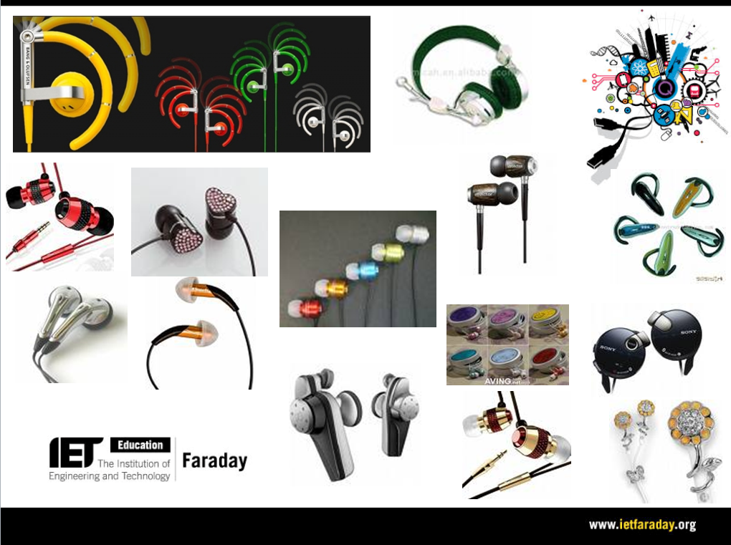  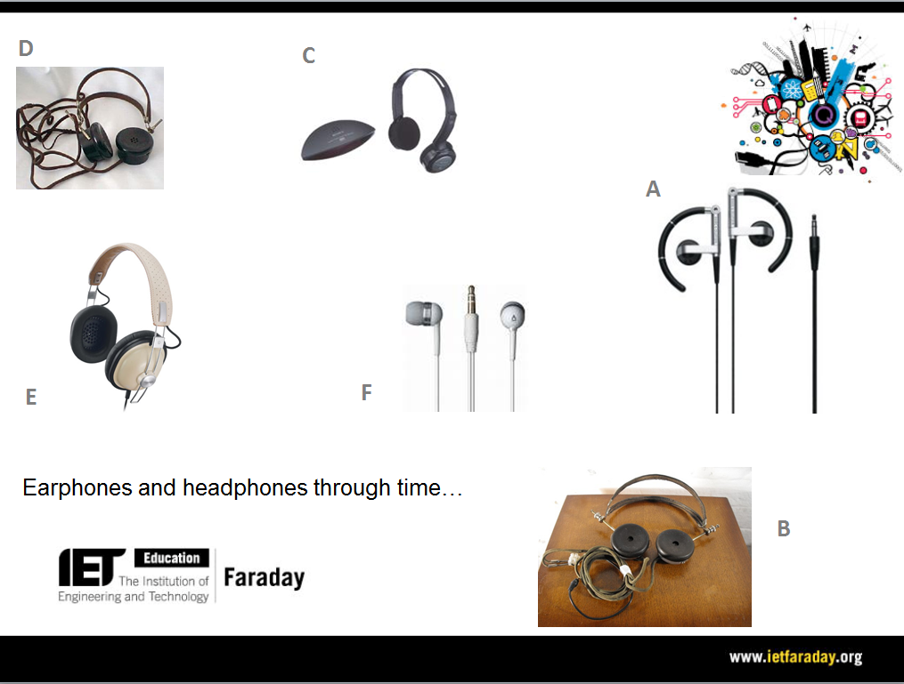
Differentiation
Basic |  |  | Extension
 |  |  | Following on from this starter activity students could then complete the main activity in this series entitled ‘Acoustic Engineering 2.’
Resources |  |  | Required files
 Sound Design film  - Projector/Whiteboard  - A range of earphones and headphones (these could be  provided by the students or collected by the department  over time). |  |  | Acoustic Engineering (Presentation)
Additional websites
- It is also possible to test their products in terms of audio quality. Visit the following site: http://www.youtube.com/watch?v=cvBtQmY2B5I
Related activities (to build a full lesson)
Starters (Options)  - ACTIVITY: Structural Engineering  - ACTIVITY: Sound insulation  - ACTIVITY: Acoustic Engineering 1  Main (Options)  - ACTIVITY: Structural Engineering 1  - ACTIVITY: Structural Engineering 2 |  | Main (cont.)  - ACTIVITY: Sound insulation  - ACTIVITY: Acoustic Engineering 2  Plenary  - Opportunities within activity for presentations, peer/self assessment  - Reflection on Objectives and PLTS skills used

The Engineering Context
- The story Sound Design
- How it works? Stage Door Design
- How it works? Ventilation System
- Who makes it work? Daryl Prasad
- Who makes it work? Rukhsana Adam

Curriculum links and PLTS
England  Design & Technology  - 3a, 3d | Northern Ireland
Scotland  Technologies  - TCH 3-01a | Wales  Design & Technology  - 2a, 2b, 4a, 4g
GCSE D&T  AQA D&T  - 3.1.1, 3.3.1, 3.3.3  Edexcel D&T  - 1.15  Eduqas D&T  - 2.2 Core: 1, 2, 4, 6  OCR D&T  - 1.2a, 2.1a iii/vii, 8.1a | GCSE Engineering  AQA Engineering  - 3.6

Personal, learning & thinking skills (PLTS)
> Creative thinker

