Structural Engineering 1
Explore how architectural and building issues can be resolved through real-life case studies

Subject(s): Science, Design & Technology, Mathematics  Approx time: 60 mins |  |  | Key words / Topics:  - structure  - architecture  - pressure  - design limitations
Suggested Learning Outcomes
- To be able to identify the key features of a structural component
- To be able to identify the various pressures a structural element can undergo
- To apply their knowledge of structures to a given task in order to design an effective solution
Introduction
The ‘Structural Engineering’ scheme of work has been designed to either reinforce or extend basic knowledge of structures to students by providing a real life context. It is not intended to form an introduction to structures.
Purpose
Students will investigate the design of the O2 Dublin building in terms of structure. They will look specifically at the requirements of the building and the constraints in terms of structural design and also the solution provided. This will form the stimulus for students to investigate structures in detail. The students will then be asked to explore possible solutions to a given structural design.
Activity |  |  | Teacher notes
CASE STUDY 1 – THE DUBLIN 02 ARENA  The activity looks at the O2 arena from a structural perspective allowing the student to understand some of the complex engineering decisions when designing a building.  Watch the video – Sound Design  Ask the students to research the building in more detail by answering the following questions:  - What were the key issues the architect had to resolve?  - Why did they not want any columns supporting the roof structure?  - What was the span they had to achieve in metres?  CASE STUDY 2 – STANSTED AIRPORT  Having looked at the O2 arena from a structures perspective, students can now reinforce what they have learnt by investigating Stansted Airport. This is another real life context where the design of the structure was crucial for a successful outcome.  Introduce – Powerpoint: Structural Engineering, Stansted Airport  Slide 3 – Basic information relating to the design of the airport.  The actual paper models produced by the architect as they try to develop a feasible solution are shown. Discuss with the class the similarities between some of the designing that goes on in schools (i.e. paper modelling) and in industry.  The biggest problem was how the designers were going to provide the airport terminal with large, uninterrupted spaces for the efficient flow of passengers.  Slide 4 – Shows how the architects solved the problem – highlighting the structural elements that were provided to give the roof the necessary structural support and at the same time providing passengers with the uninterrupted space for movement.  Slide 5 – Introduces task one (this is a very simple exercise where they can start to experience structures in 3D).  ‘In pairs design a structure that will support the given piece of A4 card 300mm off the ground. The base (footprint) of the structure cannot exceed 100mm square.  You have ten minutes to design and model a solution.’  This activity has been designed to allow the students to apply the information they have learnt so far into a practical activity. Testing can take place by simply placing the given piece of card on top of each structure. |  |  | The students will need to produce an A3 sheet presenting the research / information they have found. It will need to include the following information:  - Various images of the building and roof design  - The key design issues the solution overcame  Internal views explaining some of the solutions:  - Actual sizes, location maps, architectural drawings  - A personal analysis of the O2 arena  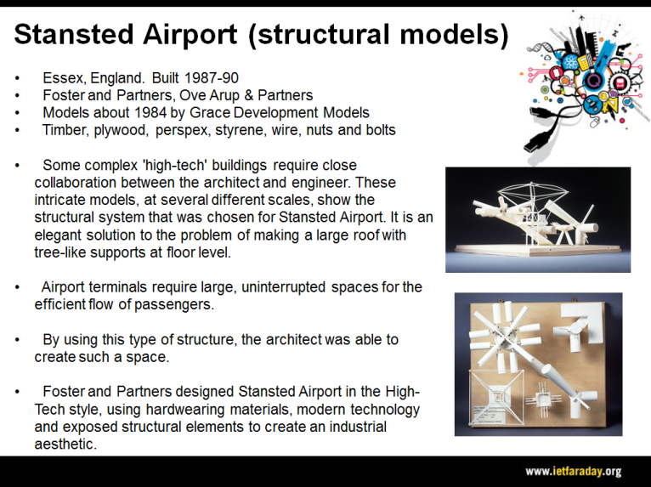  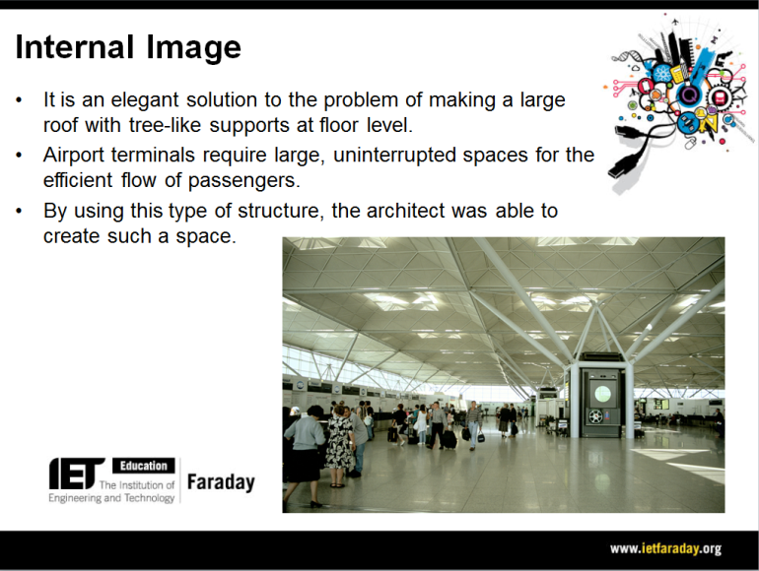  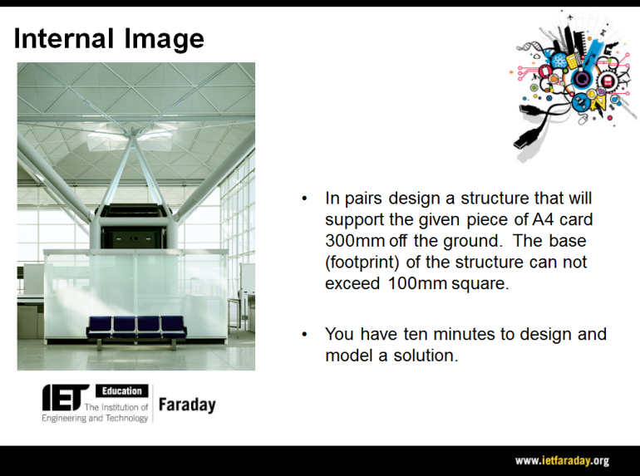
Differentiation
Basic |  |  | Extension
On completion of this exercise, students can go on to complete a further activity within this series:
- Structural Engineering 2
Resources |  |  | Required files
- Projector/Whiteboard |  |  | Structural engineering, Stansted Airport (Presentation)
Additional websites
- More information can be found at: http://www.fosterandpartners.com/projects/stansted-airport/
Related activities (to build a full lesson)
Starters (Options)  - ACTIVITY: Structural Engineering - Starter  - ACTIVITY: Sound insulation 1  - ACTIVITY: Acoustic Engineering 1  Main (Options)  - ACTIVITY: Structural Engineering 1  - ACTIVITY: Structural Engineering 2 |  | Main (cont.)  - ACTIVITY: Sound insulation 2  - ACTIVITY: Acoustic Engineering 2  Plenary  - Opportunities within activity for presentations, peer/self assessment  - Reflection on Objectives and PLTS skills used

The Engineering Context 
- The story Sound Design
- How it works? Stage Door Design
- How it works? Ventilation System
- Who makes it work? Daryl Prasad
- Who makes it work? Rukhsana Adam

Curriculum links and PLTS
England  Design & Technology  - KS3 1d, 1e, 3a, 4a | Northern Ireland  Manufacturing  - Selecting and using materials fit for purpose  - Safe use of a range of tools and processes appropriate to materials
Scotland  Technologies  - TCH 3-01a | Wales  Design & Technology  - 2c, 2d, 4b, 4d
GCSE D&T  AQA D&T  - 3.3.1, 3.1.6.2, 3.2.2, 3.3.4, 3.3.5  Edexcel D&T  - 1.15.1, 1.17, 2.4, 4.4, 7.4  Eduqas D&T  - 2.1 Core: 9, 10, 11  - 2.2 Core: 2, 8  OCR D&T  - 2.1a vii, 5.2a | GCSE Engineering  AQA Engineering  - 3.1.1, 3.6
GCSE Science  AQA Combined Science Trilogy  - 6.5.1  AQA Combined Science: Synergy  - 4.6.1  Edexcel Combined Science  - Physics: 9  Eduqas Combined Science  - 2.3: 3.1  OCR Gateway Science: Combined Science A  - P2.3  OCR 21st Century Science: Combined Science B  - P6.3: 1, 2 | GCSE Physics  AQA Physics  - 4.5.1  Edexcel Physics  - 9  Eduqas Physics  - 3.1  OCR Gateway Science: Physics A  - P2.3  OCR 21st Century Science: Physics B  - P6.3: 1, 2

Personal, learning & thinking skills (PLTS)
> Team worker

