Repeated Graphical Patterns
Interpret wave patterns in a graph

Potential GCSE content covered
- Reading and interpreting graphs
- Using Sequences
In the classroom

Allow the students some time to read the slides. They can work in pairs, or small groups, to answer the questions on the first slide, then bring the class together (see discussion points below).
The problem on the second slide is aimed at making the students think about the period of the pattern, and using this to predict what the shape will look like at various points.

Problem Solving

Students will need to think about how they can use the graph to answer the questions. They need to recognise when a maximum or minimum value occurs and be able to describe this in terms of the coordinates of the point.

The students will need to look for patterns in the graphs, both symmetrical and periodic; these ideas can then be transferred into answering the questions on the second slide.

Discussion Points

What are the maximum and minimum values of the data?
This question provides an opportunity to discuss maximum and minimum values, you could mention turning points and changing gradient either side of the point, emphasising that at a maximum and minimum point the gradient is zero.

How frequently does the pattern repeat?
Here you can mention the idea of the period of a function, perhaps show some other periodic functions like sine and cosine, which they may have seen, or will see in the future.

Where are the vertical lines of symmetry?
Compare how frequently these occur in relation to the period of the function.

About which points does the graph have rotational symmetry?
Compare how frequently these occur in relation to the period of the function, and their location compared to the lines of symmetry.

Compare the approaches used to solve the problems on the second slide.

Extending the problem

Investigate some different functions such as transformations of sine and cosine graphs using GeoGebra, and comment on the max/min values and the period and how this is affected by changing parameters.

Answers

Shown on the graph below

Maximum Value y = 6.8, Minimum Value y = - 6.8, Vertical lines of symmetry (in green), centres of rotational symmetry shown in black.
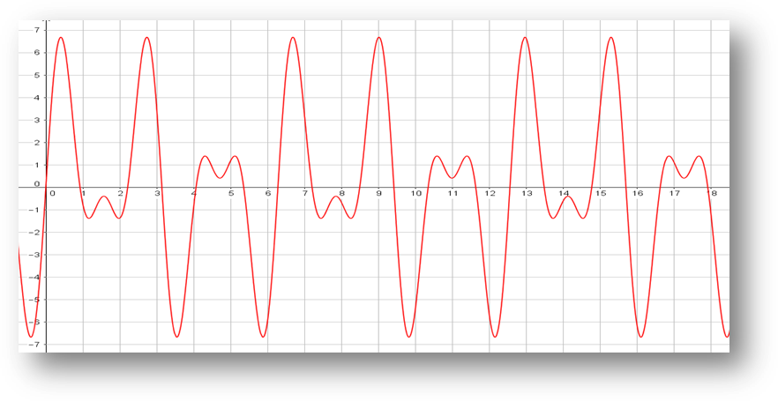

Slide 2

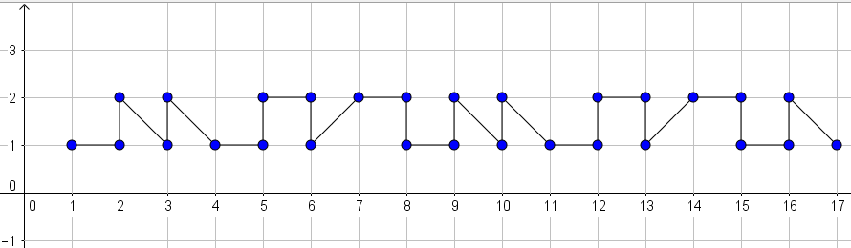

This pattern repeats every 7 squares.

Pattern | 1 | 2 | 3 |  | n
Start Point | (1,1) | (8,1) | (15,1) |  | (7n-6)

Observing the pattern from pattern 2 onwards we can see that the pattern starts on (one more than a multiple of 7).

The starting point of the box is 42, which is a multiple of 7, so the pattern will start again on 43. This means the section in the grid will be (see below)

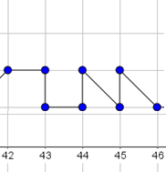

Curriculum links

England | Northern Ireland
> A 14. Plot and interpret graphs (including reciprocal graphs and exponential graphs) and graphs of non-standard functions in real contexts, to find approximate solutions to problems such as simple kinematic problems involving distance, speed and acceleration  > N 24. Recognise and use sequences of triangular, square and cube numbers, simple arithmetic progressions, Fibonacci type sequences, quadratic sequences, and simple geometric progressions ( r n where n is an integer, and r is a rational number > 0 or a surd) and other sequences | > T1 - Look at data to find patterns and exceptions  > T2 - Use linear expressions to describe the nth term of an arithmetic sequence  > T5 - Discuss, plot and interpret graphs (which may be non-linear) modelling real situations
Scotland | Wales
> MTH 3-13a Having explored number sequences, I can establish the set of numbers generated by a given rule and determine a rule for a given sequence, expressing it using appropriate notation  > MTH 4-13a Having explored how real-life situations can be modelled by number patterns, I can establish a number sequence to represent a physical or pictorial pattern, determine a general formula to describe the sequence, then use it to make evaluations and solve related problems | Using Geometry Skills  > Y11 - Reflect shapes in horizontal and vertical lines  > Y11 - Describe reflection in horizontal or vertical lines  Using Algebra Skills  > Y11 - Express the nth term rules algebraically,  e.g. n², n² + 1, n² + 3, n² – 3, n³

