

Explore engineering careers at www.tomorrowsengineers.org.uk
Name: . . . . . . . . . . . . . . . . . . . . . . . . . . . . . . . . . . . . . . . . . . .
When driving there are often distractions that may affect your concentration, for example
music, people talking to you and signs on the side of the road.

Write down your method:

Your task is to devise a suitable way of testing a person's ability to not get distracted.

First, you will have to devise something that requires a lot of concentration. This could be a game on the internet, completing a puzzle or memorising a list.

As the person is completing their task you need to come up with a suitable way of distracting them.

Remember, your method has to be a fair test, repeatable (you can repeat the experiment again and get the same results) and reproducible (so others could follow your method and get similar results). It should also allow you to gather data that can be recorded.

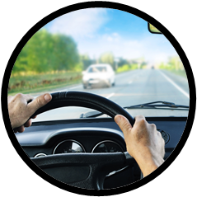
Why is it important when driving to not get distracted?


Explore engineering careers at www.tomorrowsengineers.org.uk
Carry out your test on members of your group and record your results in the space below:

Describe what your results show:
Carry out your test on older family members and record the results in a table in the space below:

Describe what your results show:
Homework

