

Explore engineering careers at www.tomorrowsengineers.org.uk
Name: . . . . . . . . . . . . . . . . . . . . . . . . . . . . . . . . . . . . . . . . . . . . . . . .
Your reaction time is how long you take to respond to a change in your environment.
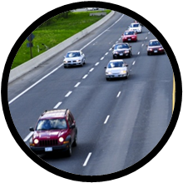
Why is it important when driving to have fast reactions?

Write down your method:

Your task is to devise a suitable test which can be used to measure a person's reaction times.

Take a look at the methods on these webpages and choose one. Remember, your investigation has to be a fair test.

www.mathsisfun.com/games/reaction-time.html
www.bbc.co.uk/science/humanbody/sleep/sheep/reaction_version5.swf
www.topendsports.com/testing/tests/reaction-stick.htm

Name and age | Reaction time (ms)
Name and age | Test 1 | Test 2 | Mean

Explore engineering careers at www.tomorrowsengineers.org.uk
Name and age | Reaction time (ms)
Name and age | Test 1 | Test 2 | Mean
Describe what your results show:
Describe what your results show:
Homework
Carry out your test on older family members and record the results in the table below:

Carry out your test on members of your group and record your results in the table below:

