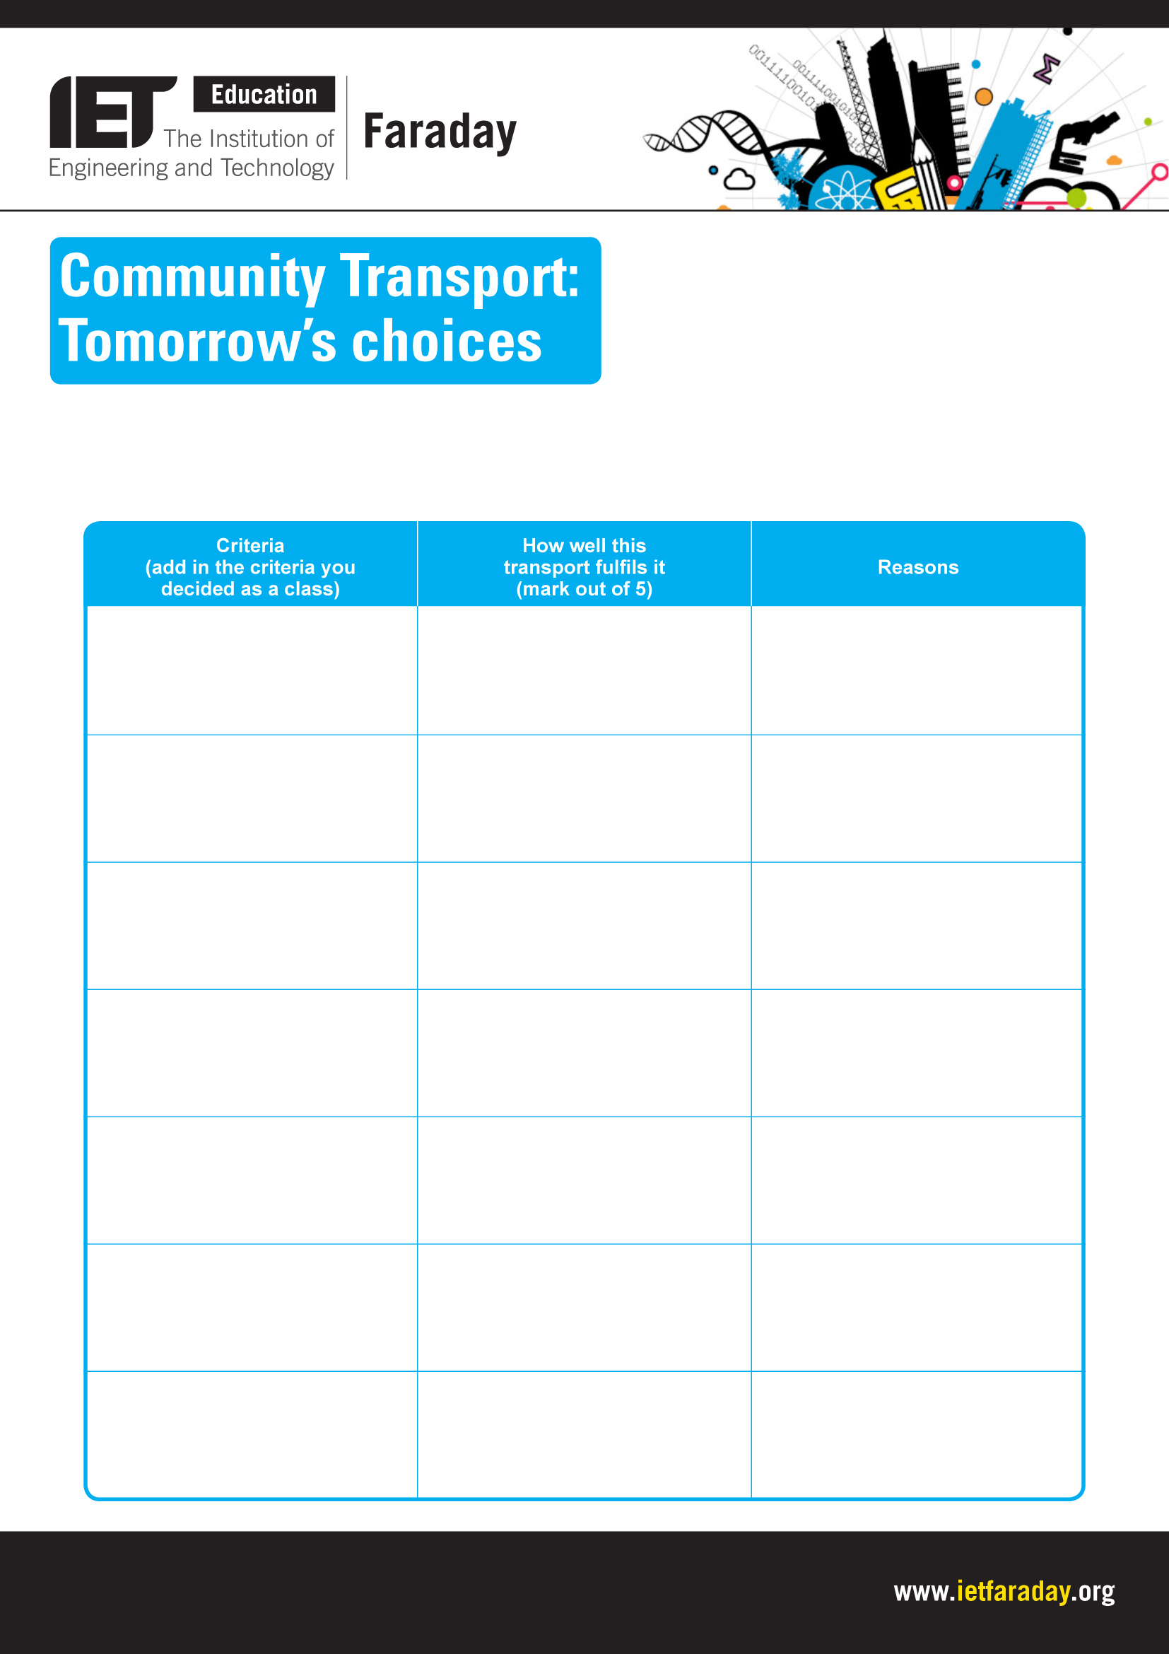
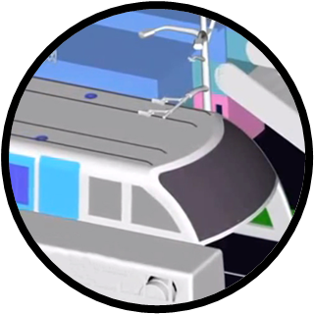
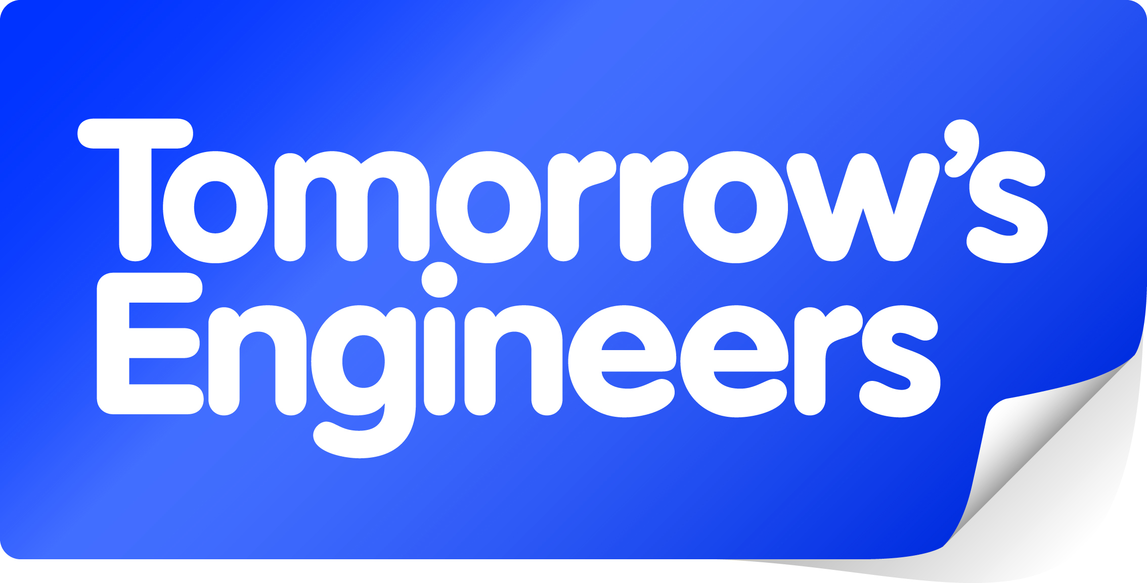
Explore engineering careers at www.tomorrowsengineers.org.uk
Name of transport: Straddle bus

Website for research:
https://www.wired.co.uk/article/china-elevated-transit-bus

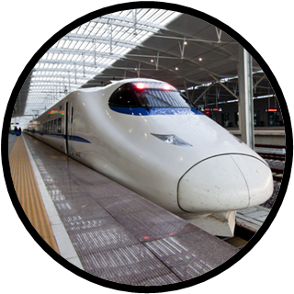
Explore engineering careers at www.tomorrowsengineers.org.uk
Name of transport: Bullet train

Website for research:
https://web-japan.org/kidsweb/hitech/shinkansen/index.html

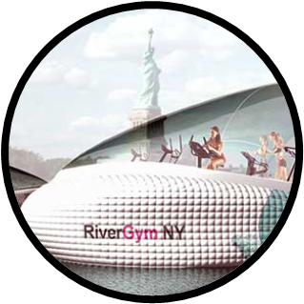
Explore engineering careers at www.tomorrowsengineers.org.uk
Name of transport: River gym

Website for research:
https://inhabitat.com/the-floating-human-powered-gym/

Image: Dr. Mitchell Joachim, Terreform 1.
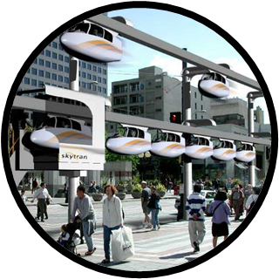
Explore engineering careers at www.tomorrowsengineers.org.uk
Name of transport: SkyTran

Website for research:
www.skytran.net/

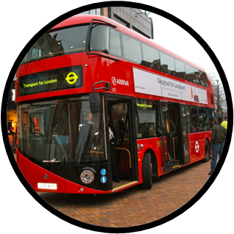
Explore engineering careers at www.tomorrowsengineers.org.uk
Name of transport: Hybrid bus

Website for research:
https://en.wikipedia.org/wiki/Hybrid_electric_bus
Chris Jenner /
Shutterstock.com
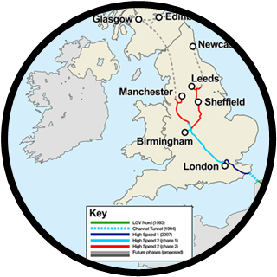
Explore engineering careers at www.tomorrowsengineers.org.uk
Name of transport: HS2

Website for research:
https://www.hs2.org.uk/

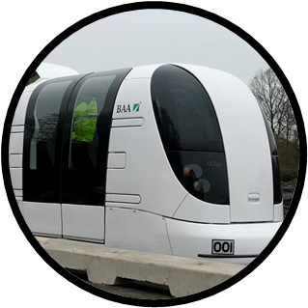
Explore engineering careers at www.tomorrowsengineers.org.uk
Name of transport: Personal rapid transport

Website for research:
https://en.wikipedia.org/wiki/Personal_rapid_transit

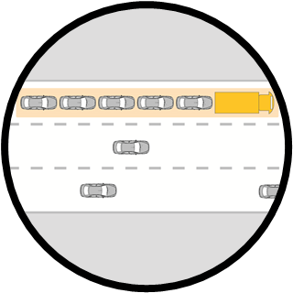
Explore engineering careers at www.tomorrowsengineers.org.uk
Name of transport: Road trains

Website for research:
http://news.bbc.co.uk/1/hi/technology/8349923.stm

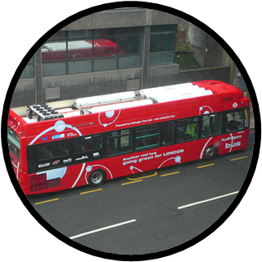
Explore engineering careers at www.tomorrowsengineers.org.uk
Name of transport: Fuel cell bus

Website for research:
https://www.fuelcellbuses.eu/wiki/fuel-cell-electric-buses-fuel-cell-electric-buses/about-fuel-cell-electric-buses

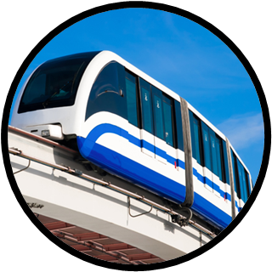
Explore engineering careers at www.tomorrowsengineers.org.uk
Name of transport: Monorail

Website for research:
https://en.wikipedia.org/wiki/Monorail

