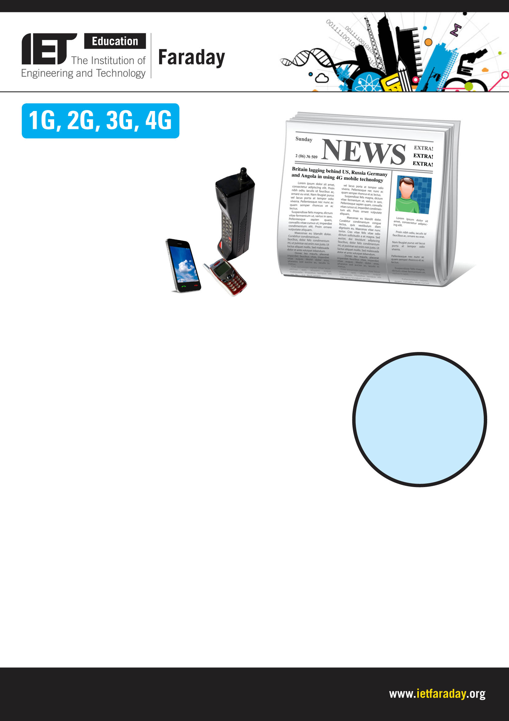
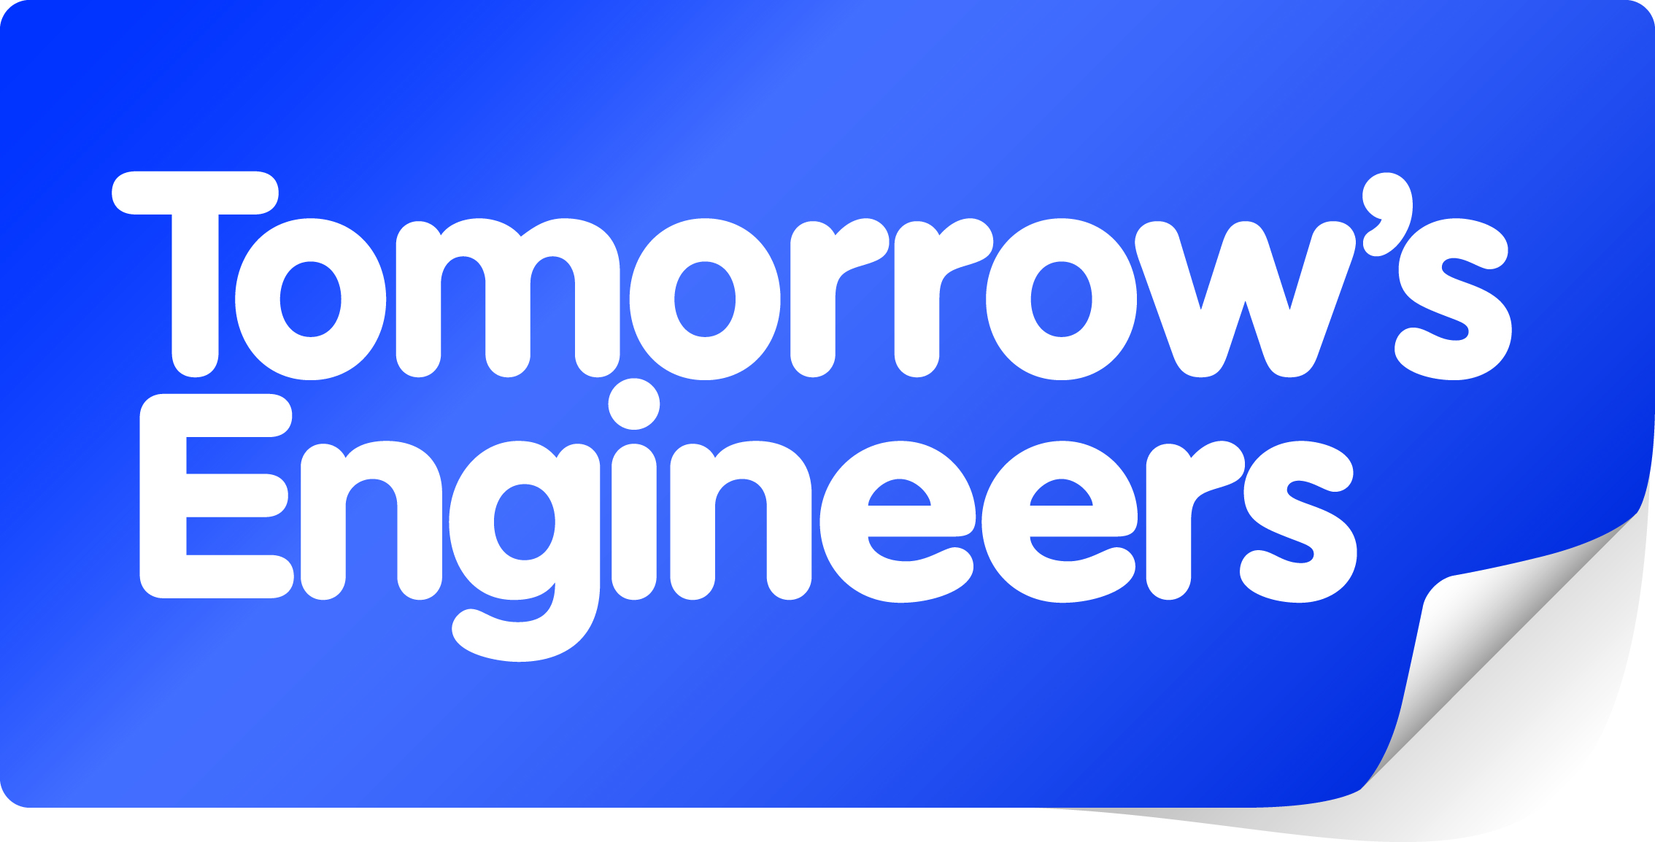
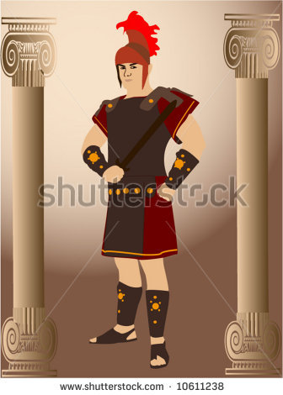
Explore engineering careers at www.tomorrowsengineers.org.uk
By ‘4G’, we mean the ‘fourth
generation’ of mobile phone.
But what were the earlier
generations of mobile phones?

1G was the first generation
This was the analogue signal technology that was first introduced in 1979. These were cell phones in that they used a network of transmission towers, also known as cell towers. They became widely used across the rest of the world in the 1980s. The 1G phones had a very low bandwidth and were prone to interference.
Before this, there were mobile radio telephones (which did not use transmission towers). These earlier phones are sometimes referred to as ‘0G’ or pre-cellular.

2G - second generation
These were similar to 1G technology, in that they sent and received digitally
encoded signals to cell towers. They were first introduced in 1991. A big
advance was the use of spare bandwidth to carry SMS (text) messages. This
was thought to be a gimmick at first and was slow to catch on. The first SMS
text message from phone to phone was sent in 1993. Now SMS is used more
than voice calls.
The digital handsets are smaller as they require less power, a problem in rural
areas where the cell phone masts are spread out more. The lower power
signals drop out in the fringe areas away from any mast.
A digital signal means that more data is compressed into the bandwidth available (see bandwidth analogy).

3G – gave us smart phones
3G was introduced in 2001. It used different radio frequencies so needed new masts and new mobile phones. But the greater bandwidth from 3G enabled lots of the new services that we associate with smart phones such as video calls, web browsing, GPS services, picture messages, smart apps etc.

4G – instant downloads and HD TV
There seems to be no way for us to resist the pressure from new upgraded technology. Eventually it will push out what we have now, because it is better. Just like the horse and cart were replaced by motor cars, 4G will bring even greater bandwidth and with it more data. This has the potential to give instant downloads and HD TV but new phones will be needed to use it.

Analogue and
digital – a difference
An analogue call gets
crackly and indistinct when
the signal strength is down.
A digital call remains clear,
but then drops out altogether
when the signal gets
too low

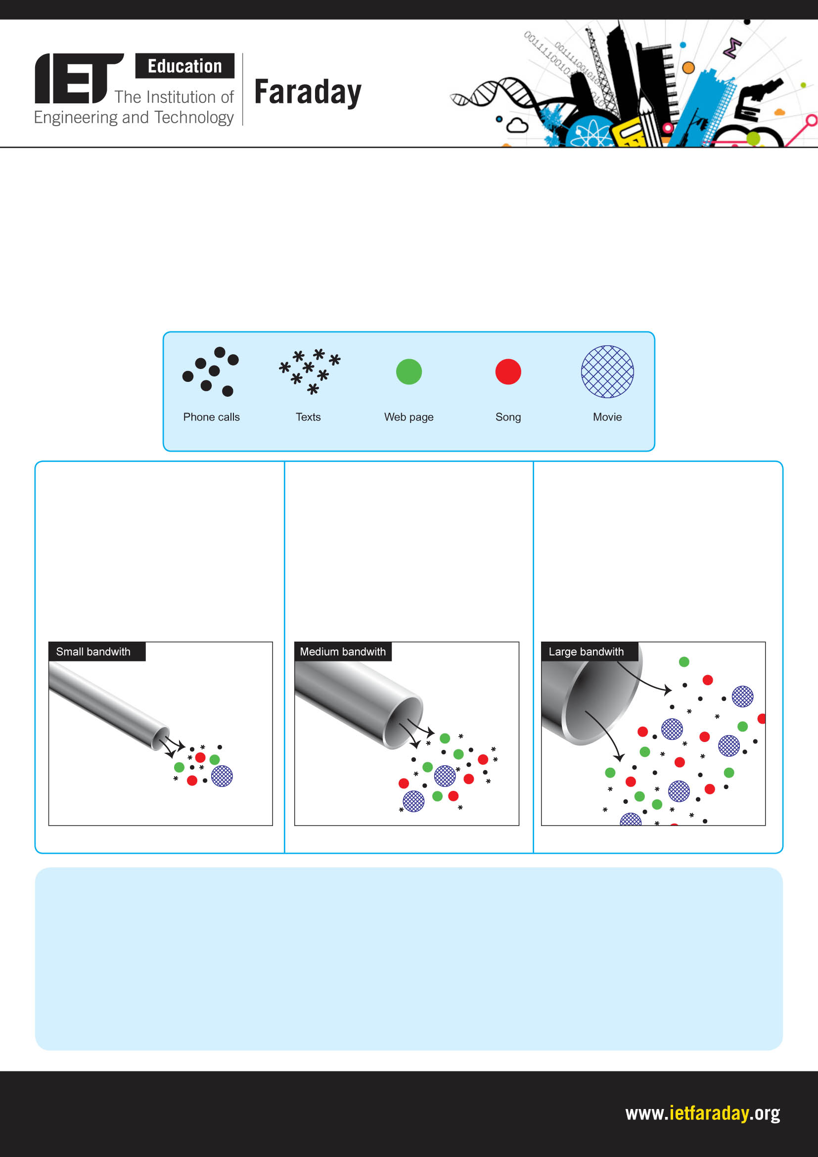
Explore engineering careers at www.tomorrowsengineers.org.uk
Bandwidth analogy
This is a term you hear a lot. The best way to explain is with a picture. Bandwidth is to do with the amount of information a signal can carry.
The information can be a small amount (i.e. digital call or a SMS message) or a bigger unit (i.e. a web page or a song download) or a very big amount (i.e. a movie).
The bandwidth of the signal is like a pipe – the bigger the bandwidth, the bigger the diameter of the pipe.
Questions
1. What does the G stand for in 3G mobile phone technology?
2. What was the big advance going from 1G to 2G?
3. What was the advanced type of phone that was possible with 3G technology?
4. a) If you have heard about 4G technology, explain what you have heard and its benefits.
b) If you have heard nothing about 4G yet, predict benefits of the technology.
A small pipe can carry lots of little digital calls and SMS messages,
but the bigger chunks such as a song download or a web page, need to
be broken up and sent in bits. The technology then sorts the bits and puts them back together again. A huge chunk of data, such as a film
would take all day to feed through
a small pipe.

A medium pipe can take the bigger chunks of data in one go and still have room for lots of calls and texts around them. But a lump like a movie still needs to be broken up and takes time to go through.

We’re after a situation like this. Enough bandwidth for all the little calls and texts, with chunks such as song downloads going through easily and even room for a film to get sent through quickly – so fast, in fact, that it can be reassembled and played in real time as it is received, without seeing any breaks.

These illustrate the different types of data that can be carried via a signal

Only phone calls and texts get through easily

This is like 3G nearly instant web pages etc

These represent what is carried by the signal

Calls and texts go
through easily.
Web pages and songs
go in fragments.
Movies take longer.
Lots of calls and texts
get through. So do
songs and web page
downloads. Movies
come in bigger lumps
so download faster.

Everything
gets through
quickly

