Product Advertisements
Investigating the necessity of developing standards and protocols for communication
Advert 1
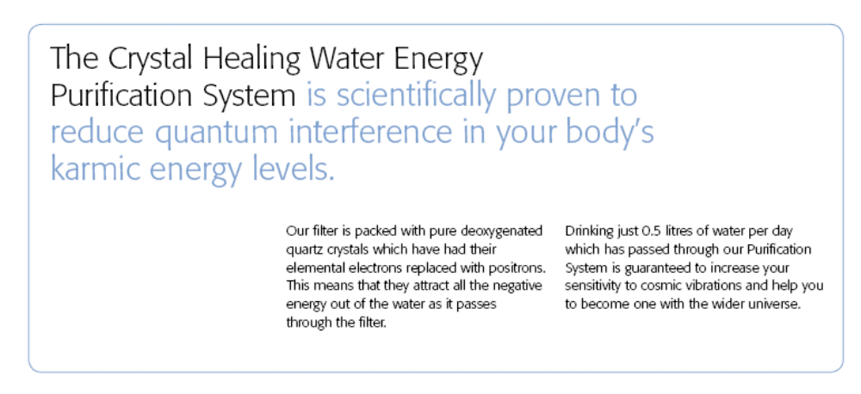

Advert 2 | Advert 3
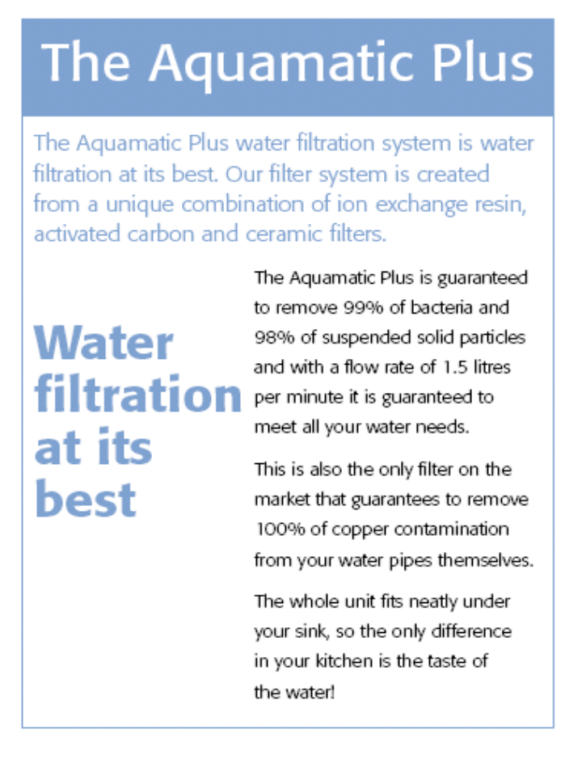 | 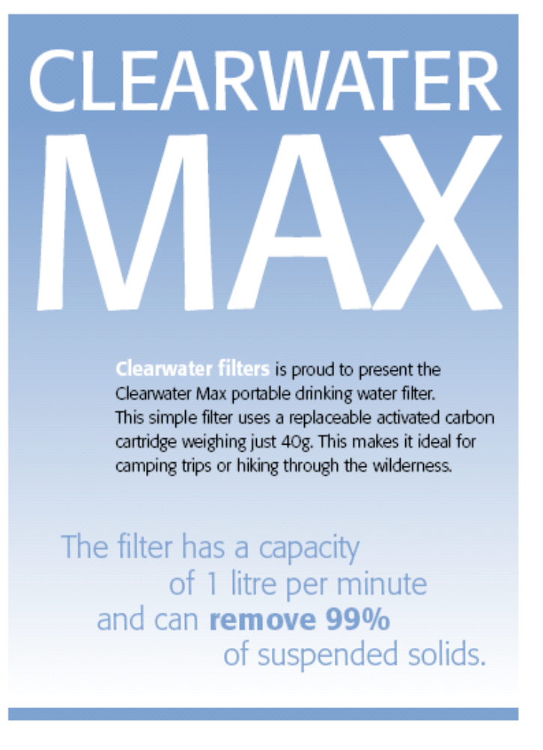

Advert 4
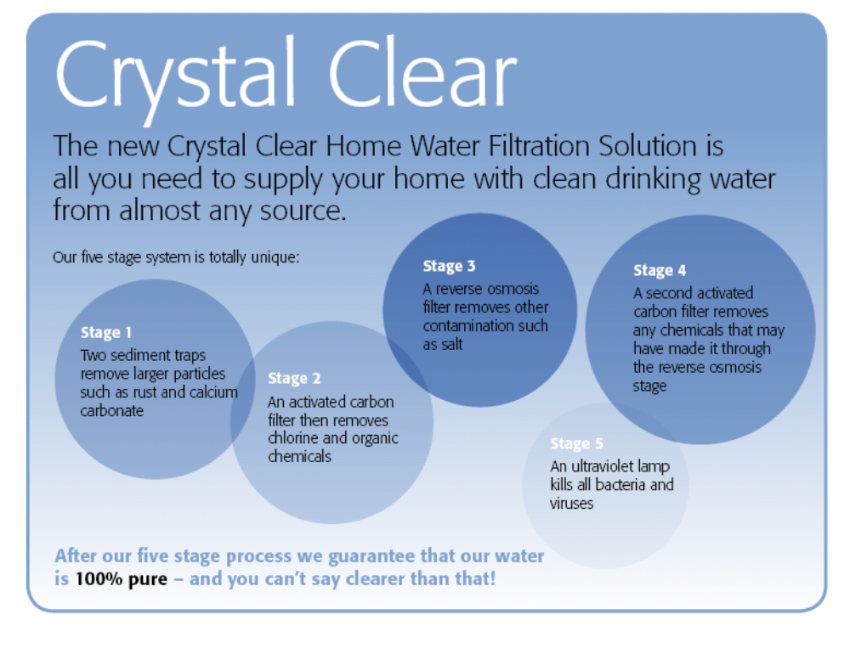

What are the manufacturers claiming about their products?

...................................................................................................................................................................................................................................................................................................................................................................................................................................................................................................
............................................................................................................................................................................................................................................................................................................................................................................................................................................................................................................................................................................................................................. ........................................................................................................................................................................................................................................................................................................................................................................... ..........................................................................................................................................................................................................................................................................................................................................................................

Do the claims have any scientific merit that can be tested?

........................................................................................................................................................................................................................................................................................................................................................................................................................................................................................................................................................................................................................................................................................................................................................................................................................................................................................................................................................................................................ .................................................................................................................................................................................................................................................. .................................................................................................................................................................................................................................................. .........................................................................................................................

What experiments could you do to test any of these claims?

........................................................................................................................................................................................................................................................................................................................................................................................................................................................................................................................................................................................................................................................................................................................................................................................................................................................................................................................................................................................................ .................................................................................................................................................................................................................................................. .................................................................................................................................................................................................................................................. ............................................................................................................................................................................................................................................................................................................................................................................................................................................................................................................................................................................................................................. ............................................................................................................................................................................................................................................................................................................................................................................................................................................................................................................................................................................................................................. ............................................................................................................................................................................................................................................................................................................................................................................................................................................................................................................................................................................................................................. .............................................................................................................................................................................................................................................................................................................................................................................................................................................................................................................................................................................................................................

