Building the Communicator
Building a communications device is really quite simple. All you need to be able to do is transmit a signal over a distance. Even complex information can be transmitted and received using very simple equipment.

Here is an example that you can build yourself.

Your teacher will give you:
- One switch
- Connecting leads
- One light bulb (3V approx) and holder
- One 3V power supply or cells
- Supply of crocodile clips

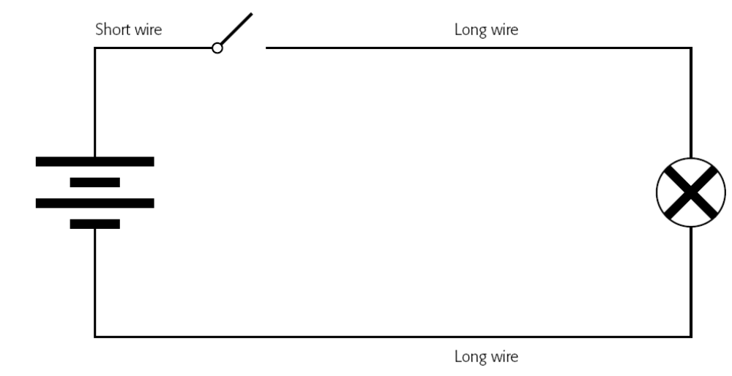
Now, design a method of communication that will allow you to communicate with another group using the above circuit.

To do this you will need to think about the following:

What kind of information do you want to send?
It might be pictures, sound or text for example. Pictures and sound would be very difficult with our set up, so really we are limited here to text which will mostly be letters and perhaps some numbers from time to time.

How will you transmit your text?
Probably the easiest thing to do is to use short flashes and long flashes.

Make a code or make a cipher?
Enciphering, in this case, means representing individual letters with sequences of short flashes and long flashes.
Encoding would mean having a sequence of short flashes and long flashes representing whole words.
Encoding is faster if you only have a few possible words that you are ever going to send, but enciphering gives you much more flexibility.

How could you speed things up?
Communication needs to be as quick as possible, particularly in applications like remote surgery, so think how you might speed things up. Think about the methods you use to speed up sending a text message on your mobile, for example.

