JAMES WEBB
SPACE TELESCOPE

Student Booklet

Could you be our engineer….?

With thanks to our sponsors…

Contents

- The Context …………………………………………………………………………….. 4
- The Brief ………………………………………………………………………………… 4
- Schedule for the day ………………………………………………………………….. 5
- Shop resource sheet …………………………………………………………………… 6
- Assessment information and criteria …………………………………………………. 10

Context
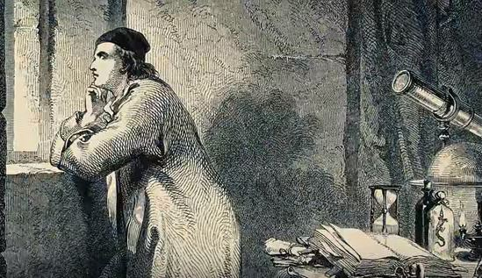
Since the beginning of humankind we have been fascinated by our night skies. When Galileo pointed his telescope to the sky in 1610 and introduced us to the wonders of Saturn’s rings and the moons of Jupiter our ideas about the natural world changed forever.

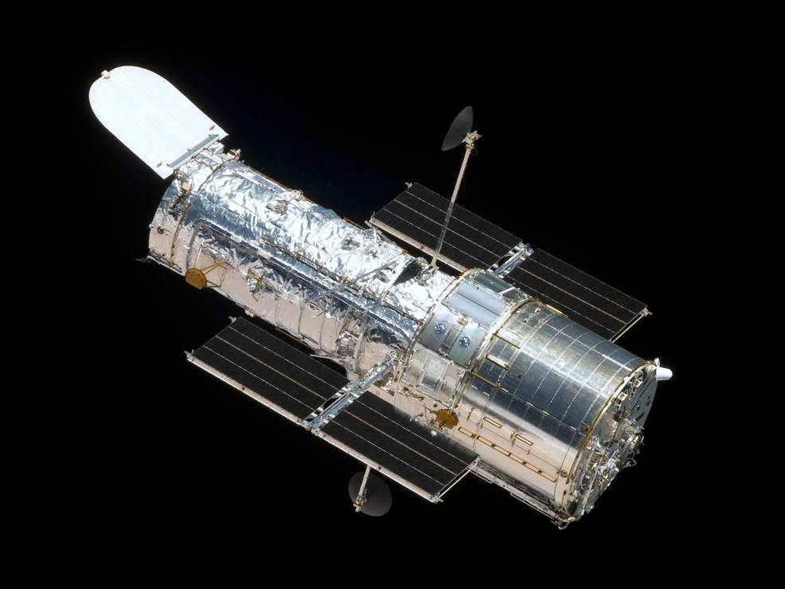
The launch of the Hubble telescope in 1990 allowed us a unique insight in to such wonders as the birth and death of stars and evolution of the galaxies. After over 18 years in space, however, it is now to be joined by the James Webb Space Telescope (or Webb for short), which will allow us to see far deeper into the universe than ever before.

Its development has not been easy. Involving countries around the world, including the United Kingdom, it has presented engineers with many challenges along the way. From keeping parts clean and dust free during development, to transporting the telescope, or parts of it, around the world, to its deployment and operation in space, engineers have had to work together to solve many problems. Webb’s mission will last approximately 10 years and we are looking for engineers to join our team in the future.
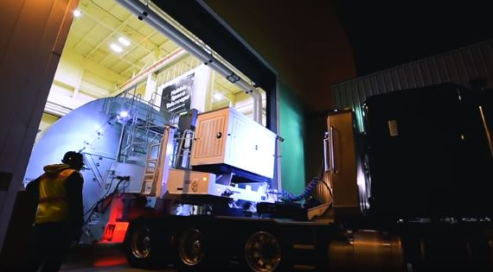
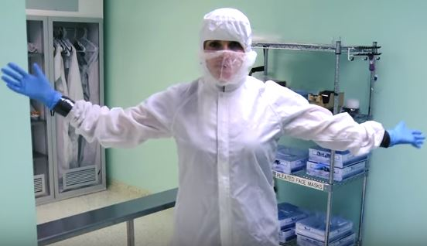

Your brief is provided in the letter from Tim Peake. You will need to demonstrate the skills and attitudes we are looking for so:

- be creative;
- plan carefully;
- work within the resources and the budget available;
- be realistic about what is achievable in the time available;
- be resilient and persevere with problems;
- record your thinking;
- keep to strict deadlines

Today is your chance to make a difference, could you be our engineer..........?

IET Faraday Challenge Day 2018-19
Engineer Brief
Hi Engineers,

Congratulations on being selected as a future engineer for the James Webb Space Telescope. I have seen the wonders of space and want you to be part of our team but you will need to demonstrate whether you have the skills to be one of our engineers of the future.

The brief:
As you have seen, engineers have been involved at all steps along the journey of the James Webb Space Telescope. We want your team to choose an area to work on to demonstrate you have the skills required.

You might choose from the following but feel free to choose another area if you think it will help with our engineering mission.
- The places in which parts of the telescope are built or assembled, such as the clean rooms.
- The ways in which we keep our engineers comfortable, safe and happy whilst they are involved with the project.
- The ways in which parts of the telescope are transported to the different sites for assembly and testing.
- Equipment which may help with the launch of the telescope e.g. launch site, rocket, alerts.
- Deployment of the telescope in space, such as unfolding each section or powering the telescope.
- The ways in which the telescope focuses light by moving the hexagonal sections of the primary mirror or analyses light to study the atmospheres of planets around nearby stars.
Once you have chosen your area you will need to:
- Engineer one aspect to help the team. Your design must include an electric circuit and should be designed as a working prototype.
- ecord your work progress by reporting on the problems, solutions and the ways in which your team has worked together.
- Present your prototype to the representatives of the James Webb Space Telescope team.
Good luck engineers!

Tim Peake
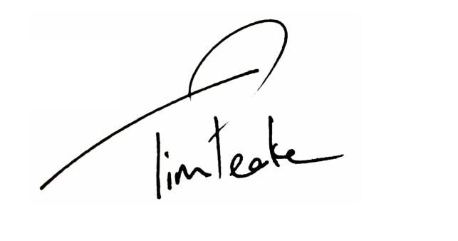

IET Faraday
Challenge Day
2018
-
19

Engineer Brief

Hi Engineers,

Congratulations on being selected as a future engineer for the
James Webb Space Telescope. I have seen the wonders of space
and want you to be part of our team but you will need to
demonstrate whether you have the skills to be one of our
engineers of the f
uture.

The

brief:

As you have seen, engineers have been involved at all steps along the journey of the James Webb Space
Telescope. We want your team to choose an area to work on to demonstrate you have the skills
required.

You might choose from the foll
owing but feel free to choose another area if you think it will help with
our engineering mission.

•

The places in which parts of the telescope are built or assembled, such as the clean rooms.

•

The ways in which we keep our engineers comfortable
, safe

and happy whilst they are involved with the
project.

•

The ways in which parts of the telescope are transported to the different sites for assembly

and testing.

•

Equipment which may help with the launch of the telescope e.g. launch site, rocket, alerts.

•

Dep
loyment of the telescope in space
,

such as unfolding
each
section or powering the telescope.

•

The ways in which the telescope focuses light by moving the hexagonal sections of the primary mirror or
analyses light to study the atmospheres of planets around nearby stars.

Once you have chose
n
your area you

will need to:

•

Engineer
one

aspect to help the team. Your design
must
include an electric circuit and should be designed
as a working prototype.

•

Record your work progress by reporting on the
problems,
solutions and the ways in which your team has worked together.

•

Present your prototype to the representatives of the James
Webb Space Telescope team.

Good luck engineers!

Tim Peake

Schedule for the day

09:15 | Register your team
09:30 | Welcome and introduction
09:50 | Project brief: Introduction to the Faraday Challenge
10:10 | Planning: Identifying the problems and generating initial ideas
10:25 | Team role selection: team decides on which roles they need
10:30 | Engineering apprenticeship: teams complete a short engineering task
10:40 | Development  - Shop opens  - Agree on final product designs
11:00 | Break
11:10 | Development continues  - Continue to design and modify where necessary  - Record progress in event log
12.00 | Teams are briefed on the content of the presentation
12:30 | Lunch – Tools down
13:00 | Development: Final preparations  - Finalise product  - Prepare presentation with notes
13:30 | - Shop closes  - Submit accounting sheet to the Shop keeper  - Practise presentation
13:50 | Presentation  - Teams present their designs to the judge(s)
14:45 | Award ceremony with final feedback and evaluation of the day
15:00 | Engineering teams depart

4. Shop resource sheet

Items to buy

Electrical components
Item | Description |  | Unit | Cost
Crocodile leads | 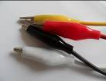 | Lead with crocodile clips at each end | Each | 4 Faradays
Insulated wire – red or black | 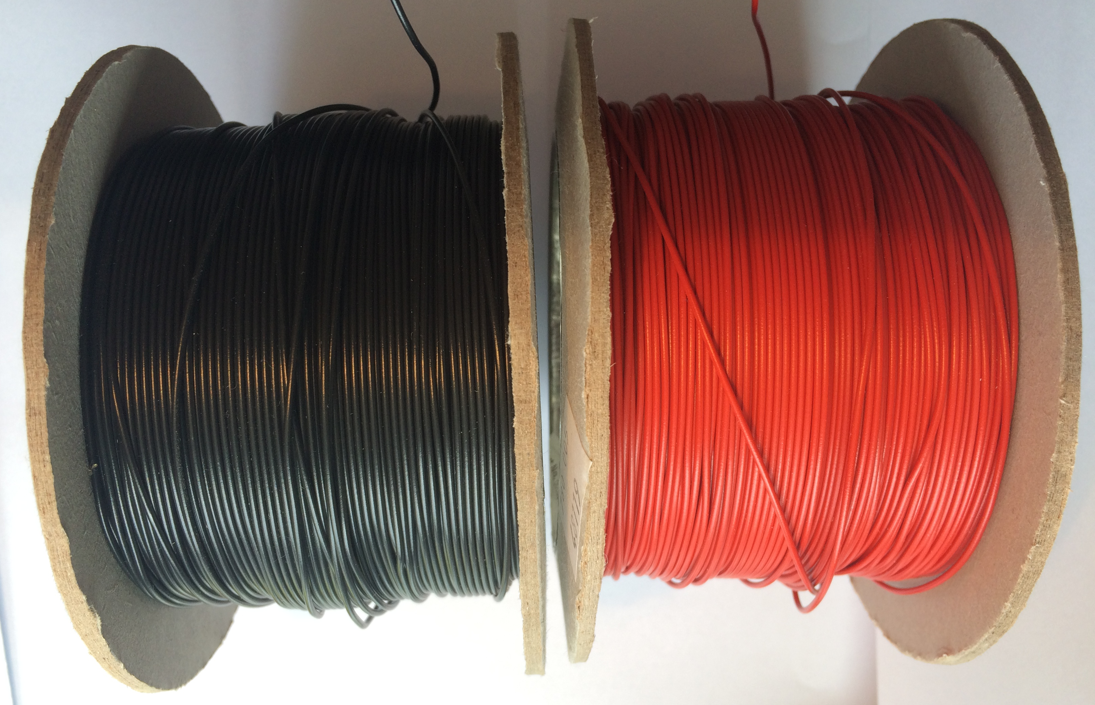  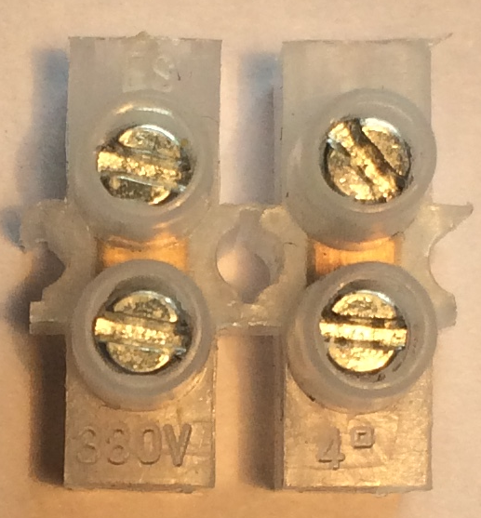 | Can be used to create a circuit using terminal blocks or used for electro-magnets | Per 30 cms | 2 Faradays
Terminal blocks |  | Can be used to connect insulated wire | Block of 4 | 1 Faraday
Crocodile clips | 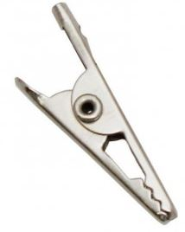 | Used with the insulated wire to create connections | Pair | 1 Faraday
Piezo buzzer | 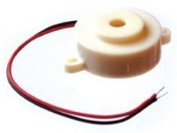 | Connect in a circuit to give a sound output | Each | 6 Faradays
LED – various colours | 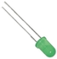 | Light Emitting Diode which lights up when connected in a circuit. Choose from red, orange, green or blue. | Each | 6 Faradays
2.5V Bulb with bulb holder | 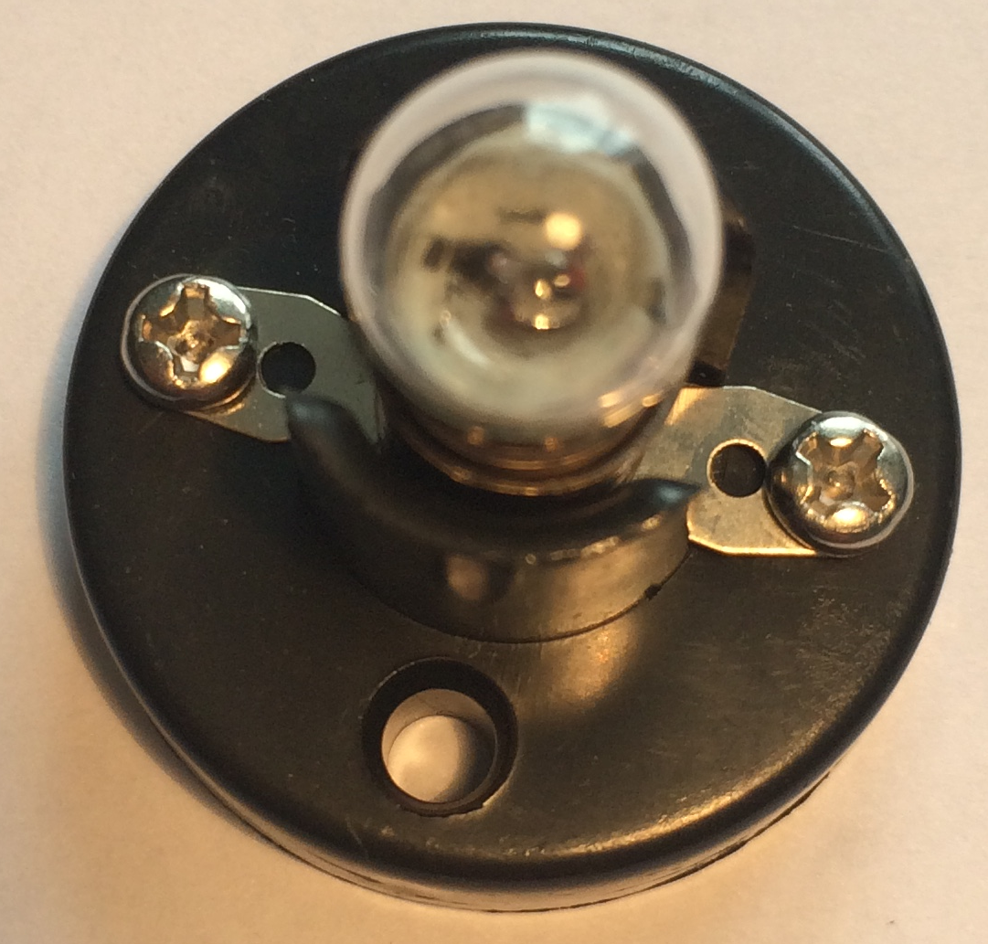 | Used as a light in a circuit. NOTE: Will not work with an LDR | Each | 6 Faradays
Motor | 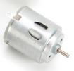 | Connect in a circuit to create clockwise or anti-clockwise movement. Will not work with a solar panel or an LDR. | Each | 6 Faradays
Solar motor | 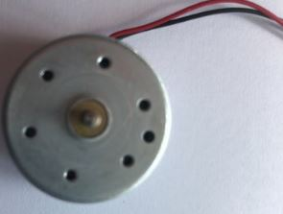 | Connect to a solar panel to create clockwise or anti-clockwise movement. | Each | 6 Faradays

Servo motor | 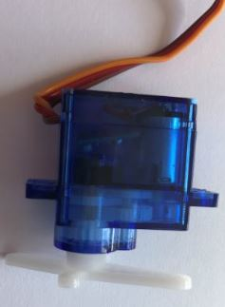 | Use with a servo motor control unit to have automatic movement to degrees or continuous control through 90^{O} | Each | 6 Faradays
Light Dependent Resistor (LDR) | 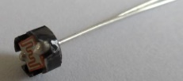 | Component that detects the light level and changes resistance in a circuit. | Each | 8 Faradays
Push button switch | 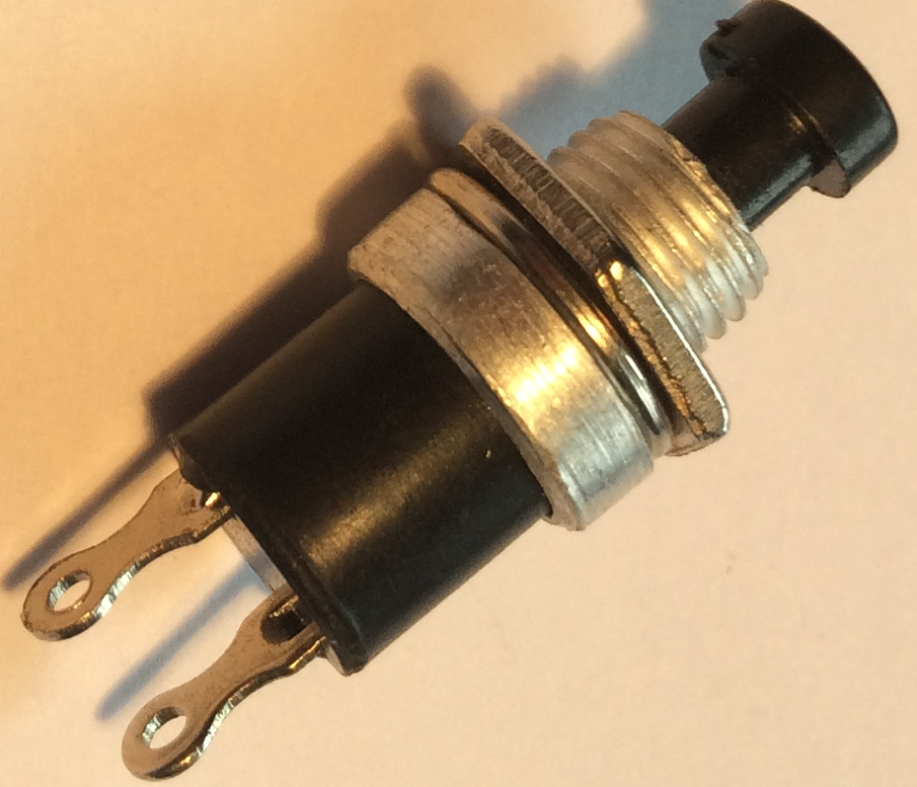 | Connects a circuit when pushed down and breaks the circuit when released. | Each | 6 Faradays
Moisture sensor | 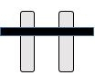 | Component which detects moisture in the surroundings. Can also be used to detect materials which conduct electricity. | Each | 8 Faradays
Servo motor control unit | 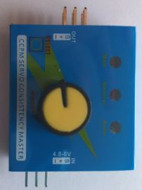 | Use this to control a servo motor. You MUST read the ‘How to …’ sheet before connecting this component. | Each | 8 Faradays
Motor holder | 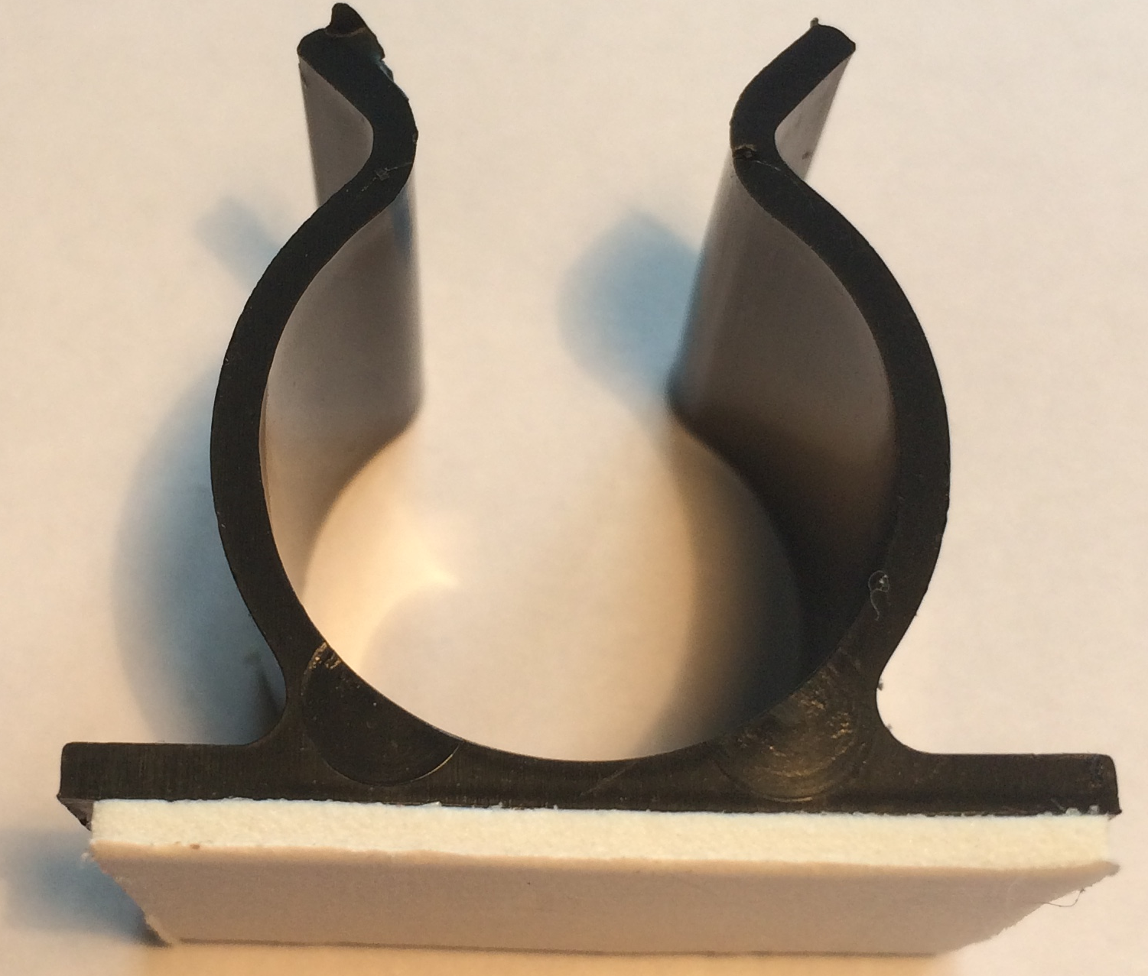 | Used to fix a motor or a syringe in position. NOTE: you will need the insert to connect a syringe. | Each | 4 Faradays
Gear attachment for motor | 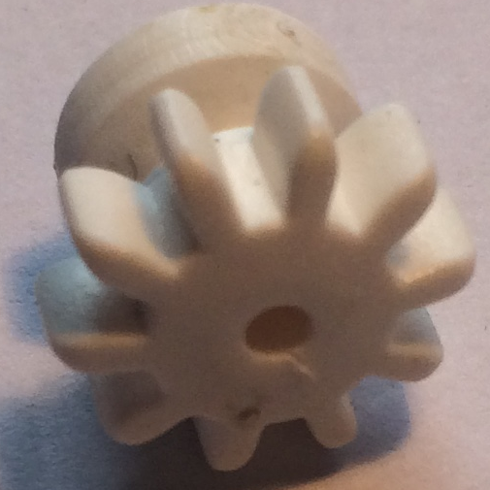 | Used to connect a motor to a cog. | Each | 2 Faradays
Pulley attachment for motor | 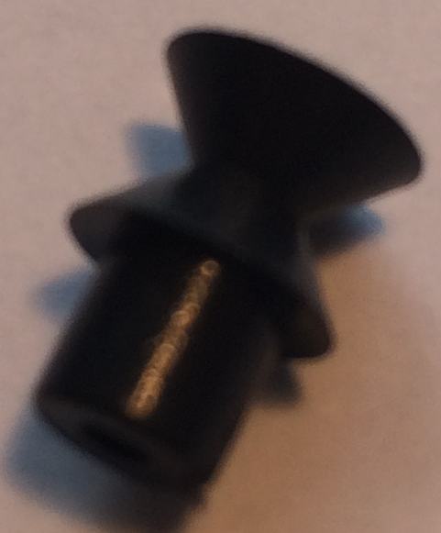 | Used to connect a motor to a pulley wheel – will need connector (e.g. elastic band) | Each | 2 Faradays
Solar panel | 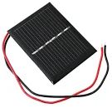  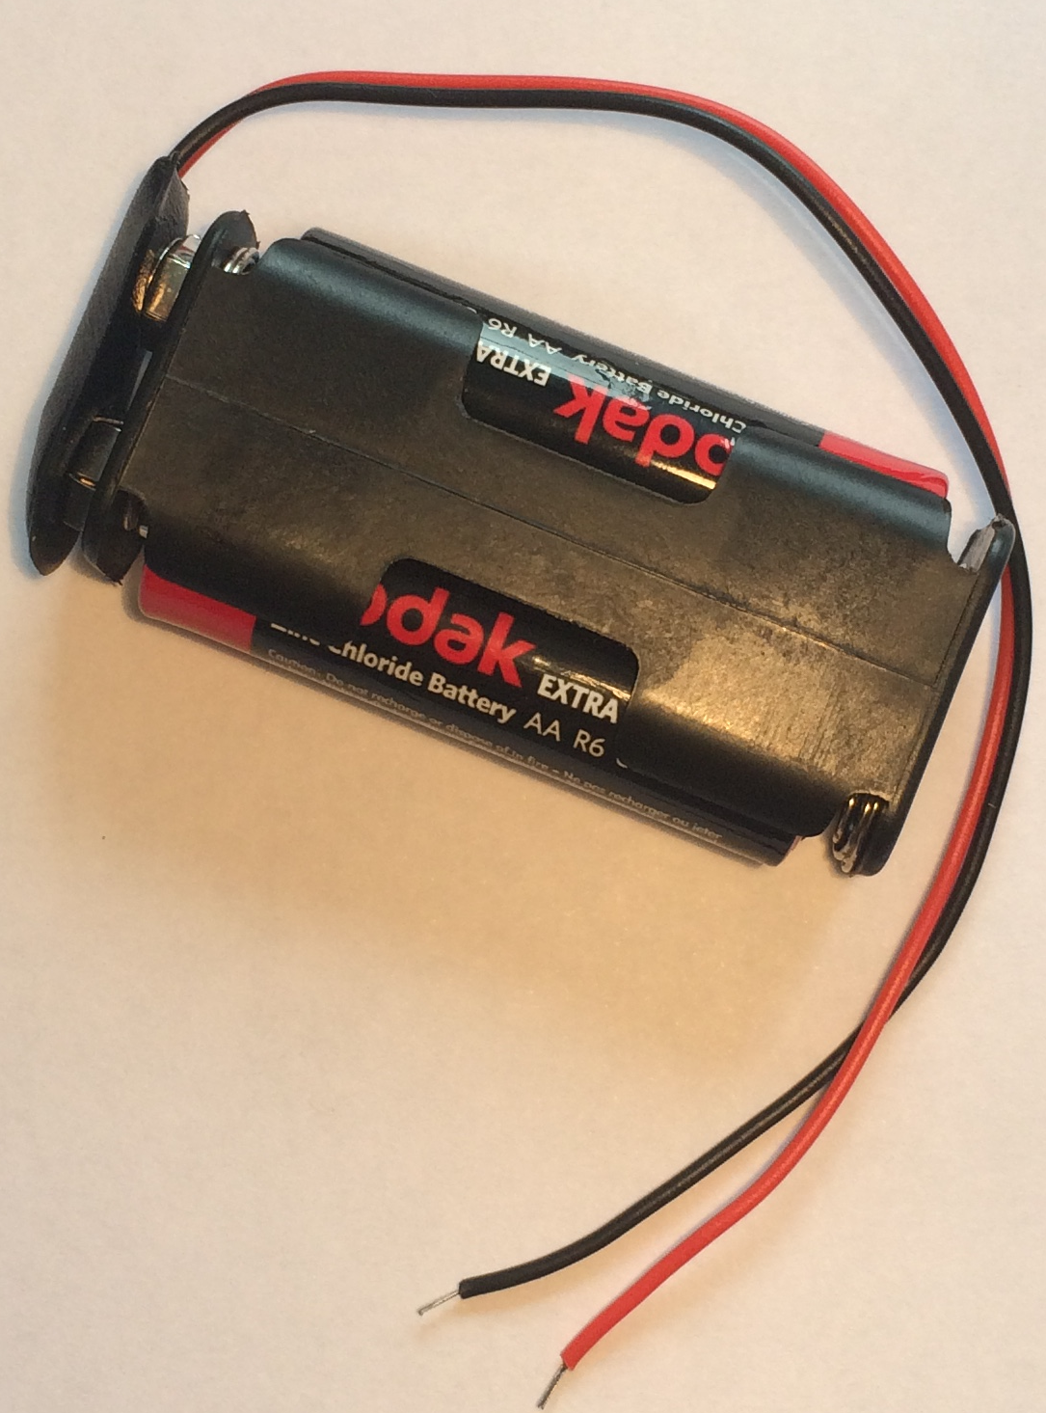 | Used to power components using the power of the sun. You MUST read the ‘How to …’ sheet before connecting this component. | Each | 6 Faradays
2AA cells in battery holder with battery snap |  | Used to provide power for your circuit | Each | 4 Faradays
4 AA cells in battery holder with jumper leads | 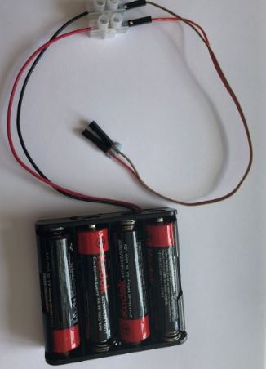 | ONLY to be used with servo motor control unit. DO NOT use with LEDs | Each | 6 Faradays

Construction materials
Item | Description | Unit |  | Cost
Correx | Used to create structures | Piece |  | 6 Faradays
Plastic syringes with tube | Used to develop pneumatic system | Pair of syringes with plastic tube | 6 Faradays
Small cog | Used in gear systems with motors | Each | 2 Faradays
Medium cog | Used in gear systems with motors | Each | 2 Faradays
Large cog | Used in gear systems with motors | Each | 4 Faradays
Dowel | Piece of solid cylindrical wooden rod used to create structures | Each | 4 Faradays
Pulley wheel 54cm | Used to connect to pulley attachments on motor | Each | 6 Faradays
Wooden wheel 54cm | Used with motors to drive something | Each | 4 Faradays
Plastic reel | Used in construction | Each | 4 Faradays
Polyfoam | A5 foam sheet – assorted colours | Each | 4 Faradays
Coloured card | A4 sheet of card – assorted colours | Each | 4 Faradays
Tin foil | A conductive material which can be used to make pressure pads or switches (MUST NOT be used in place of connecting wires) | 10cm strip | 6 Faradays
Masking tape | Can be used to secure light parts in your design. NOTE: excessive use of tape will result in an additional charge | Roll | 6 Faradays
Sponge | Can be used to make pressure switches or enhance your design. | Each | 6 Faradays
Paperclip | Used to create switches or in construction | Each | 1 Faraday
Paper fastener | Used to create switches or in construction | Each | 1 Faraday
Elastic bands | Used to hold or create working parts, including driving pulley wheels | Each | 1 Faraday
Cable ties | Can be used to hold your structures in place | Each | 2 Faradays
String | Can be used as part of your product design | 30cm piece | 4 Faradays
Hire Centre Trade Card | Use this to hire various items from the hire section of the shop – see below for details | One per team | 6 Faradays

Available with your Hire Centre Trade Card

These items can be hired from the shop if you buy a Hire Centre Trade Card. You will need to take it to the shop and show the shopkeeper each time you want to use of one of these items. You may only get one item at a time.

Stapler | Used to staple soft materials only
Hole punch | Used to make small holes in soft materials
Rulers | Used to measure any part of your product or additional items
Scissors | Used for soft materials only
Screwdriver | Used to connect insulated wire in terminal blocks or to bulb holders.
Wire strippers | Used to cut or strip insulated wire.

Free to use

The cutting station – craft knives and junior hacksaws may be used at any point BUT only 3 people will be allowed at this station at any one time. Please take care when using this equipment.

5. Assessment information and criteria

Criteria | Marks
- Planning | 13 marks
- Development of product | 20 marks
- Use of budget | 10 marks
- The product | 27 marks
- The presentation | 15 marks
- Teamwork | 15 marks
Total | 100 marks

- Planning (13 marks)
Using the planning section of the Planning and Event Log, marks will be awarded as follows:
- Does the planning diagram detail how the prototype will be constructed? (5 marks)
- Have the electronics for the prototype been detailed? (5 marks)
- Did they explain how their ideas might help the Webb telescope mission? (3 marks)

- Development of product (20 marks)

Using the Engineering Event Log and observations of the team, marks will be awarded as follows:

- Have they provided an accurate and informative event log for entry 1? (4 marks)
- Have they provided an accurate and informative event log for entry 2? (4 marks)
- Have they provided an accurate and informative event log for entry 3? (4 marks)
- Are the priorities identified for the last 30 minutes realistic and appropriate?
(4 marks)
- Have the team utilized the time effectively? (4 marks)

- Use of budget (10 marks)
Using the accountancy sheet and the prototype, marks will be awarded as follows:
- Was there an accurate record of spending? (4 marks)
- Was the budget used effectively? (6 marks)

4. The product (27 marks)
Using the presentation of your prototype, marks will be awarded for:

- Did their prototype meet the brief from the Webb telescope team? (3 marks)
- Was the choice of electronic components appropriate for the prototype? (7 marks)
- Was the choice of materials appropriate for the structure and/or mechanics of the prototype? (7 marks)
- Did the judge(s) see the electronics and structure work together effectively as intended? (7 marks)
- Was the product completed as far as possible with the time available used well?
(3 marks)

5. The presentation (15 marks)
Using the presentation of your prototype, marks will be awarded as follows:

- Did the team explain how their idea might support the Webb engineering team?
(3 marks)
- Did the team effectively demonstrate their prototype? (2 marks)
- Did the team explain how they used their engineering knowledge and skills to develop their prototype? (3 marks)
- Did the team identify what was the most challenging engineering aspect they faced during their development? (2 marks)
- Did the team explain what they did well in their teamwork and what they need to develop? (3 marks)
- Was the presentation well-structured? (2 marks)

- Teamwork (15 marks)
Using the judges’ observations of your team throughout the day, marks will be awarded as follows:

- Did the team work well together with all members engaged in the project?
(5 marks)
- Did the team work tidily and safely? (5 marks)
- Did the team use resilience and perseverance during the project? (5 marks)

