**The IET**



**Land Rover BAR**

**Teacher Handbook**

**Could you be our engineer….?**

The IET DIY Faraday Challenge Day ‘Land Rover BAR’ is based on the Faraday Challenge Day of the same name, a STEM activity day written and delivered by the Institution of Engineering and Technology (IET).

The IET Education website hosts a wide range of teaching resources for science, design and technology and maths. These include classroom activities with film clips, online games, posters, careers resources and STEM activity days.

The Institution of Engineering and Technology

IET Education 5-19

Michael Faraday House

Six Hills Way Stevenage

Herts

SG1 2AY

United Kingdom

T: +44 (0)01438 767653

F: +44 (0)01438 765526

The Institution of Engineering and Technology is registered as a Charity in England & Wales (no 211014) and Scotland (no SC038698)

**Stay safe**

Whether you are a scientist researching a new medicine or an engineer solving climate change, safety always comes first. An adult must always be around and supervising when doing this activity. You are responsible for:

* ensuring that any equipment used for this activity is in good working condition
* behaving sensibly and following any safety instructions so as not to hurt or injure

yourself or others

Please note in the absence of any negligence or other breach of duty by us, this activity   
is carried out at your own risk. It is important to take extra care at the stages marked with   
this symbol: ⚠

# Contents

1. Introduction 4
2. The Context 5
3. The brief 6
4. Checklist 7
5. Shop resources 8
6. Suppliers 10
7. Schedule for the day 11
8. Room layout 12
9. Assessment matrix 13
10. Assessment criteria 14
11. Risk Assessment 16

**1. Introduction**

The Institution of Engineering and Technology (IET) is one of the world’s leading professional societies for the engineering and technology community. As a charity we are committed to the advancement of science, engineering and technology, encouraging young people to study the Science, Design and Technology, Engineering and Mathematics (STEM) subjects and to consider careers within the engineering and technology sectors. We provide a wide range of activities, classroom materials and other learning resources, including the IET Faraday Challenge Days, to schools across the UK.

**Who is it for?**

The Faraday Challenge ‘Coding the Future’ has been designed for six teams of six students (36 students in total) aged between 11-13 years. The challenge has been specifically designed to give students the opportunity to research, design, develop and make creative solutions to genuinely tough engineering problems, independent of their level ability. This activity is therefore suitable for a range of different ability levels without adaptation. However, the challenge will work best for students who can work effectively as a team and have good problem solving and perseverance.

**How to use the challenge resources**

The aim of this challenge is to introduce students to ways in which engineers work together and use cutting edge technology to improve performance for Ben Ainslie’s Land Rover BAR team. Running this challenge could be a great opportunity to make links with a local university, college or industry. This may mean splitting the day into different sessions for example:

Session 1 – Imagine and Design (incorporating stage 1 and 2)

Session 2 – Create (incorporating stage 3)

Session 3 – Present (incorporating stage 4 and 5)

The resources are set up to be used with the BBC micro:bit and Touch Develop code editor ([www.microbit.org](http://www.microbit.org)) and so may need to be adapted to fit with the technology that you have available and the code editor you are using.

# 

# 2. The Context

This year Ben Ainslie’s Land Rover BAR team have been competing in the six America’s Cup World Series events held around the world, the preliminaries to the America’s Cup finals starting in Bermuda in May 2017.

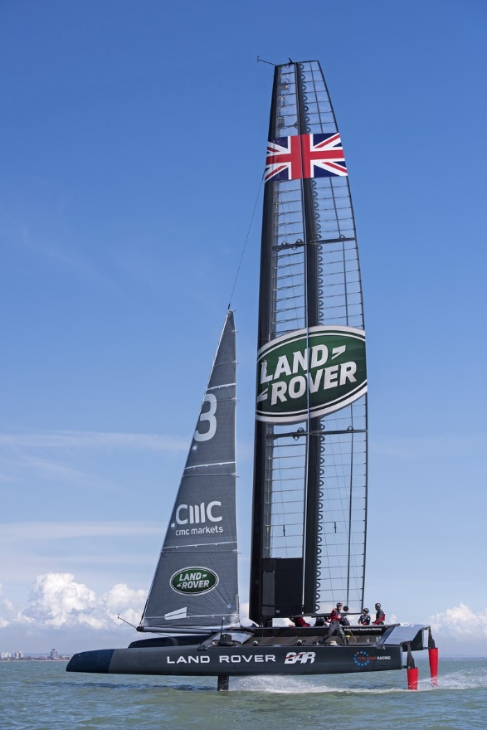

Recent developments in design and engineering have meant the racing has reached new levels with the boats travelling five times as quick as previous generations. This new generation of boats flies across the water!

Land Rover BAR is constantly looking for ways to improve performance and work with a wide range of experts to do this. The role of engineers is crucial and they are looking for future engineers who may be able to contribute to their success.

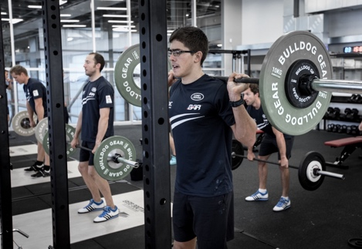

The performance of the crew members is just as important   
as the performance of the boat and the team needs to work   
hard to maintain optimum fitness.

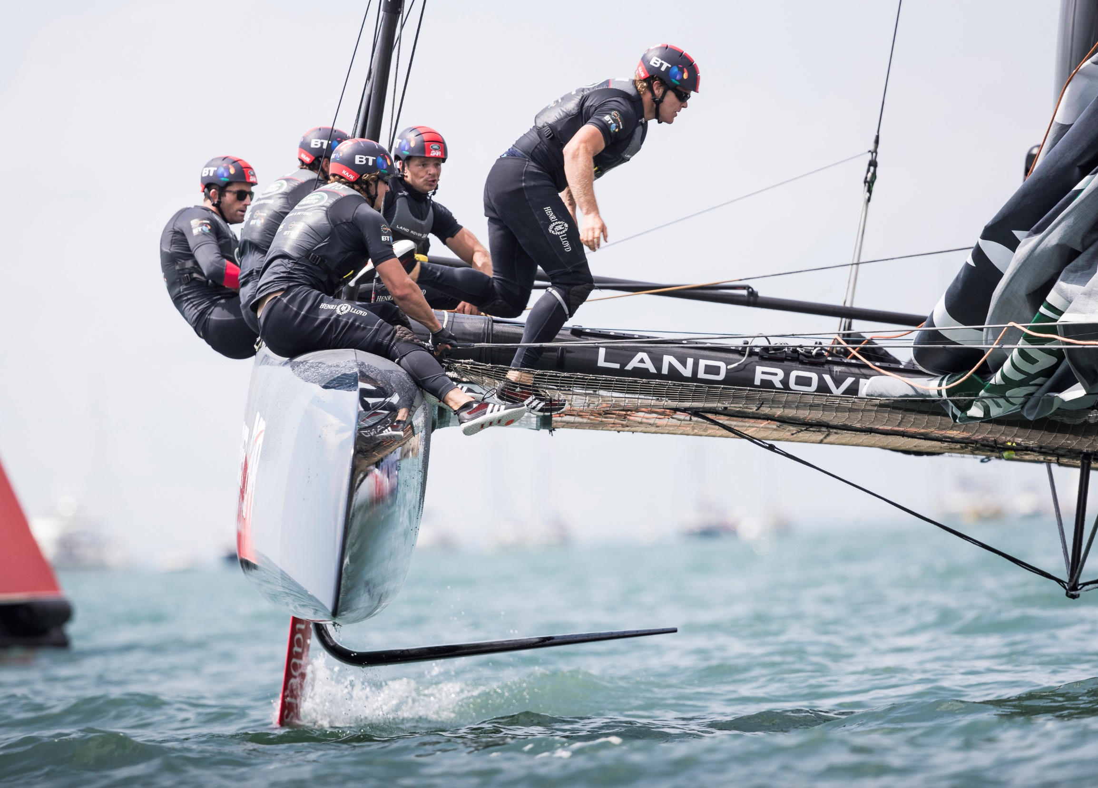

The environment in which they are sailing can mean the difference between success or failure.

**Today is your chance to make a difference, could you be our engineer..........?**

# 3. The Brief

The team wants you to focus on three areas:

* Human performance
* Boat performance
* Environment.

Your challenge is to use the micro:bit technology to develop **two** products which could help improve performance for the Land Rover BAR team. Your products do not need to be in the same area but they do need to help improve performance in at least one of them.

You will need to work effectively as a team. In order to do this your team will need some of you to take on a role in addition to being a Faraday Land Rover BAR Software Engineer. These additional roles will give some of your team the responsibility for managing or marketing the project, budgeting and keeping to time.

You will need to develop a presentation to the Land Rover BAR judges which explains how your products could improve performance.

Your team will need to:

1. **Identify** a range of ideas for improving performance in each of the three areas using the micro:bit.
2. **Identify** the two products that your team are going to put forward. Remember that these do not have to be from the same area but you must be able to demonstrate how they improve performance.
3. **Code** your micro:bit to bring your ideas to life.
4. **Construct** any components you need to add to your micro:bit to make it work effectively.
5. **Develop** your presentation.
6. **Demonstrate** the capabilities of your two ideas by **presenting** them to the Land Rover BAR judges.

**Considerations**

Your two Land Rover BAR products must:

* improve performance in at least one of the three areas
* have relevant and useful real-life applications
* demonstrate engineering skills and show creativity and innovation
* be effective and cost efficient.

# 4. Checklist

|  |  |
| --- | --- |
| **Student tables** | **Notes** |
| Student booklet | 1 per table |
| Roles and responsibilities (laminated) | 1 per table |
| A4 Reflections and planning sheet | 1 per table |
| Coding Apprenticeship (laminated) | 2 per table |
| Team name (laminated) | 1 per table |
| Faraday branded currency | **Each team** - 1 x 20F, 3 x 10F, 4 x 5F, 10 x 1F = F80.00 |
| Lanyards, clear badge holders and name tags | 6 role cards per table - student to update with name and additional role and insert into reusable lanyard |
| Student team registration form | 1 per student table |

|  |  |
| --- | --- |
| **Challenge Leader** | **Notes** |
| Presentation - hard and electronic copy |  |
| Assessment matrix | 1 per event (please enter into electronic version for calculating scores and uploading for IET) |
| A4 plain paper | Up to 3 sheets free per team for presentation notes |
| 15 x laptops and charging leads | 2 per team plus a spare |
| Box of Micro:bits | 16 (2 per team plus spares) |
| USB leads | 14 plus spares |
| Extension leads | 3 x 6 gang |
| Battery packs | X 4 |
| Speakers | X 1 |
| Large toothbrush | X 1 |

|  |  |
| --- | --- |
| **Prizes** | **Notes** |
| Prizes x 6 | 1 per team member of winning team (if required) |
| Certificates | 1 per student – give to teachers to write names in and present back at school |

|  |  |
| --- | --- |
| **Shop** | **Notes** |
| Shop manager sheet for shopkeeper | Put on a clipboard |
| Faraday branded currency | Shop change - 10x 20; 20x 10; 20x 5; 20x 1 |
| Materials list for shop manager | Put on clipboard with shop manager sheet |

|  |  |
| --- | --- |
| **Signage** | **Notes** |
| Shop |  |
| Judges table |  |

# 5. Shop resources

|  |  |  |  |  |
| --- | --- | --- | --- | --- |
| **Item** | **Description** | | **Unit** | **Cost** |
| Crocodile leads |  | Lead with crocodile clips at each end | Each | 6 Faradays |
| Piezo buzzer | Kittronic buzzer | Connect to the rings in a circuit to give a sound output | Each | 8 Faradays |
| LED – green |  | LED which can be connected to the rings in circuit – green. Must be used with a resistor. | Each | 8 Faradays |
| Thermistor  + 10K resistor |  | Component that detects the ambient temperature and changes resistance to allow a current to flow through a circuit. Must be used with a resistor. | Each | 16 Faradays |
| Light Dependent Resistor + 10K resistor | LDR 2 | Component that detects the light level and changes resistance to allow a current to flow through a circuit when it becomes dark. Must be used with a resistor. | Each | 16 Faradays |
| Moisture sensor |  | Component which detects moisture in the surroundings. | Each | 16 Faradays |
| Servo motor |  | This is a motor whose angular motion can be controlled. It is used if you want to move something to a specific position. | Each | 16 Faradays |
| Flex sensor |  | Used to detect whether a material is bending. | Each | 16 Faradays |

|  |  |  |  |  |
| --- | --- | --- | --- | --- |
| **Item** | **Description** | **Unit** | | **Cost** |
| Strapping | Used to strap the BBC micro:bit on for wearable technology products | 30 cm piece | | 8 Faradays |
| Tape measure | Used for measuring distance for distance/time or speed calculations | Each | 6 Faradays | |
| Strong clear plastic | Rectangular piece of plastic | Each | 4 Faradays | |
| Dowel | 15cm piece of solid cylindrical wooden rod used to create structures | Each | 6 Faradays | |
| Polyfoam | A5 foam sheet – assorted colours | Each | 12 Faradays | |
| Green wire | Used to connect structures (not for connection to the micro:bit) | 20 cm piece | 4 Faradays | |
| Coloured card | A4 sheet of card – assorted colours | Each | 8 Faradays | |
| Tin foil | A conductive material | 30cm strip | 6 Faradays | |
| Masking tape | Can be used to secure parts in your design - do not stick anything to your BBC micro:bit or it may not work properly. | 30cm piece | 6 Faradays | |
| Thick foam | Can be used to make pressure switches or enhance your design. | Each | 6 Faradays | |
| Cable ties | Can be used to hold your BBC micro:bit onto a background | Each | 4 Faradays | |
| Scissors | Used for soft materials only – do not use to cut wires or any part of your BBC micro:bit. | Each | 4 Faradays | |
| Stapler | Used to staple soft materials only – do not use to staple anything to your BBC micro:bit | Each | 6 Faradays | |
| Hole punch | Used to make small holes in soft materials | Each | 4 Faradays | |
| Rulers | Used to measure any part of your product or additional items | Each | 4 Faradays | |
| String | Can be used as part of your product design | 30cm piece | 6 Faradays | |

**AVAILABLE ON THE LAPTOP:**

|  |  |  |
| --- | --- | --- |
| **Item** | **Description** | **Cost** |
| Coding support sheets | PDFs of support sheets and PowerPoints under ‘New to Coding’ | FREE |

**AVAILABLE ON THE JUDGES/PRESENTATION TABLE:**

|  |  |  |
| --- | --- | --- |
| **Item** | **Description** | **Cost** |
| Coding support sheets | Hard copies (laminated) of ‘How to …..’ support sheets | FREE |

# 6. Suppliers

|  |  |  |
| --- | --- | --- |
| Resource | Supplier | Website link |
| Micro:bit | Kitronik | <https://www.kitronik.co.uk/bbc-micro-bit-accessories.html> |
| Piezo buzzer | Kitronik | <https://www.kitronik.co.uk/c3301-piezo-buzzer-with-drive.html> |
| Servo motor | Kitronik | <https://www.kitronik.co.uk/2568-mini-360-degree-servo.html> |
| LED | RS UK online | <http://uk.rs-online.com/>  RS Stock No.247-1678 |
| Flex sensor | Proto-pic (Note: these are not always in stock and delivery times can be extensive.) | <https://www.proto-pic.co.uk/flex-sensor-22.html?gclid=CjwKEAjw34i_BRDH9fbylbDJw1gSJAAvIFqUcx27NV89P7pV4XwxTFH4futaeg_RLPyLTHWT36y2vxoCs7bw_wcB> |
| Moisture sensors | These are easily made using small nails and a piece of balsa wood or similar. |  |
| Thermistors and light dependent resistors | RS UK online | Stock details on these change so visit site to identify the best for your challenge. |

**7. Schedule for the day**

|  |  |
| --- | --- |
| **08:00** | **Set up room as per layout** |
| **09:00** | **Engineering teams arrive at school** |
| **09:15** | **Teams to tables to register their team** |
| **09:30** | **Welcome and introduction – hosting by school for visiting teams if required** |
| **09:35** | **Introduction to the Faraday Challenge** |
| **10:00** | **STAGE 1: Identifying the problems and generating initial ideas**   * Brainstorming of ideas |
| **10.15** | **Allocation of roles** |
| **10:20** | **Coding apprenticeship** ⚠ |
| **10:30** | **STAGE 2: Development** ⚠   * Shop opens * Agree on final product designs |
| **11:10** | **Break** |
| **11:20** | **STAGE 3: Modifications** ⚠   * Continue to design and code and modify where necessary |
| **12:10** | **Briefing for the presentation**   * Project and/or marketing managers are briefed on the content of the presentation |
| **12:30** | **Lunch** – Tools down |
| **13:00** | **STAGE 3 continued: Final preparations** ⚠   * Finalise coding * Prepare presentation with notes |
| **13:30** | **STAGE 4: Presentation** ⚠   * Shop closes and coding finishes – laptops are removed * Submit accounting sheet to the Shop keeper * Practise presentation |
| **14:00** | **STAGE 5: Final test**   * Teams present their designs to the judges |
| **14:45** | **Award ceremony**   * Final feedback and evaluation of the day and winning team announced |
| **15:00** | **Finish - Engineering teams depart, pack away resources** |

**8. Room layout**

**Notes:**

* Each team table will need 6 chairs and be large enough for 6 students to work comfortably with 2 laptops and peripheral items. The judges’ table and shop will each need 2 chairs. Table positions do not need to be exact and can be arranged to best accommodate the shape and size of the venue.
* The laptop charging tables must be next to a minimum of 3 plug sockets (or extension reel plugged into one socket) and be near the front of the room. It will need to be large enough to hold 14 laptops.

**BACK**

**Team 3**

**FRONT – Projection screen**

**Team 6**

**Team 5**

**Team 1**

**Shop **

**Judge’s table**

**Team 2**

**Team 4**

**Team 7 Teachers**

**Charging table by double power point long enough for 14 laptops**

**Presentation table**

**Refreshments table**

# 9.. Assessment matrix

**Host name: ………………………………………………………. Date: …………………………….**

|  |  |  |  |  |  |  |  |  |
| --- | --- | --- | --- | --- | --- | --- | --- | --- |
| Assessment Criteria | | Team  1 | Team  2 | Team  3 | Team  4 | Team  5 | Team  6 | Team  7 |
| Planning | 10 |  |  |  |  |  |  |  |
| Development of prototype | 20 |  |  |  |  |  |  |  |
| Use of budget | 8 |  |  |  |  |  |  |  |
| Functionality of coding | 12 |  |  |  |  |  |  |  |
| Functionality of product | 22 |  |  |  |  |  |  |  |
| The pitch | 16 |  |  |  |  |  |  |  |
| Teamwork | 12 |  |  |  |  |  |  |  |
| **Total score** | **100** |  |  |  |  |  |  |  |
| **Faradays spent** |  |  |  |  |  |  |  |  |

|  |  |
| --- | --- |
| **Team** | **School/Team name** |
| 1 |  |
| 2 |  |
| 3 |  |
| 4 |  |
| 5 |  |
| 6 |  |
| 7 |  |

# 10. Assessment criteria

|  |  |
| --- | --- |
| Criteria | Marks |
| 1. Planning | 10 marks |
| 1. Development of product | 20 marks |
| 1. Use of budget | 8 marks |
| 1. Functionality of coding | 12 marks |
| 1. Functionality of product | 22 marks |
| 1. The pitch | 16 marks |
| 1. Teamwork | 12 marks |
| **Total** | **100 marks** |

1. **Planning (10 marks)**

Using Stage 1 of the planning sheet provided, marks will be awarded for:

* Identifying at least two ideas in each of the three areas which are appropriate   
  to the challenge ***(6 marks)****.*
* Demonstrating creativity and innovation in the ideas recorded ***(4 marks)***

1. **Development of the Land Rover BAR products (20 marks)**

Using Stage 2 and 3 of the planning sheet provided, marks will be awarded for:

* Identifying two ideas for products within the three themes which could be developed ***(4 marks)****.*
* Identifying how each of these products could potentially improve performance   
  ***(4 marks)****.*
* Providing an honest and accurate description of the problems encountered in developing their products ***(4 marks).***
* Identifying and implementing solutions to the problems encountered ***(4 marks).***
* Providing an honest and reliable description of how effectively the team worked both as a whole and individually ***(4 marks).***

1. **Use of budget (8 marks)**

Using the accountancy sheet, marks will be awarded for:

* Providing an accurate record of spending ***(3 marks).***
* Using the budget creatively to enhance your product and make it work effectively and efficiently ***(5 marks)****.*

**4. Functionality of micro:bit coding (12 marks)**

Using the presentation of your products and the judges’ observation of your code, marks will be awarded for:

* Developing two codes which are appropriate for the intended purpose ***(6 marks)***
* Using the functions of Touch Develop accurately ***(6 marks)***

**5. Functionality of the Land Rover BAR products (22 marks)**

Using the presentation of your products, marks will be awarded for:

* Engineering of your products, including any external components and packaging ***(10 marks).***
* Functions of the product can improve performance for the Land Rover BAR team ***(6 marks).***
* How well the productswork ***(6 marks).***

1. **The presentation (16 marks)**

Using the presentation of your products, marks will be awarded for:

* Explaining your reasons for choosing the area(s) you have worked on and for choosing your final two products ***(4 marks).***
* How effectively you demonstrate the ways in which your products will improve performance for the Land Rover BAR team ***(4 marks).***
* Explaining how you have used your engineering knowledge and skills to produce your two products ***(4 marks).***
* Explaining how the roles you took in your team enabled you to work effectively ***(2 marks)***
* Effective and creative communication of your ideas to the Land Rover BAR team within the time limit ***(2 marks).***

1. **Teamwork (12 marks)**

Using the judges’ observations of your team throughout the day, marks will be awarded for:

* How well you work as a team with all members working together effectively ***(5 marks)****.*
* Demonstrating resilience and perseverance in the development of your product ***(5 marks).***
* How tidy, safe and organised your working area is kept ***(2 marks)****.*

# 11. Risk Assessment: Example

The following risk assessment is given as guidance. It is advised that the school refers to the CLEAPSS Model Risk Assessment Documents for D&T.

|  |  |  |  |
| --- | --- | --- | --- |
| **Risk Assessment and Operating Procedure - IET** | | | |
|  | | | |
| **Activity: DIY Faraday Challenge Day** | | | |
| **Persons at risk** | Students taking part in the Faraday Challenge Day and adults in the location | | |
| **Maximum Group Size** | 36 students | Recommended Staffing/Student Ratio | 1:18 |
|  | | | |
| **Risk Assessment** | | | |
| **Hazards** | | **Control Measures** | |
| 1. **Use of electrical equipment – risk of electric shock** | | All electrical equipment is low voltage. | |
| 1. **Use of electrical equipment – short circuit causing heating** | | Warn students of the possibility of burns when connecting and disconnecting components. All pupils will receive a briefing about correct use of electrical components. | |
| 1. **Basic use of hand tools (screwdrivers, scissors, hole punches, staplers) – risk of cutting or abrasion** | | Warn students of the risks and advise them of safe working practices. | |
| 1. **Use of extensions cables – risk of tripping** | | Make sure that extension cables are not extended across the floor where students and adults will be walking. Ensure students and adults are aware of the location of the cable. | |
| **Location issues** (to be completed by Host School) | |  | |
| Further Action Required: 1. Ensure all persons staffing the Faraday Challenge Days are aware of and competent to comply with this risk assessment and the control measures. | | | |

# Risk Assessment: Example (page 2)

|  |  |
| --- | --- |
| **Working Practice** | |
| **Group structure** | One Faraday Challenge Day Leader and one member of staff from the host school to be present during the whole day to oversee use of equipment and to keep order. |
| **Restrictions** | To be completed by Host School |
| **Emergency**  **Procedure** | Follow the lead from the Host School. |
| **Safety Equipment** | First aid kit and fire extinguisher (electrical fires) to be provided by Host School. |
| **Name and role of school representative** |  |
| **Signature of the school representative** |  |
| **Date of this Review** |  |