Identify star constellations night stargazing handout

Instructions
- Print off this handout
- Use a night star map or watch the suggested stargazing videos
- When you identify a star constellation tick the check circle
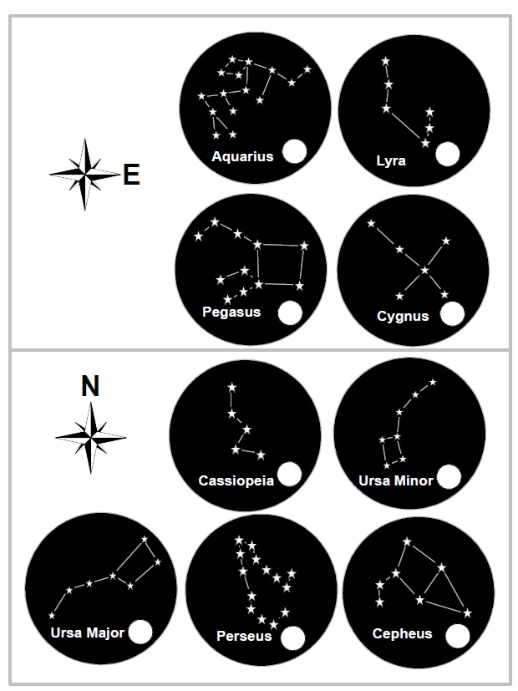
- Good star hunting!

