Nature reinvented quiz

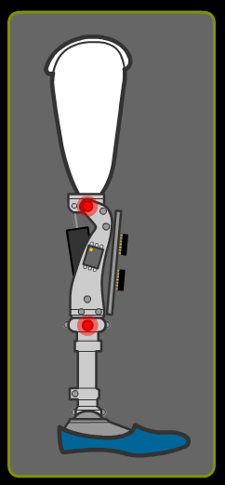
Materials that change shape when electrified, liquids that get thicker and stickier in a magnetic field, and advanced mechanical and electrical devices that blend with human tissue, often outperforming their natural equivalents – it all sounds like science fiction.

In reality, this is the world of smart materials and prosthetic engineering.

Have a go at the quiz below. Hint: You may find it useful to watch our Nature reinvented video first!

Good luck.

- What do the letters ACL stand for?
- Auxiliary Cruciate Ligament
- Anterior Cruciate Ligament
- Additional Cruciate Ligament
- Automatic Cruciate Ligament

- What is a smart material?
- A material that is used for decorative purposes because of its looks
- A material used in the manufacture of computer chips
- A material which can alter one or more of its properties when it receives some kind of external stimulus
- A material used in clothing manufacture

- Which of these is an example of a biological polymer?
- Calcium carbonate
- Protein
- Polyvinylchloride
- Acetic acid

- What is an alloy?
- A mixture made up of a metal and a gas
- A mixture made up of two or more gases
- A mixture made up of two or more non-metals
- A mixture made up of two or more different metals

- What method of bonding is usually involved in joining metals and non-metals?
- Ionic bonding
- Doric bonding
- Covalent bonding
- Hydrogen bonding

- What set of properties make the metal titanium particularly useful for medical applications?
- It’s strong, heavy, can be alloyed with other materials and is highly toxic
- It’s strong, light, can be alloyed with other materials and is non-toxic
- It’s shiny, valuable and doesn’t form alloys with other metals
- It’s slightly radioactive so implants are easy to detect

- In normal circumstances, what does the body try to do at any alien objects which end up inside it?
- It tries to encapsulate them in order to protect itself
- It tries to dissolve them
- It tries to push them back out through the skin
- It tries to push them into the intestines from where they can be expelled from the body

- Some patients require prosthetics because of bone cancer. This is a very rare disease and affects about…
- 7 in 1 million people
- 1 in 7 million people
- 7 in 1,000 people
- 1 in 7,000 people

- A magnetorheological fluid…
- changes its properties in the presence of a gravitational field
- changes its properties in the presence of a magnetic field
- changes its properties in the presence of an electric field
- is completely unaffected by the presence of a magnetic field

- A compound called lithium tantalate (LiTiO3) is an example of a piezoelectric material. This means that it can change its volume if a voltage is applied across it. If 1 mole of lithium atoms weighs 7g, 1 mole of titanium 48g and 1 mole of oxygen 16g, how much does half a mole of lithium tantalate weigh?
- 41.5g
- 108.2g
- 51.5g
- 103.0g

Answers

- b
- c
- b
- d
- a
- b
- a
- a
- b
- c

