Additional Electromagnetic Support
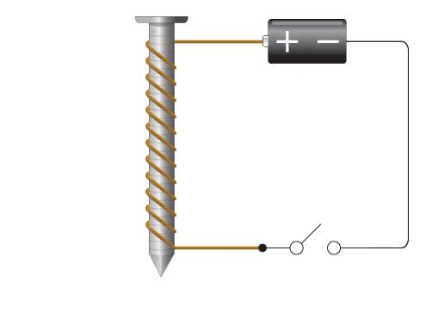
Power wire
Cell
Ground wire
Electromagnet
Diagram 1
Diagram 2
Core
Current source

Coils

An electromagnet is a very simple device. Simply passing an electric current through a conductor generates a magnetic field (diagram1)

The magnetic field can be strengthened by winding the conductor into a coil.

There are three main ways in which this field can be further strengthened:
- Increase the current flowing through the coil by increasing the power of the electricity source and/or the diameter of the coil wire
- Increase the number of turns on your coil
- Add a core to the coil – some materials are better than others here

As part of your task you need to create an electromagnet which is as strong as possible. However, as you will have to purchase your components and you have a fixed amount of funds with which to do it you won’t be able to do everything you might want to.

You will therefore need to decide which is going to have the biggest effect on the strength of your magnet:
- Longer wire
- Providing a core

If your power pack has a voltage control you may also be able to alter the current through your electromagnet. Diagram 2 (above) shows how you might set up your arm. Think about where to place your switch. Will the arm operator also switch the magnet on and off? If so, does the switch need to be fixed to the handle end of the arm?

