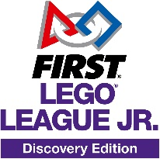
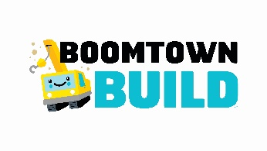

Example questions

Teamwork
What was your job on the team?
What has been your favourite part of being on your team?
How did you help each other?

BOOMTOWN
Tell me about your town…
How did you choose the buildings you’ve included in your town?
How did you include the LEGO® bridge in your design? (if used)
What is your favourite part of your new town?
Is there anything else you would like to share about your new town?

Crossing the river
Why was the river a problem for your town?
How did you solve the problem of crossing the river?
What could you do differently next time?

General
What did you learn about buildings/structures/towns/cities?
How did you learn about buildings/structures/towns/cities?
How will people live/move around/learn/work in your town?
What did you find out about the sorts of things we need?
What other problems did you find when designing your town?
How did you solve the problems?
What is the most interesting thing you learned about building a new town?
Would you like to build a real new town when you’re older? Why or why not?
What was the most fun part of FIRST® LEGO® League Jr. Discovery (designing, building, testing, sharing your work, etc.)?
Tell me about this part…

