What is the probability of picking fruit of a named colour from the bag?
?
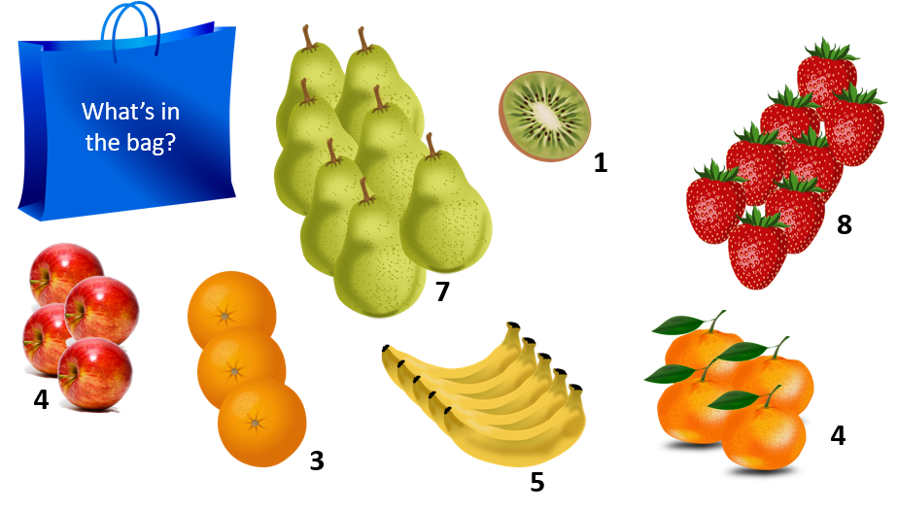

- How many items of fruit are there in the bag?

….…... + …….... + …….... + …….... + …….... + …….... + …….... = ………………
- What is the probability of picking only red fruit?
Total Red Fruit | Fraction of the  whole bag | Simplified fraction

- What is the probability of picking only green fruit?
Total Green Fruit | Fraction of the  whole bag | Simplified fraction

- What is the probability of picking an orange-coloured fruit?
Number of Strawberries | Fraction of the  whole bag | Simplified fraction

