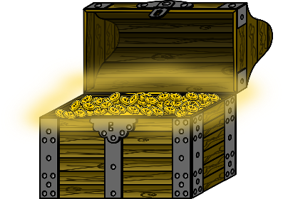
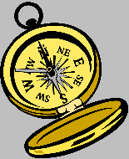
Treasure Hunt – For the Pirate’s Treasure

- Start your treasure hunt at position (0,0).
- Move (7,8).

- What feature have you arrived at?
________________________________________________________
________________________________________________________

- Move (7,4).

- What feature have you arrived at?
________________________________________________________
________________________________________________________

- Move (-3,4).

- What things have you passed on the way?
________________________________________________________
________________________________________________________

- What place have you arrived at?
________________________________________________________
________________________________________________________

- Move (-6,-2)

Now dig up the treasure!

- Where is the treasure hidden?
________________________________________________________
________________________________________________________

