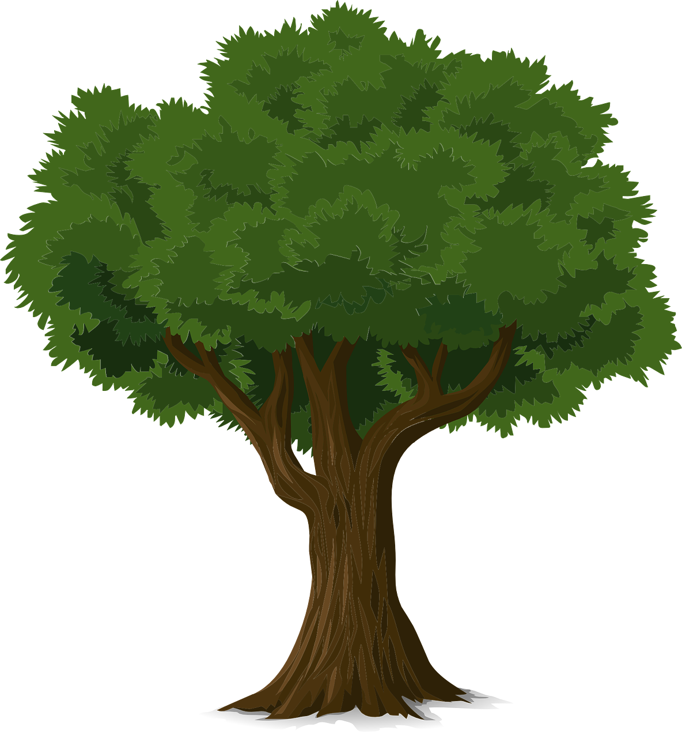
How many items from one tree?
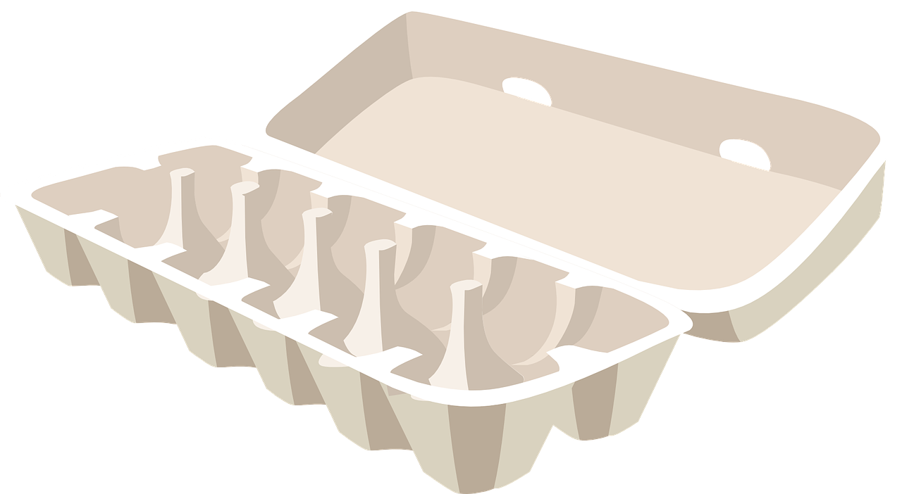
?
Choose some packaging and weigh it in grams.
Then work out how items can be made from one tree:
Packaging | Weight (g) | Weight (kg) | Divide 40kg by Weight (kg) | Total Number of items?
Egg box | 55g | 0.055kg | 40  ____  = 727.27  0.055 | 727

