**Skill Sheet: Ratios (Drawing Scale and Gear Ratio)**

Ratios show the relationship between two values. For example, the ratio between 500 mm and 125 mm is 4:1, as 500 is 4 times the value of 125. Ratios do not have units.

***What You Need to Know:***

Two common uses of ratios in design & technology are to communicate the scale on drawings and gear ratios.

On technical drawings, the size of the drawn item is typically either smaller or bigger than the actual item. The **scale** represents the size of the drawing compared to its actual size. A scale of 1:1 is actual size. A scale of 1:2 implies that the drawing is half the size of the part; 2:1 implies that the drawing is twice the size of the part.



***Examiners***

***Top Tip***

*Ratios must be presented as two numbers in the lowest possible integer values, e.g. 2:1, 3:7*

The **gear ratio** determines the speed of two gears that are in contact by their teeth. The gear providing the input into the system is called the driver gear. The gear providing the output from the system is called the driven gear. The formula to calculate the gear ratio is:

number of teeth on driven gear Ndriven Speeddriver

Gear ratio = = =

number of teeth on driver gear Ndriver Speeddriven

***Example:***

Figure 1 shows a gear train.

**Figure 1**

Calculate the gear ratio of this gear train.

***Answer:***

Gear ratio = Ndriven / Ndriver  = 30 : 10 = 3 : 1

***Now Try These:***

1. A technical drawing has a scale of 1:5. The length of a part shown on a drawing is 20 mm.

Calculate the length of the actual part.

___________________________________________________________________________________________

___________________________________________________________________________________________

1. In a simple gear train, the driver gear has 30 teeth and the driven gear has 20 teeth.

The driver gear rotates at a speed of 120 rpm. Determine the speed of the driven gear.

___________________________________________________________________________________________

___________________________________________________________________________________________

___________________________________________________________________________________________

**Practice Sheet: Ratios (Drawing Scale and Gear Ratio)**

***Now Try These:***

1. In a simple gear train, the driver gear has 12 teeth and the driven gear has 8 teeth, figure 1.

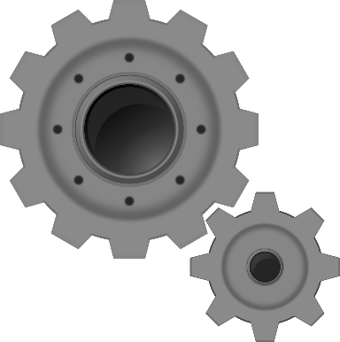Calculate the gear ratio.

___________________________________________________________

___________________________________________________________

___________________________________________________________

___________________________________________________________

**Figure 1**

1. A part is 240 mm long. On a technical drawing, the drawing of the part is 48 mm long.

Determine the scale of the drawing.

___________________________________________________________________________________________

___________________________________________________________________________________________

___________________________________________________________________________________________

1. The scale on a drawing is 3:1. A part has a diameter of 60 mm.

Determine the diameter of the part on the drawing.

___________________________________________________________________________________________

___________________________________________________________________________________________

___________________________________________________________________________________________

1. An engineer is designing a gear train consisting of two gear wheels. The driver gear has 81 teeth and rotates at a speed of 40 rpm. Determine the size of the driven gear needed to achieve an output speed of 90 rpm.

___________________________________________________________________________________________

___________________________________________________________________________________________

___________________________________________________________________________________________

___________________________________________________________________________________________

___________________________________________________________________________________________

___________________________________________________________________________________________

___________________________________________________________________________________________

**Answers:**

**Skill Sheet: Ratios (drawing scale and gear ratio)**

1. 20 mm / 5 = 4 mm
2. Gear ratio = Ndriven / Ndriver  = 20 : 30 = 2 : 3

Rearranging gear ratio = speeddriver/ speeddriven, speeddriven = speeddriver/gear ratio = 120 / (2/3) = 180 rpm

**Practice Sheet: Gear ratio and mechanical advantage**

1. Gear ratio = Ndriven / Ndriver = 8 : 12 = 2 : 3
2. 48 : 240 = 1 : 5

size of output wheel = velocity ratio x size of input wheel = (5/2) x 60 = 150 mm

1. 3 x 60 = 180 mm
2. Gear ratio = speeddriver/ speeddriven, = 40 : 90 = 4 : 9

Rearranging Gear ratio = Ndriven / Ndriver, Ndriven = gear ratio x Ndriver = (4/9) x 81 = 36 teeth