How to design a spaghetti roof structure
Design and engineer a roof structure
Subject(s): Science, Design & Technology, Mathematics  Approx time: 60 mins |  |  | Key words / Topics:  - structure  - architecture  - pressure  - design limitations
Suggested Learning Outcomes
- To be able to identify the key features of a structural component
- To be able to identify the various pressures a structural element can undergo
- To apply their knowledge of structures to a given task in order to design an effective solution
Introduction
The ‘Structural Engineering’ scheme of work has been designed to either reinforce or extend basic knowledge of structures to students by providing a real life context. It is not intended to form an introduction to structures.
Purpose
Students will investigate the design of the O2 Dublin building in terms of structure. They will look specifically at the requirements of the building and the constraints in terms of structural design and also the solution provided. This will form the stimulus for students to investigate structures in detail. The students will then be asked to explore possible solutions to a given structural design.
Activity |  |  | Teacher notes
This activity gives students the opportunity to develop their structural understanding in a practical exercise.  Ask the students to design and engineer a roof structure that will span an area of 500mm x 300mm.  Key requirements are:  - It must span the area without any part of the structure touching the floor  - Minimum amount of spaghetti is to be used  - Minimum amount of glue to be used  Remember that too much glue will add significant weight to the structure and therefore make it more liable to failure.  Identify which pieces (members) of the structure are in tension and which in compression. This will help you identify which members may need strengthening. |  |  | Specific constraints:  - Material that can be used – spaghetti  - Construction method – hot glue gun  The students can work in pairs and there will be a testing rig to place their structure onto for testing.  See photos on the Powerpoint: ‘Structural Engineering – Structural Design (Presentation).  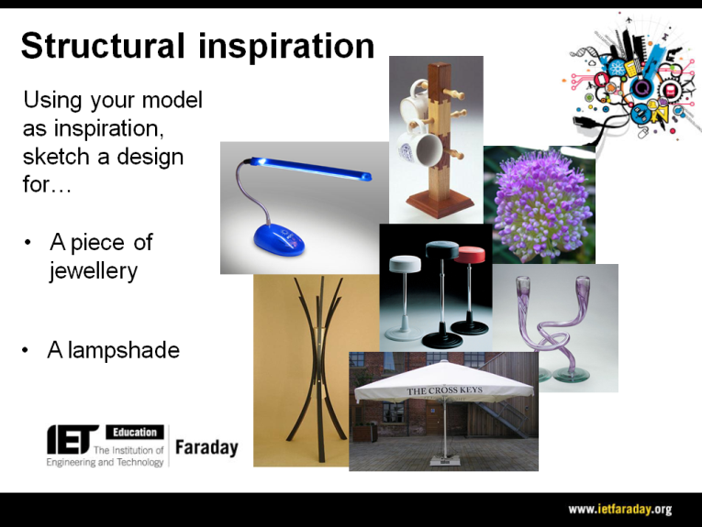
Differentiation
Basic |  |  | Extension
Go through the Powerpoint: ‘Structural Engineering – Structural Design.’ This slide can be used as inspiration for designing products that have a structural need. Using the models they produced earlier (in the activity: ‘Structural Engineering 1’) as their inspiration, ask the students to design either a piece of jewellery or a lampshade.

This activity should produce another design(s) for the three products (two minutes each). Once again, these can be added to the collection of sketches produced throughout this workshop.
Resources |  |  | Required files
- Projector/Whiteboard |  |  | Structural engineering – Structural Design (Presentation)
Additional websites
- More information can be found at: http://www.fosterandpartners.com/projects/stansted-airport/
Related activities (to build a full lesson)
Starters (Options)  - ACTIVITY: Structural Engineering - Starter  - ACTIVITY: Sound insulation  - ACTIVITY: Acoustic Engineering 1  Main (Options)  - ACTIVITY: Structural Engineering  - ACTIVITY: How to design a spaghetti roof structure |  | Main (cont.)  - ACTIVITY: Sound insulation 2  - ACTIVITY: Acoustic Engineering 2  Plenary  - Opportunities within activity for presentations, peer/self assessment  - Reflection on Objectives and PLTS skills used

The Engineering Context 
- The story Sound Design
- How it works? Stage Door Design
- How it works? Ventilation System
- Who makes it work? Daryl Prasad
- Who makes it work? Rukhsana Adam

Curriculum links and PLTS
England  Design & Technology  - KS3 1d, 1e, 2a, 2b, 3a, 4a | Northern Ireland  Manufacturing  - Selecting and using materials fit for purpose  - Safe use of a range of tools and processes appropriate to materials
Scotland  Technologies  - TCH 3-01a | Wales  Design & Technology  - 2c, 2d, 4b, 4d
GCSE D&T  AQA D&T  - 3.3.1, 3.1.6.2, 3.2.2, 3.3.4, 3.3.5  Edexcel D&T  - 1.15.1, 1.17, 2.4, 4.4, 7.4  Eduqas D&T  - 2.1 Core: 9, 10, 11  - 2.2 Core: 2, 8  OCR D&T  2.1a vii, 5.2a | GCSE Engineering  AQA Engineering  - 3.1.1, 3.6
GCSE Science  AQA Combined Science Trilogy  - 6.5.1  AQA Combined Science: Synergy  - 4.6.1  Edexcel Combined Science  - Physics: 9  Eduqas Combined Science  - 2.3: 3.1  OCR Gateway Science: Combined Science A  - P2.3  OCR 21st Century Science: Combined Science B  - P6.3: 1, 2 | GCSE Physics  AQA Physics  - 4.5.1  Edexcel Physics  - 9  Eduqas Physics  - 3.1  OCR Gateway Science: Physics A  - P2.3  OCR 21st Century Science: Physics B  - P6.3: 1, 2

Personal, learning & thinking skills (PLTS)
> Team worker

