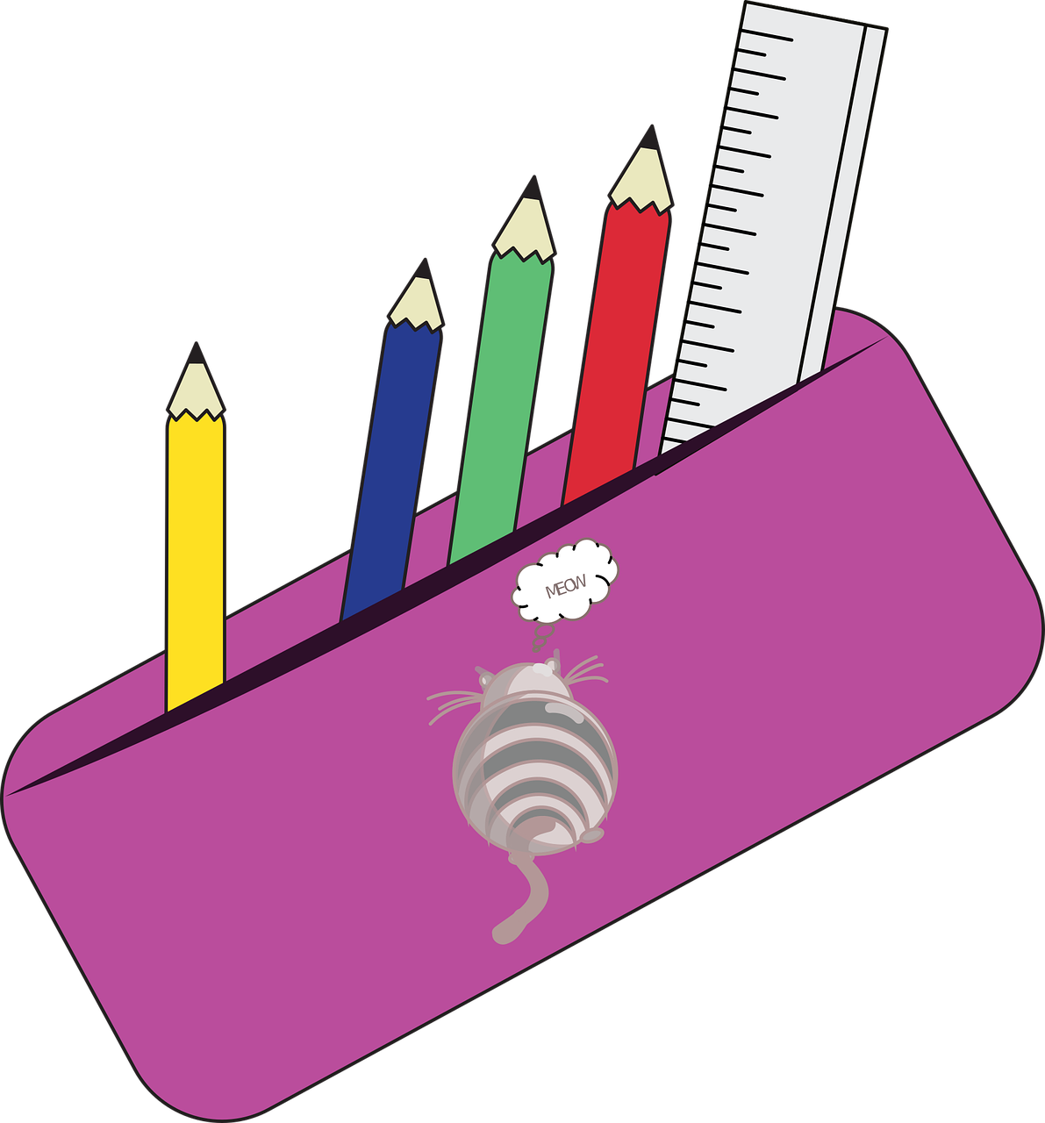

How much plastic is used in one year?

Choose some plastic items and weigh them in grams.
Then fill in the table and work out how much is used in a year.

Plastic item | Weight (g) | Weight (kg) | Use in a year, kg
Lunch box | 234g | 0.234kg
 |  | Total

