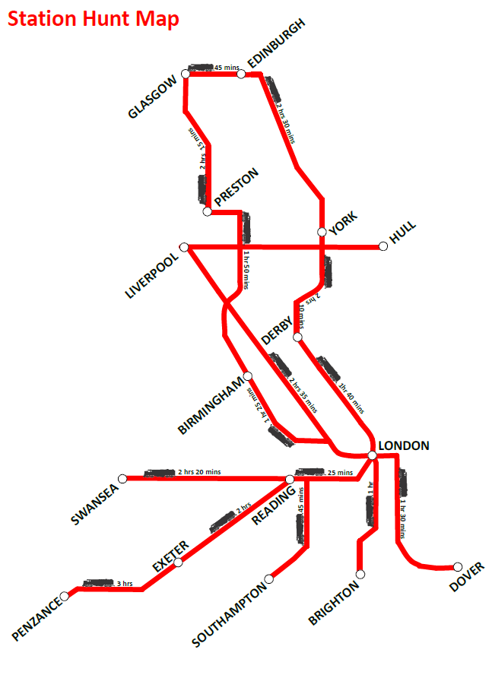Note: data on transport speeds presented above is solely for the purpose of this activity and may not be an accurate reflection of actual current times

