# Pulleys – Connected Particles in Motion

## Aims

Two objects are connected via a string that passes over a pulley, then released from rest. The aims are:

1. 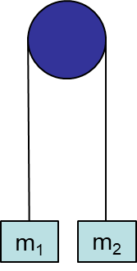to predict the time taken for the heavier mass to fall to the ground,
2. to predict the greatest height reached by the lighter mass.

## Summary of the experiment

* Use the scales to measure and record the masses of the two objects.
* Attach the pulley to a secure high point in the room.
* Hang a long tape measure from the same point (or attach it to a wall in the background).
* Pass the string over the pulley and attach the two masses to the ends, holding them level.
* Release and check that the lighter mass does not hit the pulley and that the string is long enough for the heavy mass to reach the ground.
* Set up and hold level again, noting the height above the ground of the bases of the objects.
* Set up a recording device so that the range of motion of the masses is in view, checking that the scale on the tape measure is also visible.
* Start recording and release the masses.
* Make calculations (see below) to predict the time and the height reached.
* Use the video recording to find the actual time and the actual greatest height.
* Compare and discuss the results.

## Typical calculations

Draw a separate force diagram for each object. The weight of each object is its mass in kg times the acceleration due to gravity, g, in ms-2. For instance a 95 gram mass has a weight of 0.095g Newtons. We’ll take g to be 9.8 when needed. Then apply Newton’s second law to write an equation for each object. Here’s how they look for the values measured in the video.

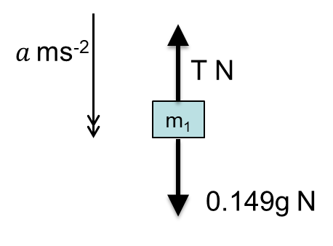 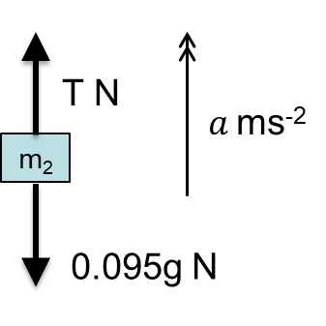



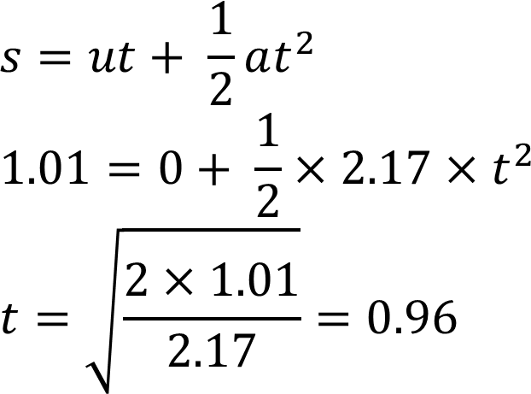a) The time taken for the heavier mass to fall to the ground is predicted to be 0.96 seconds using SUVAT.

b) The motion of the lighter object is in two stages. First the string is taut and it has an acceleration of 2.17 ms-2. Then the string becomes slack and it has an acceleration of -9.8 ms-2. The greatest height reached is predicted to be 2.24 metres.

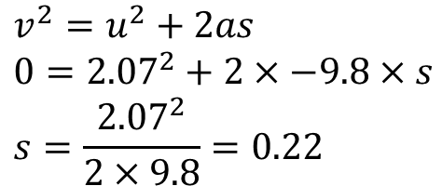Stage 1: Stage 2: Combining (initial height+1+2):

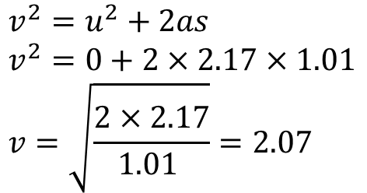

## Suggested points for discussion

Look at the modelling assumptions and any factors affecting the accuracy to see whether these account for any difference in results. A good approach is to ask the students and then discuss the ideas they raise, prompting for any key ideas that they miss. Here are some suggested lines of discussion.

Is the assumption of a ‘light’ string reasonable? If the mass of the string is small compared to the mass of the objects, which seems reasonable here, then this is unlikely to affect the results very much.

Is the assumption of a ‘smooth’ pulleys reasonable? How free-moving did the pulley feel when you were setting up the experiment?

How accurately were the measurements made? It may depend upon the scales used, but we could generally expect digital scales to give an accurate enough reading not to affect this kind of experiment. But what about measuring the time and the height? How easy was that?

## Extending the task

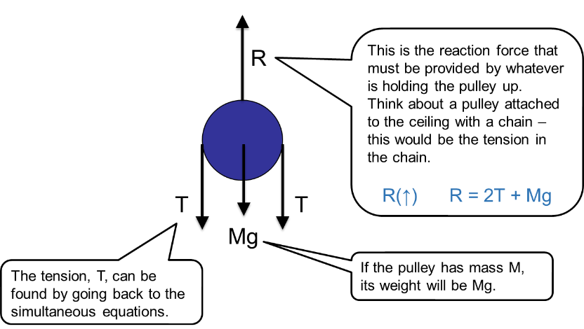Determine the forces acting on the pulley.

## Applications

Pulleys are used to raise or lower things. Some examples of pulleys involving motion are:

* traction lifts (e.g. <http://www.schumacherelevator.com/elevators/traction-elevators> );
* cranes.

Modelling the forces and motion of connected objects has lots of applications such as:

* car & caravan / train & carriages;
* skydiver & parachute.