DIY Faraday Challenge Day

Aerospace Engineers
Student Booklet

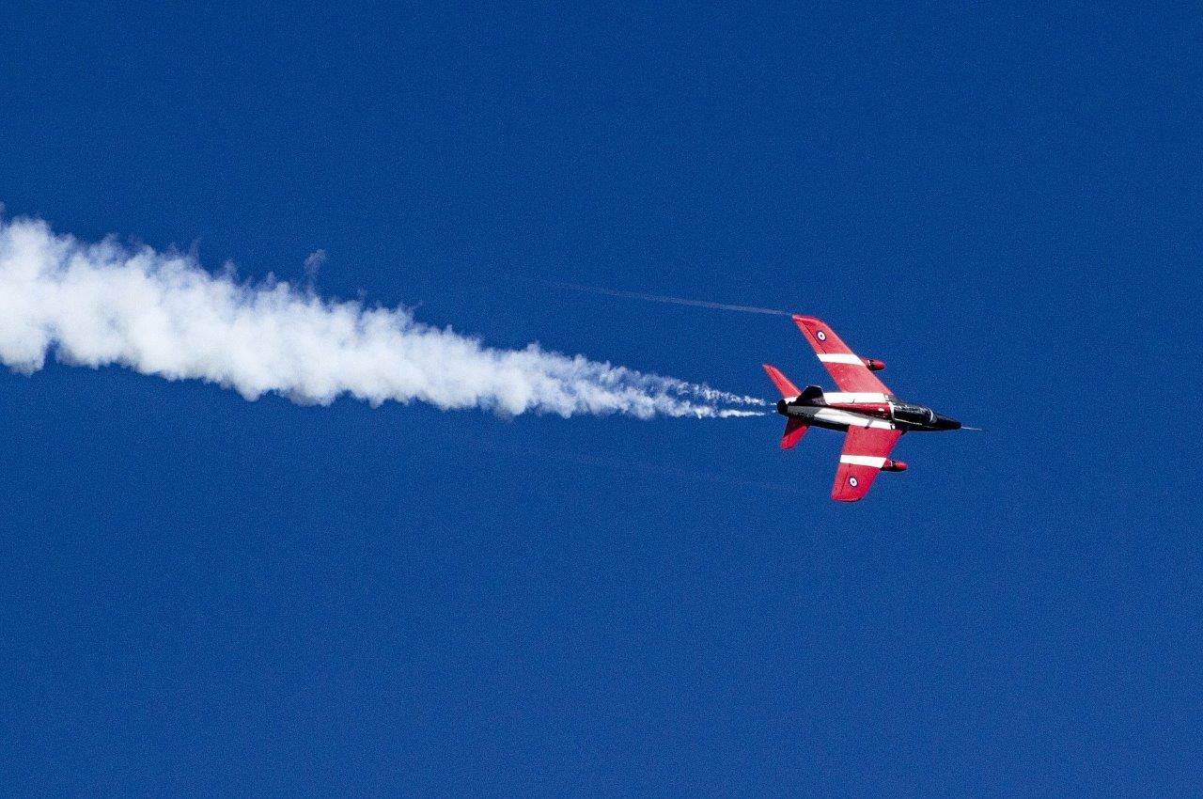

Contents

- The Context …………………………………………………………………………….. 3
- The Brief ………………………………………………………………………………… 4
- Schedule for the day …………………………………………………………………… 5
- Shop resource sheet ………………………………………………………………. 6
- Assessment information and criteria …………………………………………………. 8

1. The context

You are engineers working in the aerospace industry. Your team has been asked to design an aeroplane and a transporter.

Often engineers work in smaller teams to develop one part of a larger project and your team’s role is to design and construct the outer shell of the aeroplane. The other components, such as the wheels and the engine, will be fitted by another engineering team. This means you will also need to design a vehicle which will be able to transport your plane from one of the design areas to the area where it will be fitted with its wheels and engine.

2. The Brief

Engineers usually build prototypes to test out their ideas first. You will need to design and build a prototype aeroplane and vehicle to transport it. Your aeroplane must be able to fly as far as possible and your prototype transporter must be able to carry it at least 3 metres in a straight line towards the next place where it will be fitted out. You must include at least one electrical component (e.g. motor, bulb, buzzer) in the design for your transporter. No electrical components should be included in the aeroplane as this will be done by another engineering team later in the development stage.

You may want to think about how you could transport your aeroplane safely by warning people it is coming and whether you may need to transport it in the dark.

You will need to work as a team as real-life engineers throughout the day if you are going to succeed in this challenge. To do this you will need to take on additional roles which will give some members of your team responsibility for managing your time, your money and the overall project.

You will present your ideas at the end of the day to the judge(s) and the other young engineers on your challenge day.

Your team will need to:

- Identify ideas for both the aeroplane and the transporter.
- Construct the designs you have chosen.
- Manage your budget effectively.
- Record your ideas and the problems you have encountered during the day.
- Present your final prototypes for judging.

Remember:

- Your aeroplane must be able to fly as far as possible
- Your transporter must be able to carry your aeroplane at least 3 metres safely

3. Schedule for the day

09:15 | Register your team
09:30 | Welcome
09:35 | Introduction to the IET Faraday Primary Challenge
09.55 | Using motors mini-task
10.05 | STAGE 1: Planning and design
10:20 | Allocation of roles
10:30 | STAGE 2: Building and development  - Shop opens
11.00 | BREAK (working)
11.10 | Stage 2 continues: Modification and testing
12.30 | LUNCH (non-working)
13:00 | Stage 2 continues: Final modification and testing
13:45 | Shop closes
14:00 | STAGE 3: Presentations  - Team presentations of their prototype  - Final marking  - Evaluation of the day
14:45 | Award ceremony  - Feedback to teams  - Presentation to winning team
15:00 | Finish – Engineering teams depart

4. Shop resource sheet
Below are the items available to buy in the shop.

Item | Unit | Cost
General items
Masking tape | 30cm | 5 Faradays
Sticky tape | 30cm | 8 Faradays
Coloured card A4 | Each | 4 Faradays
Polyfoam A5 sheet | Each | 8 Faradays
Tissue paper | Strip 25cm wide | 4 Faradays
Corrugated plastic 15cm x 21cm | Each | 10 Faradays
Straws | 1 straw | 2 Faradays
Recycled Items (cardboard tubes, plastic trays) | Each | 5 Faradays
String | Per metre | 5 Faradays
Paper fasteners | 5 fasteners | 1 Faraday
Paper clips | 5 paper clips | 1 Faraday
Elastic bands | Each | 1 Faraday
Blu Tak | Small Strip | 5 Faradays
Wooden dowel 5mm | 1 stick | 8 Faradays
Wooden lolly stick | Each | 5 Faradays
Wooden wheel 54mm | Each | 4 Faradays
Pulley wheel 54mm | Each | 6 Faradays
Large cog | Each | 8 Faradays
Medium cog | Each | 5 Faradays
Small cog | Each | 3 Faradays
Plastic cotton reel | Each | 8 Faradays
Weights | Each | 4 Faradays
Electric components
Crocodile leads | Each | 5 Faradays
Motor | Each | 4 Faradays
Pulley attachment for motor (black) | Each | 2 Faraday
Gear attachment for motor (white) | Each | 2 Faraday
Motor holder | Each | 5 Faradays
Batteries - AA size | Each | 2 Faradays
Batteries – 9V | Each | 5 Faradays
Battery snap for 9V cells and AA battery holders | Each | 2 Faradays
Battery holder - 2 AA cells | Each | 1 Faradays
Buzzers 3V | Each | 5 Faradays
Switch | Each | 6 Faradays
Bulbs 2.5V | Each | 4 Faradays
Bulb holders | Each | 5 Faradays

AVAILABLE TO HIRE:

Item | Unit | Cost
Faraday Challenge Leader consultancy time | 5 minutes | 10 Faradays
Hole punch | 5 minutes | 5 Faradays
Stapler | 5 minutes | 5 Faradays

FREE TO USE: (Excessive use may result in a charge of 10 Faradays)
Glue guns
Craft knives
Junior hacksaw
Wire cutter/stripper
Scissors
Screwdriver
Ruler

5. Assessment criteria

Criteria | Maximum marks awarded
1. Planning | 15
2. Development | 25
3. Accounting | 10
4. Quality and performance of prototype aeroplane | 15
5. Quality and performance of prototype transporter | 25
6. Teamwork | 10
Total | 100

1. Planning (15 marks)
Using Stage 1 and 2 of the planning and reflections sheet, marks will be awarded for:
- Identifying a minimum of 2 potential solutions for the prototype. (4 marks)
- Demonstrating creativity and innovation in the ideas (3 marks)
- Developing a detailed drawing of their chosen design for the aeroplane (3 marks)
- Developing a detailed drawing of their chosen design for the transporter (including electric circuit) (5 marks)

2. Development (25 marks)
Using Stage 3 of the planning and reflections sheet and observations of the teams, marks will be awarded for:
- Demonstrating STEM skills in building and development (5 marks)
- Demonstrating team resilience and a willingness to adapt initial ideas in developing and finalising the prototype. (5 marks)
- Providing an honest and accurate description of their problems encountered (5 marks)
- Identifying and implementing solutions to the problems encountered (5 marks)
- Providing an honest account of the effectiveness of their team work (5 marks)

3. Accounting (10 marks)
Using the accounts sheet and observation of the final prototypes, marks will be awarded for:
- Providing an accurate record of spending (3 marks)
- Effective and economical use of the budget (7 marks)

4. Quality and performance of prototype aeroplane (15 marks)
Using observations of the aeroplane during final presentations, marks will be awarded for:
- Quality of design and manufacture (7 marks).
- Functionality – the distance the aeroplane travels. (8 marks) Note: only the plane which flies the furthest should receive maximum marks.

5. Quality and performance of prototype aeroplane (25 marks)
Using observations of the transporter during final presentations, marks will be awarded for:
- Quality of design and manufacture using STEM knowledge (10 marks).
Functionality – the transporter travels 3 metres and is capable of transporting the aeroplane to the next place for manufacture (5 marks)
- Safety and ease of use - the developments which enable your prototype to operate safely (5 marks)
- Creativity - how your prototype could be built in real life given the limited resources available. (5 marks)

5. Teamwork (10 marks)
Using observations of the team throughout the day, marks will be awarded for:
- How well you work as a team with all members contributing to the prototypes and carrying out their assigned roles (5 marks)
- Safe use of resources and components (5 marks)

