**DIY Faraday Challenge Day**

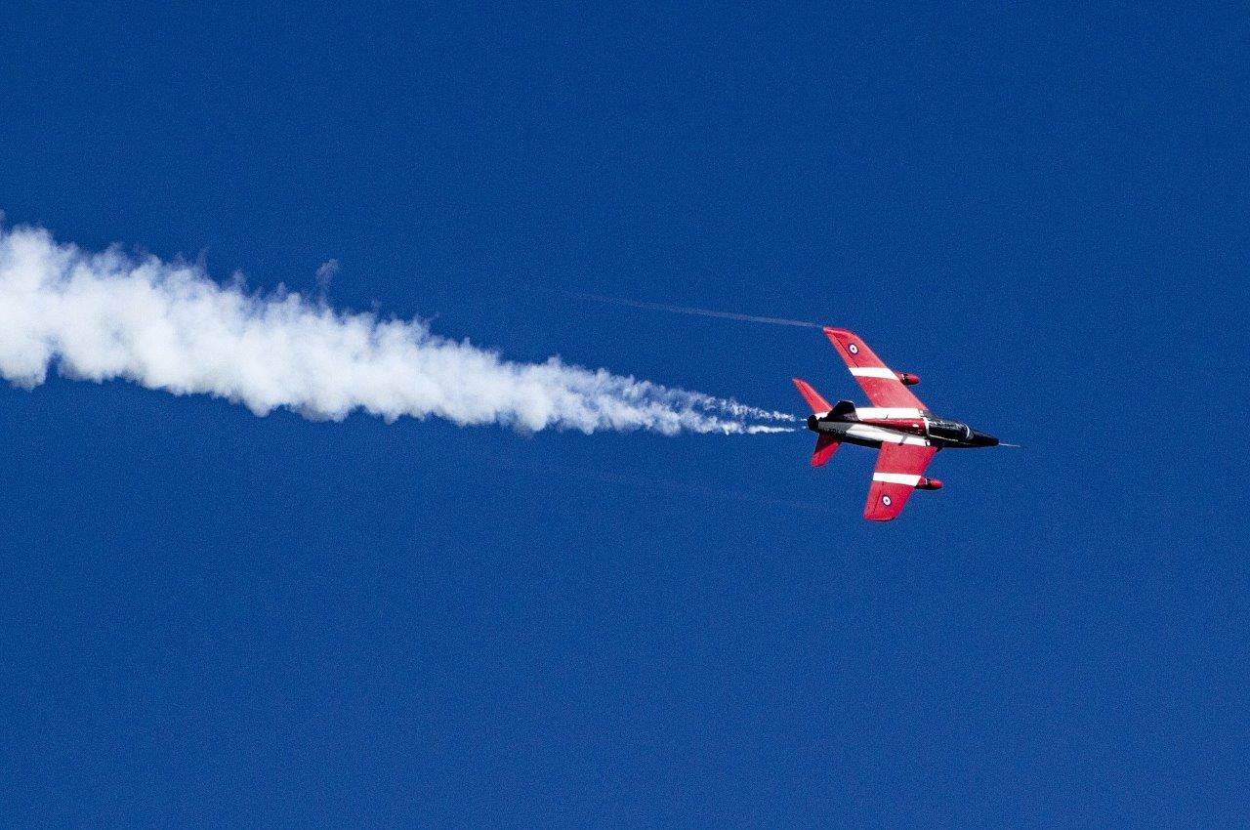

**Aerospace Engineers**

**Teacher Information Pack**

**Contents**

1. About the DIY Primary Challenge Days …………………………………………… 3
2. The Context …………………………………………………………………………... 3
3. The Brief ……………………………………………………………………………… 4
4. Resources …………………………………………………………………………… 5
5. Suppliers …………………………………………………………………………..… 7
6. Schedule for the day ………………………………………………………………… 8
7. Room layout …………………………………………………………………………… 9
8. Assessment matrix …………………………………………………………………… 10
9. Assessment criteria ………………………………………………………..…………. 11
10. Risk assessment ……………………………………………………………………… 13

**1. About the DIY Primary Faraday Challenge Day**

IET Faraday currently delivers challenge days in schools around the UK to students aged 12-13 years. As a charity, we are committed to the advancement of science, engineering and technology and to encouraging your people to study the STEM subjects and consider careers within the engineering and technology sectors.

We recognise that it is important to engage children in the STEM subjects from an early age and the DIY IET Faraday Primary Challenge Days have been developed to support this. All the resources are provided for teachers to run their own challenge day with students aged 8-11, either from their own school or with teams invited from other local schools.

The aim of the DIY Primary IET Faraday Challenge Day is to enable students to experience the ways in which engineers work in a range of sectors and to discover more about what knowledge, understanding and skills are required.

The Primary DIY Challenge Day can be used to enhance the current curriculum as it encourages students to use their existing knowledge of electrical circuits, forces, design and construction and will enable them to integrate learning in science, technology and mathematics.

Although the challenge is designed to be delivered across one day it can be split into smaller parts to accommodate the schools timetable as required.

Teamwork and independence are key principles of IET Faraday. The Challenge Day is designed for six teams of six students, with the option of a teachers’ team if you invite groups from other schools. This allows students to work independently from their teachers, to work more cohesively as a student team and to see that their teachers can learn alongside them in new contexts.

Students are encouraged to design and construct prototype solutions to genuinely tough engineering problems. Alongside using their existing STEM knowledge, they will need to use problem solving, team working and communication skills.

**2. The context**

This DIY Primary Faraday Challenge Day encourages students to consider how engineers work together in the aerospace industry. It enables students to experience the knowledge, understandings and skills engineers use within their work and the ways in which their strengths can be used to achieve an effective outcome.

**3. The Brief**

Engineers usually build prototypes to test out their ideas first. The students will need to work as a team to design an aeroplane as part of a larger product design team and then construct a transporter to move it to the next stage of development.

The transporter will need to include at least one electrical component (e.g. motor, bulb, buzzer) but the aeroplane should not include any circuits as this element will be completed at a later stage of the production process.

The prototype aeroplane must be able to fly a good distance and the prototype transporter must be able to carry it at least 3 metres in a straight line towards the next place where it will be fitted out. Students will need to think about safety, ease of use and flexibility of use. They will need to be resourceful, resilient and willing to adapt their ideas. Being an engineer can be challenging as it often entails finding out what does not work before finding out what does!

The students will have access to the Faraday shop and a budget of Faraday money. They will need to plan what resources to buy and manage and record their budget. At times they may need to make decisions about affordability and effective use and should be encouraged to identify alternative, possibly cheaper, approaches to their final designs.

At the end of the challenge day students will be asked to present their prototypes by firstly demonstrating how the aeroplane will be carried by the transporter and then flying their aeroplane as far as possible.

**4. Shop resources**

Below are the items available to buy in the shop.

|  |  |  |
| --- | --- | --- |
| **Item** | **Unit** | **Cost** |
| **General items** | | |
| Masking tape | 30cm | 5 Faradays |
| Sticky tape | 30cm | 8 Faradays |
| Coloured card A4 | Each | 4 Faradays |
| Polyfoam A5 sheet | Each | 8 Faradays |
| Tissue paper | Strip 25cm wide | 4 Faradays |
| Corrugated plastic 15cm x 21cm | Each | 10 Faradays |
| Straws | 1 straw | 2 Faradays |
| Recycled Items (cardboard tubes, plastic trays) | Each | 5 Faradays |
| String | Per metre | 5 Faradays |
| Paper fasteners | 5 fasteners | 1 Faraday |
| Paper clips | 5 paper clips | 1 Faraday |
| Elastic bands | Each | 1 Faraday |
| Blu Tak | Small Strip | 5 Faradays |
| Wooden dowel 5mm | 1 stick | 8 Faradays |
| Wooden lolly stick | Each | 5 Faradays |
| Wooden wheel 54mm | Each | 4 Faradays |
| Pulley wheel 54mm | Each | 6 Faradays |
| Large cog | Each | 8 Faradays |
| Medium cog | Each | 5 Faradays |
| Small cog | Each | 3 Faradays |
| Plastic cotton reel | Each | 8 Faradays |
| Weights | Each | 4 Faradays |
| **Electric components** | | |
| Crocodile leads | Each | 5 Faradays |
| Motor | Each | 4 Faradays |
| Pulley attachment for motor (black) | Each | 2 Faraday |
| Gear attachment for motor (white) | Each | 2 Faraday |
| Motor holder | Each | 5 Faradays |
| Batteries - AA size | Each | 2 Faradays |
| Batteries – 9V | Each | 5 Faradays |
| Battery snap for 9V cells and AA battery holders | Each | 2 Faradays |
| Battery holder - 2 AA cells | Each | 1 Faradays |
| Buzzers 3V | Each | 5 Faradays |
| Switch | Each | 6 Faradays |
| Bulbs 2.5V | Each | 4 Faradays |
| Bulb holders | Each | 5 Faradays |

**AVAILABLE TO HIRE:**

|  |  |  |
| --- | --- | --- |
| **Item** | **Unit** | **Cost** |
| Faraday Challenge Leader consultancy time | 5 minutes | 10 Faradays |
| Hole punch | 5 minutes | 5 Faradays |
| Stapler | 5 minutes | 5 Faradays |

**FREE TO USE: *(Excessive use may result in a charge of 10 Faradays)***

Glue guns

Craft knives

Junior hacksaw

Wire cutter/stripper

Scissors

Screwdriver

Ruler

**5. Suppliers**

The resources used on IET Primary Faraday Challenge Days are designed to make best use of the resources schools may already have to support science and technology teaching in the school and the resource list can be adapted to suit the schools’ budget.

It is understood that schools will have preferred suppliers but the following are some suggested retailers for further guidance.

* TTS: <http://www.tts-group.co.uk> (for electrical components, dowel, wheels, cogs, cotton reels)
* Hobbycraft <http://www.hobbycraft.co.uk> (for card, polyfoam, tissue paper, lollipop sticks)
* Poundland <http://www.poundland.co.uk> (for paperclips, elastic bands, tissue paper, bubble wrap, etc.)

**6. Schedule for the day**

|  |  |
| --- | --- |
| 08.00 | Set up room for the day |
| 09:15 | Register student teams at team tables |
| 09:30 | Welcome (and hosting arrangements if there are visiting teams) |
| 09:35 | Introduction to the IET Faraday Primary Challenge |
| 09.55 | Using motors mini-task |
| 10.05 | **STAGE 1:** Planning and design |
| 10:20 | Allocation of roles |
| 10:30 | **STAGE 2:** Building and development   * Shop opens |
| 11.00 | **BREAK (working)** |
| 11.10 | Stage 2 continues: Modification and testing |
| 12.30 | **LUNCH (non-working)** |
| 13:00 | Stage 2 continues: Final modification and testing |
| 13:45 | Shop closes |
| 14:00 | **STAGE 3: Presentations**   * Team presentations of their prototype * Final marking * Evaluation of the day |
| 14:45 | **Award ceremony**   * Feedback to teams * Presentation to winning team |
| 15:00 | **Finish – Engineering teams depart** |

**7. Room Layout**

The final layout of the room is entirely at the discretion of the school, however, it is recommended that all elements identified in the room plan below be included.

**On each team table:**

* Team number

**For motors mini-task:**

1 motor

2 x crocodile leads

1 battery holder with 2 x AA cells

I battery snap

* Student team registration
* Aerospace engineer brief – Student booklet
* Accounts sheet
* Team roles and responsibilities
* Student name badges x 6
* Lanyards/name badge holders x 6
* Faraday currency x 140 Faradays

**BACK**

**Cutting and gluing stations**

**Shop **

**Team 7 Teachers**

**Team 4**

**Team 6**

**Team 3**

**Team 5**

**Team 1**

**Team 2**

**Judge’s table**

**FRONT – Projection screen**

**8. Assessment matrix**

**Host name: ………………………………………………………. Date: …………………………….**

|  |  |  |  |  |  |  |  |  |
| --- | --- | --- | --- | --- | --- | --- | --- | --- |
| Assessment Criteria | | Team  1 | Team  2 | Team  3 | Team  4 | Team  5 | Team  6 | Team  7 |
| Planning | 15 |  |  |  |  |  |  |  |
| Development | 25 |  |  |  |  |  |  |  |
| Accounting | 10 |  |  |  |  |  |  |  |
| Quality and performance - aeroplane | 15 |  |  |  |  |  |  |  |
| Quality and performance - transporter | 25 |  |  |  |  |  |  |  |
| Teamwork | 10 |  |  |  |  |  |  |  |
| **Total score** | **100** |  |  |  |  |  |  |  |
| **Faradays spent** |  |  |  |  |  |  |  |  |

|  |  |
| --- | --- |
| **Team** | **School/Team name** |
| 1 |  |
| 2 |  |
| 3 |  |
| 4 |  |
| 5 |  |
| 6 |  |
| 7 |  |

**9. Assessment criteria**

|  |  |
| --- | --- |
| **Criteria** | **Maximum marks awarded** |
| 1. Planning | 15 |
| 2. Development | 25 |
| 3. Accounting | 10 |
| 4. Quality and performance of prototype aeroplane | 15 |
| 5. Quality and performance of prototype transporter | 25 |
| 6. Teamwork | 10 |
| **Total** | **100** |

**1. Planning (15 marks)**

Using Stage 1 and 2 of the planning and reflections sheet, marks will be awarded for:

* Identifying a minimum of 2 potential solutions for the prototype. **(4 marks)**
* Demonstrating creativity and innovation in the ideas **(3 marks)**
* Developing a detailed drawing of their chosen design for the aeroplane **(3 marks)**
* Developing a detailed drawing of their chosen design for the transporter (including electric circuit) **(5 marks)**

**2. Development (25 marks)**

Using Stage 3 of the planning and reflections sheet and observations of the teams, marks will be awarded for:

* Demonstrating STEM skills in building and development **(5 marks)**
* Demonstrating team resilience and a willingness to adapt initial ideas in developing and finalising the prototype. **(5 marks)**
* Providing an honest and accurate description of their problems encountered **(5 marks)**
* Identifying and implementing solutions to the problems encountered **(5 marks)**
* Providing an honest account of the effectiveness of their team work **(5 marks)**

**3. Accounting (10 marks)**

Using the accounts sheet and observation of the final prototypes, marks will be awarded for:

* Providing an accurate record of spending **(3 marks)**
* Effective and economical use of the budget **(7 marks)**

**4. Quality and performance of prototype aeroplane (15 marks)**

Using observations of the aeroplane during final presentations, marks will be awarded for:

* Quality of design and manufacture **(7 marks)**.
* Functionality – the distance the aeroplane travels. **(8 marks) Note: only the plane which flies the furthest should receive maximum marks.**

**5. Quality and performance of prototype aeroplane (25 marks)**

Using observations of the transporter during final presentations, marks will be awarded for:

* Quality of design and manufacture using STEM knowledge **(10 marks)**.

Functionality – the transporter travels 3 metres and is capable of transporting the aeroplane to the next place for manufacture **(5 marks)**

* Safety and ease of use - the developments which enable your prototype to operate safely **(5 marks)**
* Creativity - how your prototype could be built in real life given the limited resources available. **(5 marks)**

**6. Teamwork (10 marks)**

Using observations of the team throughout the day, marks will be awarded for:

* How well you work as a team with all members contributing to the prototypes and carrying out their assigned roles **(5 marks)**
* Safe use of resources and components **(5 marks)**

***Note:*** *If there is a tie then the cost (i.e. number of Faradays used) can be used to decide on the winning team*

# 10. Risk Assessment

The following risk assessment is given as guidance. It is advised that the school refers to the CLEAPSS Model Risk Assessment Documents for D&T.

|  |  |  |  |
| --- | --- | --- | --- |
| **Risk Assessment and Operating Procedure - IET** | | | |
|  | | | |
| **Activity: Primary Faraday Challenge Days** | | | |
| **Persons at risk** | Students taking part in the Faraday Challenge Day and adults in the location | | |
| **Maximum Group Size** | 36 students | Recommended Staffing/Student Ratio | 1:18 |
|  | | | |
| **Risk Assessment** | | | |
| **Hazards** | | **Control Measures** | |
| 1. **Use of electrical equipment – risk of electric shock** | | All electrical equipment is low voltage. | |
| 1. **Use of electrical equipment – short circuit causing heating** | | Warn students of the possibility of burns. Advise to remove connections if device fails to work immediately. | |
| 1. **Basic use of hand tools (craft knives, junior hacksaws, screwdrivers, scissors, hole punches, staplers) – risk of cutting or abrasion** | | Warn students of the risks and advise them of safe working practices. | |
| 1. **Use of glue guns** | | Ensure leads are behind table to avoid trip hazard. Monitor safe use of glue guns and have first aider on call. | |
| **Location issues** (to be completed by Host School) | |  | |
| Further Action Required: 1. Ensure all persons staffing the Faraday Challenge Days are aware of and competent to comply with this risk assessment and the control measures. | | | |

# Risk Assessment (page 2)

|  |  |
| --- | --- |
| **Working Practice** | |
| **Group structure** | It is recommended two members of staff are present during the entire day to oversee use of equipment and to keep order. |
| **Emergency**  **Procedure** | As per procedure in the host school.  If other schools attending, other staff and students to be fully briefed on risk assessment procedure prior to the day or on arrival. |
| **Safety Equipment** | First aid kit and fire extinguisher (electrical fires) to be provided by Host School. |
| **Name and role of IET Faraday Challenge Leader** |  |
| **Signature of the school representative** |  |
| **Date of this Review** |  |