Build a marshmallow igloo
Stay safe
Whether you are a scientist researching a new medicine or an engineer solving climate change, safety always comes first. An adult must always be around and supervising when doing this activity. You are responsible for:

- ensuring that any equipment used for this activity is in good working condition
- behaving sensibly and following any safety instructions so as not to hurt or injure yourself or others

Please note that in the absence of any negligence or other breach of duty by us, this activity is carried out at your own risk. It is important to take extra care at the stages marked with this symbol: ⚠
Subject(s): Science / Maths / Engineering  Approx time: 30 minutes |  | Key words / Topics:  - Forces, shapes, height, length
Equipment ⚠ |  | Ingredients
- 2 cardboard cups – you could clean out some coffee cups from a coffee shop, this will save you having to buy a whole pack  - A pair of scissors  - Marshmallows – you may want to use mini marshmallows rather than standard size.  - Plate  - Buttercream icing – this can be bought in a tub or made (see method for this in the instructions)  - If you are making butter icing, you will need an electric whisk |  | - Bag of mini marshmallows or bag of marshmallows  - If you are making the buttercream icing, you will also need  - 70g softened butter  - 150g icing sugar
Instructions ⚠
Step 1

Cut the side off one of the cups.

⚠ You need to cut it in half length ways, as if you are slicing it in half down the middle.

Make sure you leave the bottom of the cup intact; you do not want to cut this part. This will be the door of your house.

Lay the cup down so that the larger opening you have cut is lying on the plate. |  | 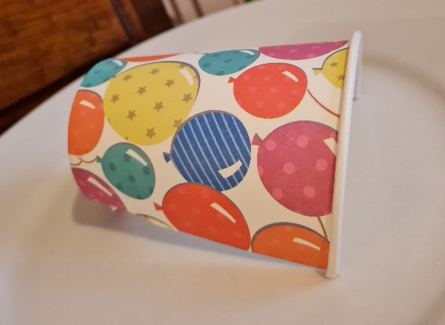
Step 2  You then need to cut into the second cup. Cut a rectangle into the cup, so it goes about a quarter of the way up. In order to be accurate, it is a good idea to measure the height of the cup, then calculate a quarter. How do we do this? Quarters mean four equal groups. So, once you have the measurement, you could either divide that by 4 or half the amount, then half again. For example, 8 divided by 2 = 4 then, 4 divided by 2 = 2. Therefore 2 is a quarter of 8. |  | 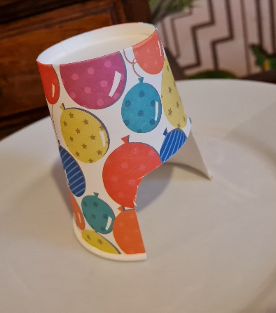
Now slot the door into the opening that you have just cut. It should create something that looks a bit like an L shape. |  | 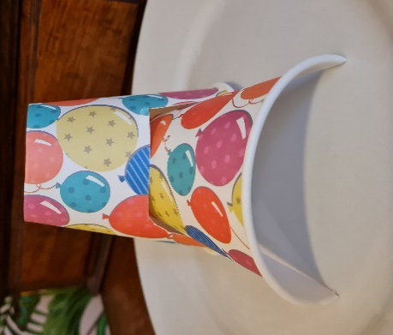
Step 3 – to make buttercream icing

Sieve the icing sugar into a bowl with the softened butter and whisk ⚠ together to form a smooth paste.

Step 4

Next, cover the cups with the buttercream icing, this will create a “cement” that you will be sticking your marshmallows to.

Step 5

Carefully stick the marshmallows to it. Make sure you ensure that all of the marshmallows are touching “shoulder to shoulder” so that it looks more like an igloo.

Step 6

Your igloo is ready to display! It might not last long though, I’m sure some people won’t be able to resist picking off a marshmallow as they walk past the winter wonderland!

Basic |  | Extension
Use your maths skills and knowledge to analyse the shape, height and length of the igloo. Do you think it is an authentic shape? You could try using a paper bowl and half the inner tube of a kitchen roll to make it a different shape. What other resources could you use to change the shape of the igloo?  Is it possible to build an arc of marshmallows without using the structure of the cups underneath? Have a go! |  | Try experimenting with different “cements”. You could use melted chocolate, caramel, (this can be bought in tubs in the cake aisle of the supermarket) or even water. Can you think of any other “cements” that you can test/use? Why are some ‘cements’ better than others? Think carefully about the consistency, does it work well when bonding with both the cups and the marshmallows.  In order to do the experiment, use a piece of paper or card. If you have a spare cup that you can cut into pieces, this will be even better.  Put whatever “cement” you have decided to experiment with on to the piece of paper/card, use a pallet knife to carefully spread it onto the paper/card.  Next put a marshmallow on top of the “cement”. You may also like to see how well the different “cements” stick the marshmallows together. If so, spread a small amount of the “cement” onto the side of the marshmallow and stick another on to it.  Now put a timer on. Test the solidity of the “cement” after 30 seconds, then a minute, then 2 minutes. Has the “cement” set? If not, do you think it will work? Which substance do you think is the best and why?
Related activities (to build a full lesson)
Starters (Options)  - Show pictures of various igloo structures and ask the children what they notice about them. Are they all the same shape? Why do you think they are built this shape? |  | Extension (options)  - IET Stronger structures activity

The Engineering Context
Igloos are always built in a certain shape. They are curved, rounded constructions. This is so that when the snow ages and moves slightly, it will continue to stay strong, stable and it won’t collapse. As you are building the igloo, think about the shape you are creating. Is it possible to build the marshmallow igloo without the cardboard structure underneath? Are you able to build a marshmallow arc that will stay up independently? Structural engineers work to ensure buildings are safe and fit for purpose.

Curriculum links
England: National Curriculum  Design & Technology Key Stage 2  Make  - select from and use a wider range of tools and equipment to perform practical tasks [for example, cutting, shaping, joining and finishing], accurately  Technical knowledge  - apply their understanding of how to strengthen, stiffen and reinforce more complex structures | Northern Ireland Curriculum  The Arts / Art and Design Key Stage 1  Use a range of media, materials, tools and processes such as: drawing, painting, printmaking, malleable materials, textiles and three-dimensional construction, selecting which is appropriate in order to realise personal ideas and intentions, for example:  - use modelling and construction techniques to make three-dimensional work.
Scotland: Curriculum for Excellence  Craft, Design, Engineering and Graphics  Design and construct models/products  - TCH2-09a I can extend and enhance my design skills to solve problems and can construct models  Application of Engineering  - TCH 2-12a I can extend my knowledge and understanding of engineering disciplines to create solutions | Wales: National Curriculum  Design and Technology Key Stage 2  Designing  - 6. consider the safety, reliability and sustainability of their activities/products  - 7. evaluate their design ideas as they develop, considering the needs of the user  Making  - 3. measure, mark out, cut, shape, join, weigh and mix a range of materials and ingredients, using appropriate tools/utensils, equipment and techniques  - 4. find alternative ways of making if the first attempt fails  Rigid and flexible materials  - 11. learn about the efficient use of materials  - 12. use techniques for reinforcing and strengthening structures in their products  Range  - tasks in which they develop and practise particular skills and techniques that can be applied in their designing and making  - tasks in which they design and make products, focusing on different contexts and materials  - they should be given opportunities to: be creative, be innovative, work independently and in groups.

Assessment opportunities
- Opportunity to peer assess igloos.
- If in teams, students to work out what went well and what could be improved upon in another attempt.

