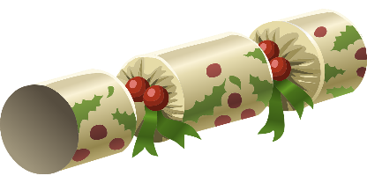**Christmas Cracker and Hat Nets**

**Stay safe**

Whether you are a scientist researching a new medicine or an engineer solving climate change, safety always comes first. An adult must always be around and supervising when doing this activity. You are responsible for:

* ensuring that any equipment used for this activity is in good working condition
* behaving sensibly and following any safety instructions so as not to hurt or injure yourself or others

Please note that in the absence of any negligence or other breach of duty by us, this activity is carried out at your own risk. It is important to take extra care at the stages marked with this symbol: ⚠

**Instructions** ⚠

1. Print off the nets and decorate the cracker with colour
2. Carefully cut out, on the solid lines, the outline of cracker net with scissors
3. Fold along the dotted lines making sure the lines go through the centre of the diamonds. Use a ruler to make a sharper fold. Fold away from yourself
4. Use the fold lines to help you carefully cut out the diamonds
5. Add glue to tabs A, B and C. Stick tab A to its opposite edge on the cracket centre, and B and C to the form the top
6. Tie the top of the cracker with thin coloured string to keep it in shape
7. Add the hat and, if you wish, a small gift inside the cracker. Put these inside the cracker before tying and gluing the bottom
8. Give your cracker to a friend

**Hat** ⚠

1. Decorate the hat with colour
2. Carefully cut out the hat nets with scissors
3. Use sticky tape to join the hat together and one end
4. Place the hat template around your head and add sticky tape to where it snuggly fits your head
5. Carefully cut off any excess paper from the net



