Christmas Gift Tokens
1. Carefully cut out the front cover and gift token. ⚠
2. Print off page 2 for the number of tokens you need for your book.
3. Put the front cover onto your gift tokens and staple them together. ⚠
4. Write your Christmas promises onto the gift tokens.
5. Give your Christmas gift tokens as a gift on Christmas day.

Front cover
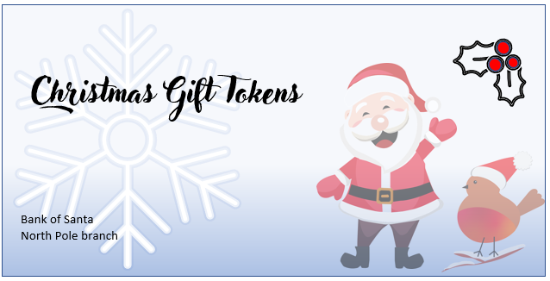

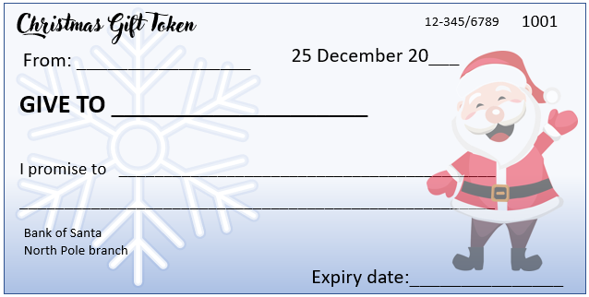
Gift token
Some ideas for Christmas promises ⚠

- Clean the kitchen
- Clean the living room
- Clean the dining room
- Clean the bathroom
- Clean the playroom
- Clean the office
- Clean the bedroom
- Pick up litter
- Help to vacuum
- Help to sweep
- Help with the laundry
- Help to dust
- Take household rubbish out
- Help to recycle rubbish
- Mow the lawn
- Help to weed the garden
- Wash the windows
- Clean out the wardrobe
- Clean out the refrigerator
- Wash the car
- Clean bed linens
- Clean the garage
- Help with the shopping
- Help to bake a cake
- Cook a simple meal
- Fold the laundry
- Iron some clothes

