Electric dough
Stay safe
Whether you are a scientist researching a new medicine or an engineer solving climate change, safety always comes first. An adult must always be around and supervising when doing this activity. You are responsible for:

- ensuring that any equipment used for this activity is in good working condition
- behaving sensibly and following any safety instructions so as not to hurt or injure yourself or others

Please note that in the absence of any negligence or other breach of duty by us, this activity is carried out at your own risk. It is important to take extra care at the stages marked with this symbol: ⚠
Age range: 7-11  Approx time: Approximately 45-90 minutes to make the dough and investigate its properties. |  | Key words / Topics:  - Circuits  - Electricity  - Conductors and Insulators
Equipment
You will need:
- DC power supply (4 x AA in a battery pack)
- A light emitting diode (LED) – any colour
For the insulating dough  - 225g plain flour  - 115g sugar  - 45ml vegetable oil  - 120ml distilled water (you can get this from a chemist)  - 2 drops of green food colouring |  | For the conductive dough  - 225g plain flour  - 45g sugar  - 15ml vegetable oil  - 240ml cold tap water  - 45ml cream of tartar  - 2 drops of red food colouring
Instructions ⚠
To make the dough
Step 1
Make up the insulating dough by putting all the ingredients together in a bowl and adding two drops of green food colouring.
Step 2
Mix everything together until it looks like a dough. You can add more food colouring if it doesn’t look very green at this stage.
Step 3
Sprinkle flour on your work surface and tip your dough out. Knead it until it is smooth and stretchy.

Step 4
Now make the conductive dough by putting all the ingredients into a pan.
⚠ Ask an adult to help you at this stage
Step 5
Place the pan on a medium heat and stir gently until it thickens.
Step 6
Tip it out onto a floured work surface and leave it to cool.
To make the circuit ⚠
Now you are ready to make your circuit.

Step 1

Take one medium sized ball of the green insulating dough and two medium sized balls of the red conductive dough.
Step 2
Sandwich the insulating dough between the two layers of conductive dough.
Step 3
⚠Put the terminal wires from the battery pack into your two layers of conductive dough.
Step 4
Put the two legs of your LED into the two layers of conductive dough. You will need to make sure the longer leg of your LED is in the same layer of conductive dough as the positive terminal (red wire) of your battery pack or it won’t work.
Battery pack

Science
Conductors and insulators

Good conductors allow electrical current to flow freely through them because they contain positively or negatively charged particles, called ions, that are able to move freely.

Insulators do not allow electrical current to move freely through them as they either have no charged particles or their ions are held in fixed positions and cannot move.
Sometimes a substance can be a conductor in one form but an insulator in another. Salt is a really good example of this.

Bonds in molecules

Solid salt, the thing you may put on your chips, has ions which are held in fixed position because of the type of bonding between its two components, sodium and chlorine. We call this ionic bonding. Solid salt (sodium chloride) does not conduct electricity. This is what a molecule of salt looks like.
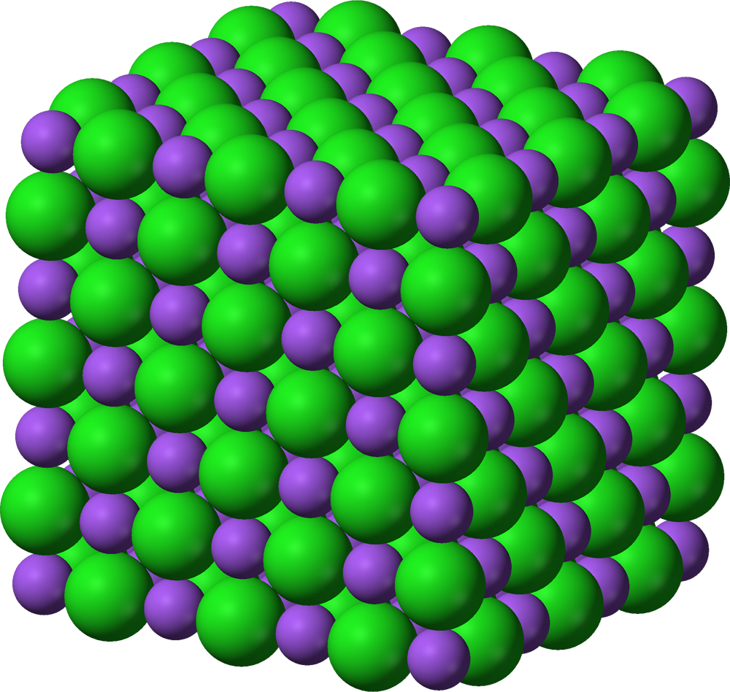

But, when we dissolve salt in water, the bonds break down and the molecules of salt separate into sodium ions which are positively charged and chloride ions which are negatively charged. These ions also move freely as the water molecules mix between them to prevent them forming ionic bonds again. Salt water does conduct electricity.
O⁻
H⁺
H⁺
Cl⁻
Na⁺
O⁻
H⁺
H⁺
O⁻
H⁺
H⁺
O⁻
H⁺
H⁺
O⁻
H⁺
H⁺
O⁻
H⁺
H⁺
O⁻
H⁺
H⁺
O⁻
H⁺
H⁺
Na⁺
O⁻
H⁺
H⁺
Cl⁻

Sugar is different. It has a much more complex chemical structure than salt with the carbon, hydrogen and oxygen atoms held together by strong covalent bonds. These bonds don’t break down easily, even when we dissolve sugar in water. The sugar molecules stay together and just mix in with the water molecules.
O⁻
H⁺
H⁺
O⁻
H⁺
H⁺
O⁻
H⁺
H⁺
O⁻
H⁺
H⁺
O⁻
H⁺
H⁺
C₁₂H₂₂O₁₁
C₁₂H₂₂O₁₁
C₁₂H₂₂O₁₁

Other substances

When we add cream of tartar to water it also breaks down, releasing potassium ions which are free moving. So, when we mix together the ingredients to make our conductive dough, the sodium, chlorine and potassium ions in the dough allow the electricity to flow through it.

In our insulating dough, the flour and sugar do not break down to release ions, so it does not allow electricity to pass freely through it. We have to use distilled water which is very pure because tap water often contains other elements which may conduct electricity, and this would affect our dough.

Insulators

We can’t just make our circuit with conductive dough though, as electricity is lazy. If we don’t make it pass through the LED, then it will take the easier route through the conductive dough. It is still flowing but we just can’t see anything happening because it’s not going through the LED. We call this a short circuit. If we leave it connected, the batteries will get very hot and will eventually use up all their stored energy.

By putting the layer of insulating dough in between, we force the electricity to go round in a loop passing through the LED. We call this a closed circuit. If you didn’t want to make the insulating dough you could use other materials which are insulators.

Investigate which materials you could use instead of the insulating dough.

Related activities (to build a full lesson)
Check out our Santa detector activity to investigate conductors and insulators further with another hands-on experiment.

The Engineering Context
This video is a good introduction to how electricity works https://www.bbc.co.uk/bitesize/clips/zxksb9q.

Curriculum links
England: National Curriculum  Design and Technology  - KS2: 1b, 2a, 2b, 4c  Science  KS2 Electricity:  - construct a simple series electrical circuit, identifying and naming its basic parts, including cells, wires, bulbs, switches and buzzers  - identify whether or not a lamp will light in a simple series circuit, based on whether or not the lamp is part of a complete loop with a battery  - recognise that a switch opens and closes a circuit  - use recognised symbols when representing a simple circuit in a diagram | Northern Ireland Curriculum  Science and Technology  - Movement and energy: The causes and effect of energy, forces and movement
Scotland: Curriculum for Excellence  Technologies  - TCH 2-09a, TCH 2-11a, TCH 2-12a  Sciences  - SCN 2-09a | Wales: National Curriculum  Design and Technology  - KS2 Designing: 5  - KS2 Making: 2, 3, 4  - KS2 Systems and control: 14  Science:  - KS2 How things work: 1

