Identifying sensors for space
Look at the different images of components below. Only some of them can be used as sensors.

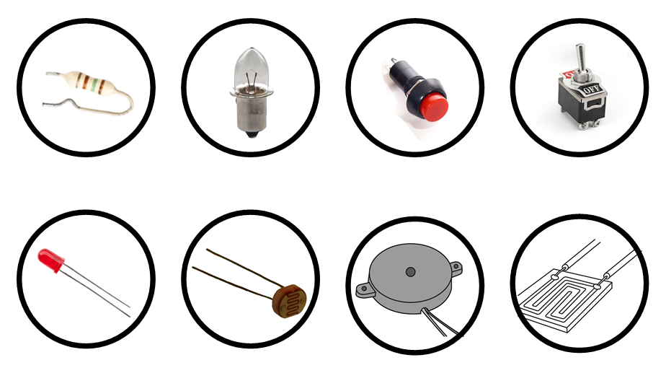
Write the name and cut out and draw a picture of the components against the correct descriptions below.
Name of Component: | Picture: | How it works:
 |  | Its resistance changes as the light intensity changes. It has a high resistance in one state and a low resistance in the other.
 |  | When it gets wet, its resistance changes from high to low.
 |  | It reacts to changes in temperature. It has a high resistance in one state and low resistance in the other.

