Transistor sensor circuit explanation

Schematic | Description
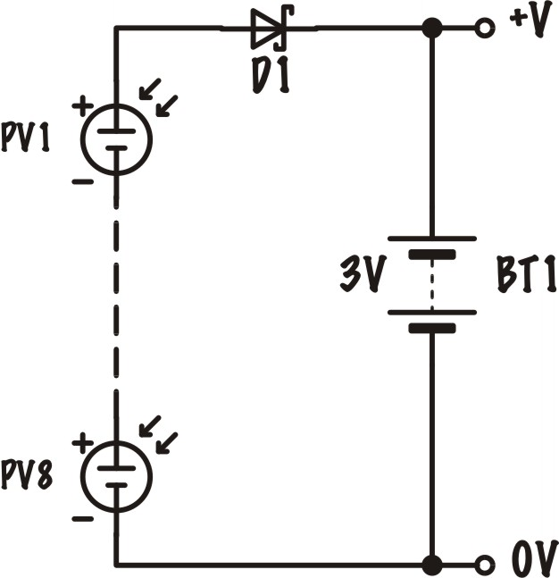 | To charge a 3-Volt battery pack the total voltage generated by the photovoltaic cells (connected in series) should be greater than that of the battery.  The Schottky diode (D1) prevents the battery from discharging through the PV cells if the potential difference across them drops – for example, if the light source is removed or goes away.
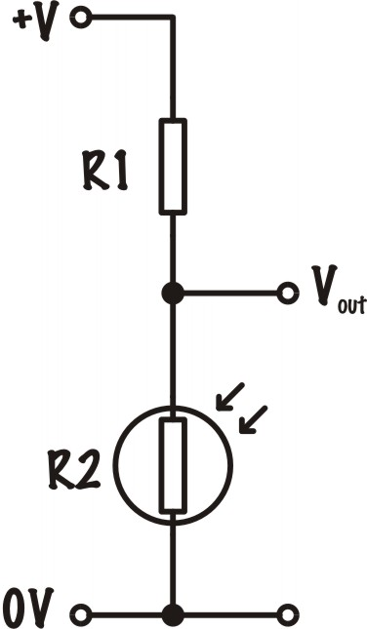 | The sensing part of the circuit is comprised of a Light Dependant Resistor (LDR), R2 connected in series with a fixed-value resistor R1.  This arrangement is called a potential divider. As it gets dark the resistance of R2 increases, so the voltage (energy drop) across it increases, giving a higher voltage at ‘V_{out}’
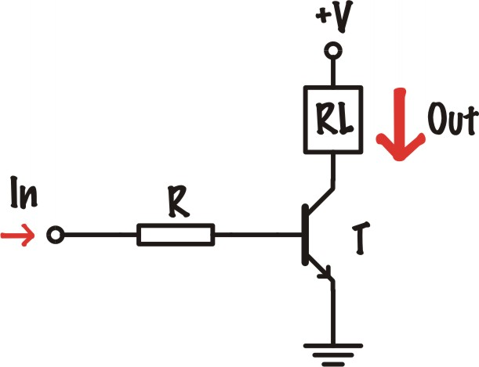 | A transistor acts as an electronic switch. When a small current is applied to its base leg, it allows a large current to flow between its collector leg and its emitter leg. In the circuit diagram, the collector leg is positioned at the top, connected to the relay. The emitter leg is positioned at the bottom, connected to the earth or zero volts/the negative rail of the power supply.  The resistor, R, protects the transistor.
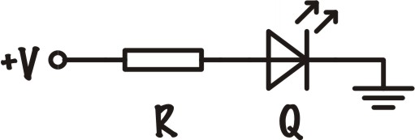 | The LED must be connected the correct way around (anode to the positive and cathode to zero volts). The resistor, R, protects the LED.

