What is a photovoltaic cell?
Solar energy has been given lots of attention in recent years. This is because it is a sustainable energy source. This means that it is naturally replenished and will not run out, unlike non-renewable energy sources such as coal, gas and oil. When used on satellites, this also means that you don’t have to transport fuel to the satellite.

Solar energy comes from the sun. There are lots of so-called energy-saving devices which include solar panels. These range from pocket calculators to office blocks. These do not actually save energy – they use the energy from the sun to reduce the need for other forms of energy.

There are two types of solar panel:
- Solar thermal cells convert the energy from the sun directly into heat. Most often this is water, used for heating.
- Photovoltaic cells convert the ultraviolet (UV) radiation in sunlight into an electrical voltage.

‘Photo’ comes from the Greek phōt meaning ‘light’ and ‘voltaic’ from the measure of potential difference, named after the scientist Volta,The French physicist, Becquerel, was the first to identify the photovoltaic effect in 1839. However, it wasn’t until the 1880s that the first solar cell was built.
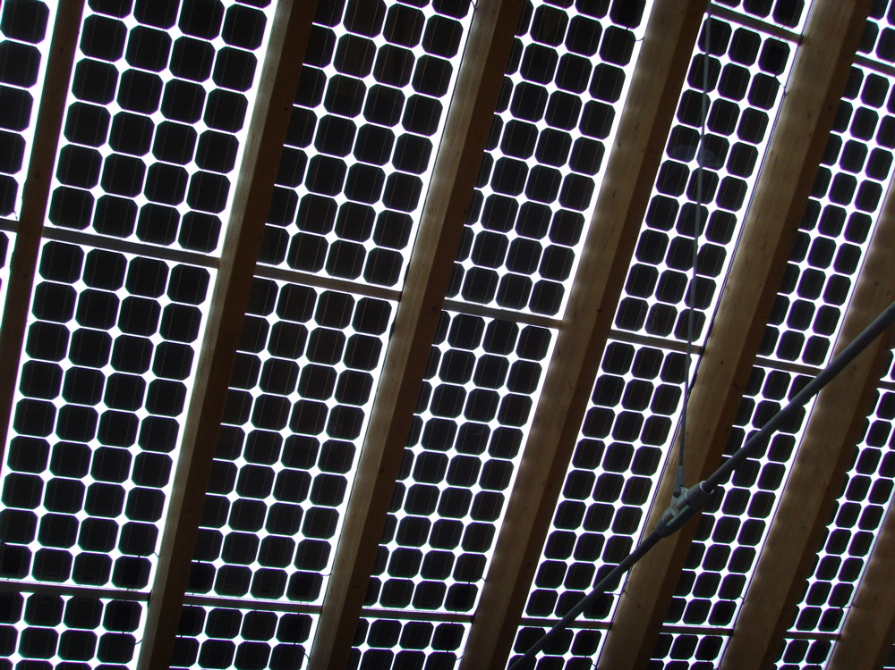

This image shows a photovoltaic roof (Centre for Alternative Technology)
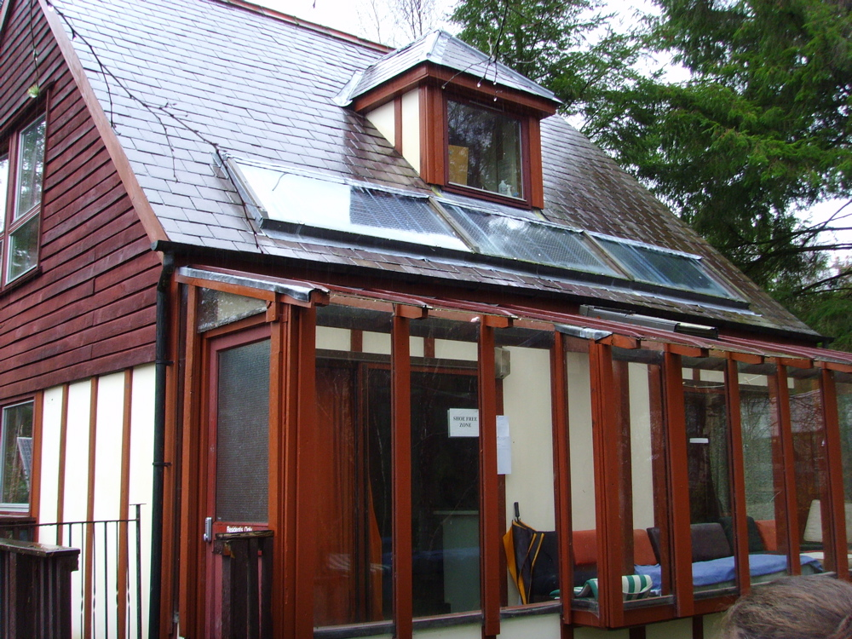

There are a number of different types of photovoltaic (PV) cell. Typically, they are made from thin layers of photosensitive chemicals on a base material, such as ceramic. In recent years a lot of work has gone into reducing the cost of PV cells and making them more efficient. This work has included developments in the materials used, how they are made and designing them to reduce the size to voltage output ratio.

This image shows solar panels on a roof (Centre for Alternative Technology)

How does it Work?

PV cells work by converting energy from sunlight into direct current (dc). Here’s the science bit: photons from sunlight excite (or energise) electrons in the PV, which causes a potential difference (voltage) that in turn causes a current to follow when connected in a circuit. The circuit symbol for a PV cell is shown to the right.
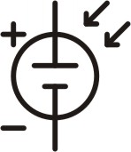
PVs can be used to directly power a circuit. However, this limits their use to daylight hours. To overcome this weakness, you can use PVs to charge batteries. This enables energy to be stored for future use.

In order to efficiently charge a battery, the voltage rating of the PV should be slightly higher than that of the battery. For example, rechargeable AA batteries, made from nickel cadmium or nickel metal hydride, have a potential difference of 1.5 volts. To recharge two of them would require 2 x 1.5 V = 3V. They could be charged using eight 0.4 volt PV cells connected in series, supplying a total of 8 x 0.4 V = 3.2V.

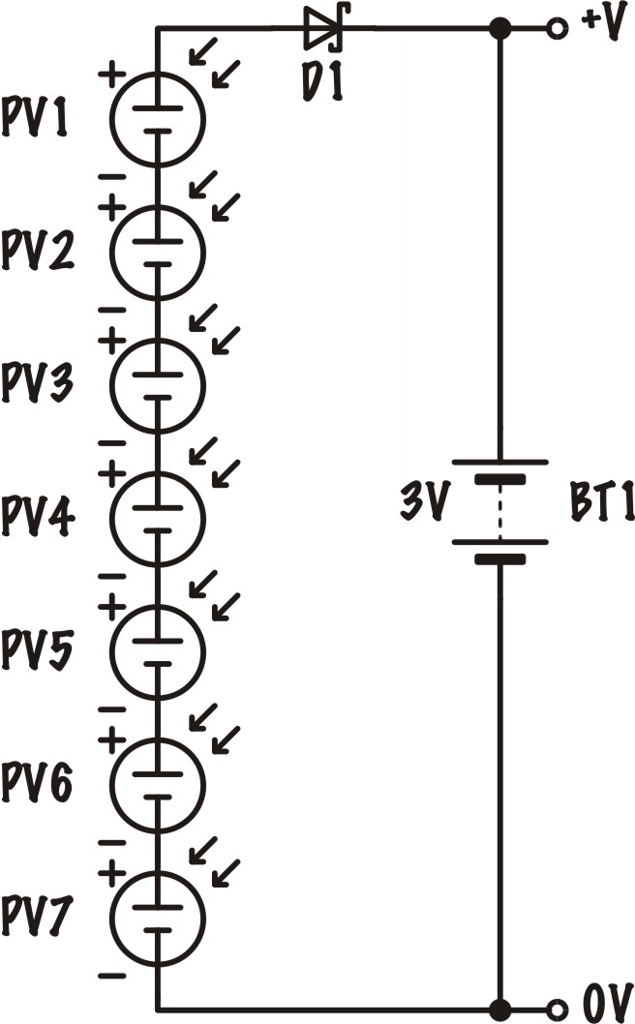
When selecting a suitable PV cell to recharge some batteries, there are three factors that you should consider:

- It’s overall size
- The voltage
- The current rating - the higher the current rating the shorter the charge time.

In the circuit diagram shown, component D1 is a Schottky Diode. This is very important, as it prevents the battery (BT1) from discharging when the voltage generated by the PV drops below 3 Volts.

Some Questions about the Use of Photovoltaic Cells

- How do photovoltaic cells differ from solar thermal cells?
- What commonly available products use photovoltaic cells?
- What are the advantages and disadvantages of photovoltaic cells?
- What factors would affect the positioning of a photovoltaic cell?
- Why are photovoltaic cells used on the JWST?

