Inclined Planes – Friction and Resolving Forces

Stay safe

Whether you are a scientist researching a new medicine or an engineer solving climate change, safety always comes first. An adult must always be around and supervising when doing this activity. You are responsible for:

• ensuring that any equipment used for this activity is in good working condition
• behaving sensibly and following any safety instructions so as not to hurt or injure yourself or others

Please note that in the absence of any negligence or other breach of duty by us, this activity is carried out at your own risk. It is important to take extra care at the stages marked with this symbol: ⚠

Aims

A block rests on a wooden plane and is attached to a string that passes over a pulley and connects to a hanging mass. In Part A the coefficient of friction between the block and the plane is determined experimentally with the plane horizontal. In Part B the plane is raised at one end to a known position. A prediction is made of the hanging mass required so that the block is on the point of sliding up the plane.

Part A Part B
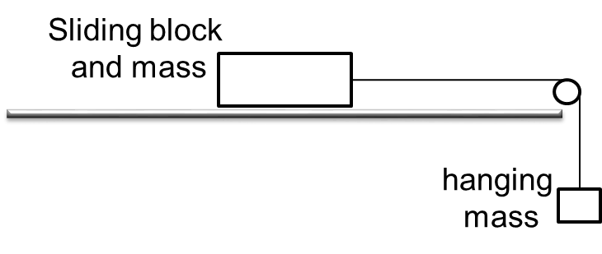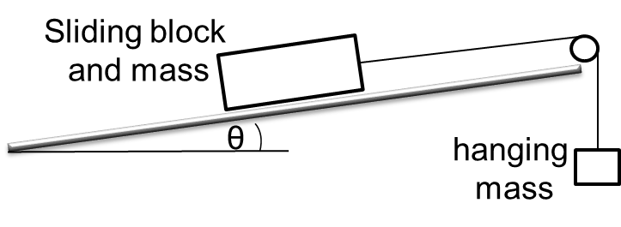

Summary of the experiment

Part A
- Use the scales to measure and record the total mass of the sliding block and mass.
- With the plane horizontal, rest the sliding block and mass on the plane and attach the string to the block.
- Pass the string over the pulley and attach to the hanging bag into which you will add more mass.
- Add sufficient mass (e.g. pasta) to the bag so that the block is just on the point of sliding.
- Remove the bag and use the scales to record the mass that was needed.
- Make calculations (see below) to determine a value for the coefficient of friction, $μ$.
Part B
- Raise the pulley end of the plane to a measured height above the surface.
- Rest the sliding block and mass on the plane and attach the string over the pulley to the bag as before.
- Add sufficient mass to the bag so that the block is just on the point of sliding up the plane.
- Make calculations (see below) to predict the hanging mass required so that the sliding block and mass is just on the point of sliding up the plane.
- Remove the bag and use the scales to record the mass that was needed.
- Repeat for different angles of incline. Compare and discuss the results.

Typical calculations

In each part draw force diagrams for each object separately. The weight of each object is its mass in kg times the acceleration due to gravity, g, in ms⁻². For instance a 127 gram mass has a weight of 0.127g Newtons. We don’t substitute for g to begin with as it often cancels out, but we’ll take g to be 9.8 when needed. Use the length of the ramp and the end height to find sinϴ and cosϴ. Write equilibrium equations. The block is in limiting equilibrium so use the relationship between the friction force and the normal contact force to complete the calculations. Here are the calculations for the video example.

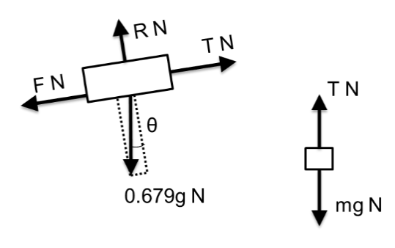
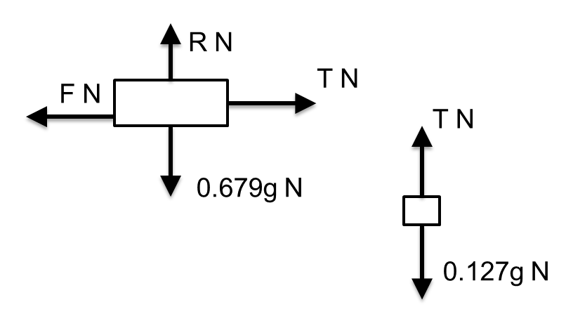
Part A Part B
sinϴ = 0.1
cosϴ = 0.995

use your value of μ
For the hanging mass:
R(↑) T = 0.127g

For the block:
R(↑) R = 0.679g
R(→) F = T
F = 0.127g

In limiting equilibrium:
μ = Fmax /R
μ = 0.127g /0.679g
μ = 0.187
For the hanging mass:
R(↑) T = mg

For the block:
R(↖) R = 0.679gcosϴ
R(↗) T = F + 0.679gsinϴ

In limiting equilibrium:
F = 0.187R
Hence
mg = 0.187 x 0.679gcosϴ + 0.679gsinϴ
m = 0.194
For a raised end height of 0.1 metres the predicted mass is 0.194 kg or 194 grams.

Suggested points for discussion

Look at the modelling assumptions and any factors affecting the accuracy to see whether these account for any difference in results. Here are some suggested lines of discussion.
Is the assumption of a ‘light’ string reasonable? If the mass of the string is small compared to the mass of the objects, which seems reasonable here, then this is unlikely to affect the results very much.
Is the assumption of a ‘smooth’ pulley reasonable? How free-moving did the pulley feel?
What other assumptions are made? The calculation assumes that the string is parallel to the plane. How close is this to reality? What difference would it make to the calculations if the string was at an angle?

Extending the task

Ask what would happen if you placed the sliding block and mass on the plane (without the string connected) and gradually increased the slope of the plane? Calculate a predicted value and check it.

Applications

Inclined planes are found in lots of situations such as:
- ramps (e.g. wheelchair access ramps);
- roller coasters;
- screw jacks or screw conveyors (a screw is just an inclined plane wrapped around a cylinder).

