Multimeters
Stay safe
Whether you are a scientist researching a new medicine or an engineer solving climate change, safety always comes first. An adult must always be around and supervising when doing this activity. You are responsible for:

- ensuring that any equipment used for this activity is in good working condition
- behaving sensibly and following any safety instructions so as not to hurt or injure yourself or others

Please note that in the absence of any negligence or other breach of duty by us, this activity is carried out at your own risk. It is important to take extra care at the stages marked with this symbol: ⚠
How to use a multimeter  The diagram opposite shows a switched range multimeter.  You start by inserting the two probes. The black lead is connected to the socket marked COM, short for COMMON. The red lead is connected into the socket VmA.  The central knob has lots of positions. In any given range, it is a good idea to start with the highest position and work down until you obtain a reading. |  | 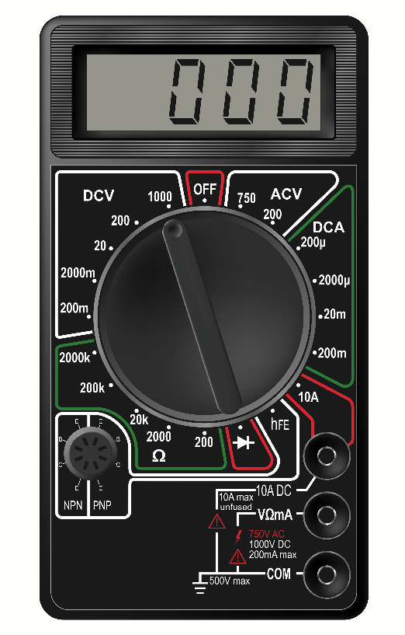  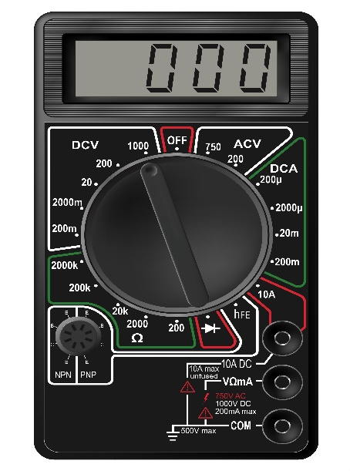
Measuring Resistance  You will need to select the resistance range. Select the highest setting and work down. Place the probes at either end of your resistor and take a reading. Note the colours and order of the rings around the resistor. Change the resistor and repeat. Do this a number of times with different resistors.  Now use your Light Dependent Resistor (LDR) and place the probes at each end. Take a reading in the light and record it. Now place your hand over the LDR, take the new reading and record it. You may need to select a different range on your meter.  Repeat this with your thermistor. Record your reading. Instead of covering it hold it between two fingers to warm it up. You may need to select a different range on your meter to take the reading. |  | 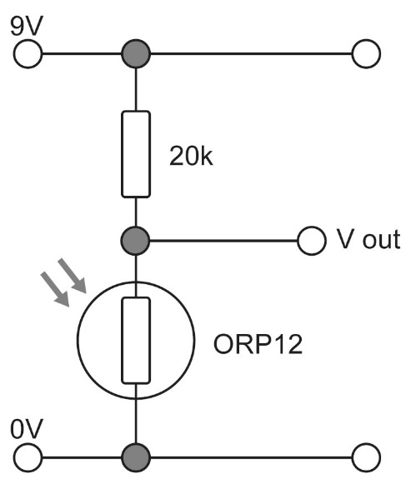
Measuring Voltage  We will be using the DC ranges indicated by on the meter.  v =  The diagram top right shows a light sensor circuit. Set up this circuit on a breadboard or using another prototyping method.  What happens to the output voltage of the light sensor circuit when you cover the LDR with your hand? Record your findings on the recording sheet.  We are now going to use our thermistor. The diagram bottom right shows a temperature sensing circuit  What happens to the voltage when you rub the thermistor with your finger?  Record your findings on the recording sheet. |  | 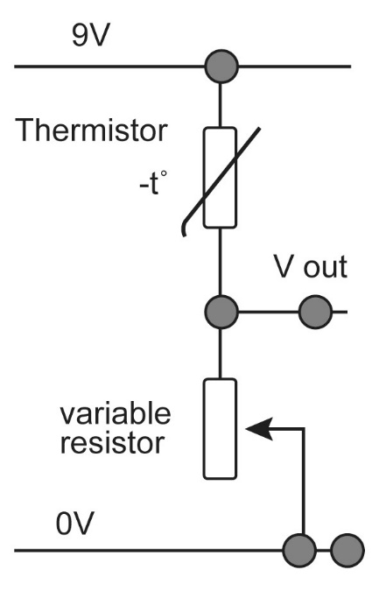
To work out the value of a resistor:
Band 1 is the first number
Band 2 is the second number
Band 3 is the number of zeroes
Band 4 is the tolerance. This is how much the resistance of the resistor might vary from its stated value.
Colour | Band 1 | Band 2 | Band 3
Black | - | 0 | None
Brown | 1 | 1 | 0
Red | 2 | 2 | 00
Orange | 3 | 3 | 000
Yellow | 4 | 4 | 0000
Green | 5 | 5 | 000000
Blue | 6 | 6 | 0000000
Violet | 7 | 7 | -
Grey | 8 | 8 | -
White | 9 | 9 | -
Gold | - | - | 0.1
Silver | - | - | 0.01
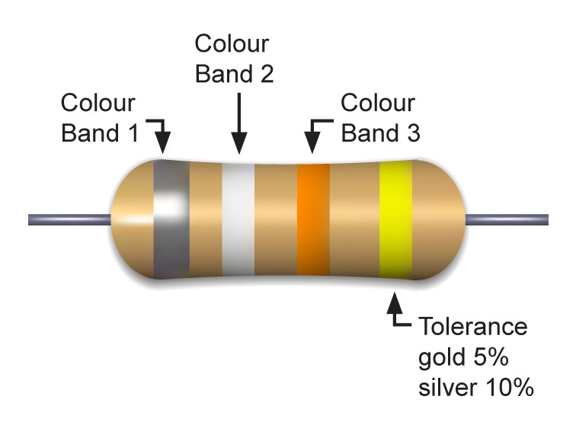
In the example below we would calculate the value to be 22000 ohms with a tolerance of 10%. It can be written as 22kΩ (1000Ω=1kΩ).

Resistor | Colour band 1 | Colour band 2 | Colour band 3 | Tolerance | Multimeter reading
Example | Red | Red | Orange | Silver
1
2
3

Multimeter Recording Sheet

Light Dependent Resistor. Multimeter readings
 | Resistance in ohms | Voltage in volts
Light
Dark

Thermistor. Multimeter readings
 | Resistance in ohms | Voltage in volts
Cold
Hot

