# Pulleys – Forces in Equilibrium

## Stay safe

Whether you are a scientist researching a new medicine or an engineer solving climate change, safety always comes first. An adult must always be around and supervising when doing this activity. You are responsible for:

• ensuring that any equipment used for this activity is in good working condition

• behaving sensibly and following any safety instructions so as not to hurt or injure yourself or others

Please note that in the absence of any negligence or other breach of duty by us, this activity is carried out at your own risk. It is important to take extra care at the stages marked with this symbol: ⚠

## Aim

There are three hanging objects attached to a string that passes over two pulleys. The aim is to predict the mass of one of these hanging objects.

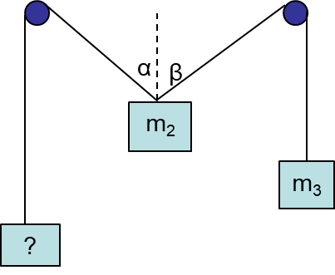

## Summary of the experiment

* Attach a sheet of paper to the board.
* Use the scales to measure and record the masses of two of the objects.
* Pass the string over the two pulleys and attach the three objects to the loops in the string, with the unknown mass to one side.
* Allow the system to hang in equilibrium (the objects must not touch the board).
* Insert a plumb line behind the objects to determine a vertical line through the hanging point of the central object.
* Mark the lines of the strings on the paper.
* Remove the paper and measure the angles $α$ and $β$ using a protractor.
* Make calculations (see below) to predict the unknown mass.
* Check the unknown mass using the scales.
* Compare and discuss the results.

## Typical calculations

Draw a separate force diagram for each object. The weight of each object is its mass in kg times the acceleration due to gravity, g, in ms-2. For instance a 93 gram mass has a weight of 0.093g Newtons. We don’t substitute for g to begin with as it often cancels out, but we’ll take g to be 9.8 when needed.

Then write equilibrium equations. Here’s how they look for the values measured in the video.

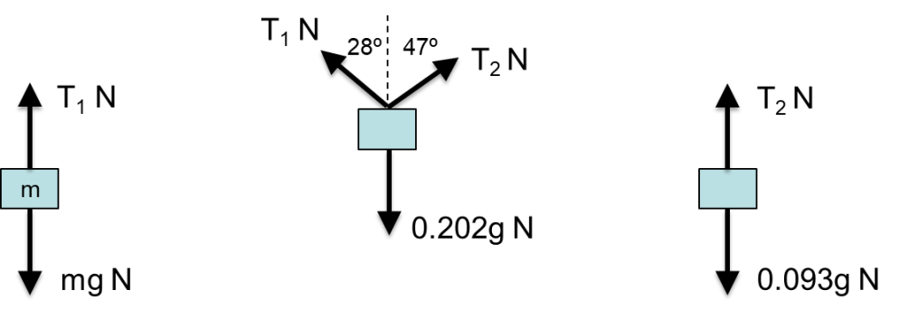



The predicted mass was therefore 0.157 kg or 157 grams.

## Suggested points for discussion

Look at the modelling assumptions and any factors affecting the accuracy to see whether these account for any difference in results. A good approach is to ask the students and then discuss the ideas they raise, prompting for any key ideas that they miss. Here are some suggested lines of discussion.

Is the assumption of a ‘light’ string reasonable? If the mass of the string is small compared to the mass of the objects, which seems reasonable here, then this is unlikely to affect the results very much.

Is the assumption of ‘smooth’ pulleys reasonable? How free-moving did the pulleys feel when you were setting up the experiment?

How accurately were the measurements made? It may depend upon the scales used, but we could generally expect digital scales to give an accurate enough reading not to affect this kind of experiment. But what about measuring the angle? How easy was that? Look back at the calculations. Would it have made much difference if you were, say, 5 degrees out on one of the angles?

## Extending the task

It is possible to measure just the middle mass, m2, along with the two angles, and then use these to predict both m1 and m3.

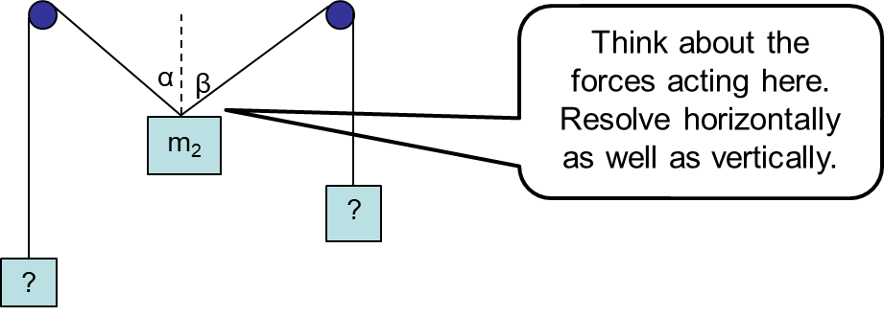

Try this out by resolving forces carefully. Or look up Lami’s theorem and use this to solve the same problem.

## Applications

Pulleys like this are often used for lifting or moving something into position and then holding it there. Applications include:

* domestic (washing lines, curtain pulls);
* sporting (gym equipment, rock climbing);
* medical (physiotherapy, rehabilitation equipment);
* industrial (cranes, access platforms on the outside of buildings).