Projectiles – Motion in 2 Dimensions

Stay safe

Whether you are a scientist researching a new medicine or an engineer solving climate change, safety always comes first. An adult must always be around and supervising when doing this activity. You are responsible for:

• ensuring that any equipment used for this activity is in good working condition
• behaving sensibly and following any safety instructions so as not to hurt or injure yourself or others

Please note that in the absence of any negligence or other breach of duty by us, this activity is carried out at your own risk. It is important to take extra care at the stages marked with this symbol: ⚠

Aims

Balls are released from rest at the top of a ramp so that they run across a table and land on the floor. The aim is to predict the position of the landing point.

Summary of the experiment

- Set up the ramp, using sticky tack to make sure it remains in place throughout the experiment.
- Measure the distance from the bottom of the ramp to the edge of the table.
- Measure the vertical height of the table surface above the floor.
- Set up a recording device so that the ball can be seen travelling from the end of the ramp to the edge of the table.
- Record the ball travelling across the table several times, and use the recording to find an average time taken from the end of the ramp to the edge of the table.
- Use the distance across the table divided by the average time to make an estimate of the speed of the ball as it leaves the table.
- Make calculations (see below) to predict the landing position of the ball.
- Mark this position on the floor with sticky tape (place a cup there if you like).
- Release the ball from the top of the ramp and see where it lands.
- Compare and discuss the results.

Typical calculations

Model the ball (particle) as a projectile moving under the action of gravity in 2D and ignore air resistance. We can treat the horizontal and vertical motion separately. Horizontally there is no force acting so the acceleration is zero and the horizontal velocity is constant. Vertically the only force acting is the weight and so the acceleration is g acting downwards (we’ll use g= 9.8 ms⁻²). Here’s how the SUVAT calculations look for the values measured in the video.

bb

Vertically:
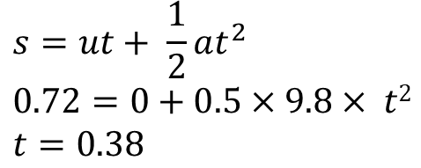

Horizontally:

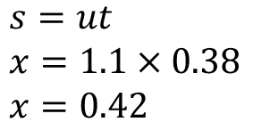

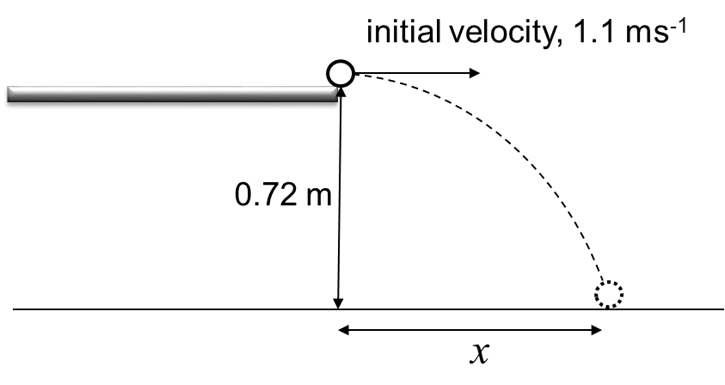
use the time calculated
The predicted landing point is 0.42 metres
from the foot of the table.

Suggested points for discussion

Look at the modelling assumptions and any factors affecting the accuracy to see whether these account for any difference in results. A good approach is to ask the students and then discuss the ideas they raise, prompting for any key ideas that they miss. Here are some suggested lines of discussion.
Is the ‘particle’ model reasonable? For a small metal ball this assumption seems very reasonable.
Is the assumption of ‘no air resistance’ reasonable? For a small metal ball this assumption is fairly reasonable, but ask what effect taking it into account would have on the predicted distance.
How accurately were the measurements made? Measuring distances is likely to have been done to a good level of accuracy, but how easy was it to determine the times taken using the video precisely?
Is the estimate of the ball speed good enough? We are using the average speed of the ball across the table as the exit speed. For these to be the same we are effectively assuming that there is frictionless contact between the ball and the table. So the exit speed is likely to be an overestimated.

Extending the task

Try using different balls with the ramp in the same set up. Try balls that are of different sizes and masses. Will they land in the same position? Discuss what you think might happen, and why, before trying them out. Note that the SUVAT calculations are independent of mass and would predict the same landing position for any ‘particle’ leaving the table with the same speed and direction.

Applications

Projectile trajectories (or paths) can be found in lots of applications such as:
- sports (e.g. basketball, golf)
- stunt ramps
- ballistics
- water fountains.

