Understanding Ergonomics and Anthropometrics
Measuring sizes of hands and presenting data
Subjects: Design & Technology, Engineering  Approx. time: 40 - 50 minutes |  |  |  | Key words / Topics  - anthropometric data  - bar chart  - data presentation  - ergonomics  - measurements  - primary data
Stay safe
Whether you are a scientist researching a new medicine or an engineer solving climate change, safety always comes first. An adult must always be around and supervising when doing this activity. You are responsible for:

• ensuring that any equipment used for this activity is in good working condition
• behaving sensibly and following any safety instructions so as not to hurt or injure yourself or others

Please note that in the absence of any negligence or other breach of duty by us, this activity is carried out at your own risk. It is important to take extra care at the stages marked with this symbol: ⚠
Suggested Learning Outcomes
- To understand what is meant by ergonomics and anthropometrics in design.
- To be able to give examples of ergonomic design and the use of anthropometric data.
- To gather anthropometric data for use in the design of a product.
Introduction
This is one of a series of resources designed to support the delivery of the new 9-1 GCSEs in Design & Technology and Engineering, first taught from September 2017. Each resource covers a key topic from one or more of the specifications for these subjects. This resource focusses ergonomics in design and the gathering and use of anthropometric data.

Designers must consider how people will interact with their products and systems. The use of ergonomics and anthropometric data allows them to make sure their products are comfortable and efficient to use.
Purpose of this activity
In this activity, learners will collect data relating to the hand sizes of different people for use in designing a shopping bag carrier. It will build knowledge and understanding of how ergonomics and anthropometric data is gathered for use in designing products.

This could be used as the first part of a two-lesson mini unit of learning, with the activity ‘Designing an Ergonomic Product’ as the follow up activity. Alternatively, it could be used as a one-off main lesson activity to build knowledge and understanding of the topic.

Activity |  |  |  | Teacher notes
1. Introduction to ergonomics and anthropometrics (5-10 mins)  Teacher to introduce the meaning of the terms ergonomics and anthropometrics. Show an example of a product that has been ergonomically designed and discuss the features that make it ergonomic. The example product could be handed out for learners to examine and touch.  Discuss examples of where anthropometric data has been used to produce a successful product.  2. Introduce the hand measuring task (5 mins)  Introduce the task. Learners will take measurements of the dominant hand of ten people. Demonstrate how to use measuring equipment, such as a tape measure, to measure the length and width of person’s hand using a volunteer from the class.  3. Taking and recording measurements (20-30 mins)  Learners take the required measurements. These can be recorded on the handout provided or they can produce their own table in their books, or on A4 paper.  Learners calculate the total length and total width for the sample taken and the mean average for each.  4. Review of data gathered (5-10 mins)  Class to discuss data gathered and draw conclusions.  Explain that the data can be used to design a product suited for use by the target group that has been sampled. |  |  |  | This activity can be completed as individuals or in small groups (see note regarding taking the measurements below).  Taking measurements  If doing this as a standalone activity, the measurements taken can be of any ten people, such as ten members of the class. If this is to be used as an introductory activity for ‘Designing an Ergonomic Shopping Bag Holder’ then ideally these measurements should be from people aged 60+. This could be done by visiting a local residential home or set as a homework activity. Learners could be placed in groups with each measuring the hand sizes of grandparents or other relatives to produce the overall data.  If it is not possible to gather data for this age group then separate data can be provided for the follow up activity, with the data gathered here used as an example/rough guide.  Measurements should be taken for each person’s dominant hand. So, if they are right handed this would be their right hand, or left handed it would be their left hand.  The length and width of the hand should be measured in mm. That is the distance from the wrist to the tip of the middle finger and the distance between the end of the thumb and the end of the smallest finger. To ensure the measurements taken are comparable, all people having their hand measured should form it in the shape shown below.  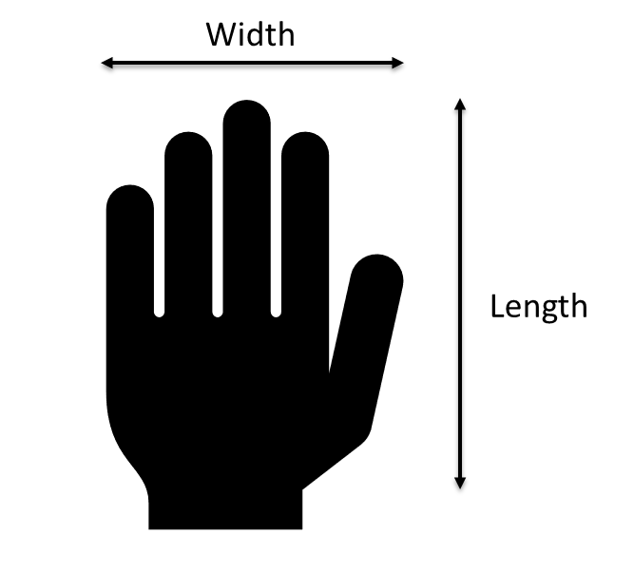
Differentiation
Basic |  |  |  | Extension
If completing as group activity, more able learners can be paired with less able learners.  Maths ‘champions’ could be identified within the class. Their job is to support learners as needed with recording the data and performing the required calculations. |  |  |  | Learners could present the data that they have gathered in the form of a bar chart. They could write a paragraph explaining the meaning of their data and how it could be used in the design of a product for the target group sampled.
Resources |  |  |  | Required files
- Projector/Whiteboard  - Tape measures, rulers or other measuring equipment for hand sizes |  |  |  | Understanding Ergonomics and Anthropometrics Teacher Presentation  Understanding Ergonomics and Anthropometrics Learner Handout
Additional websites
The following websites can be used for additional background information or to aid with the activity:
- Technology Student – Ergonomics and anthropometrics: Practice exam style questions on the topic. http://www.technologystudent.com/despro_flsh/revise11.html
- Ergonomics blog – Teaching materials: Introduction to ergonomics and related teaching materials. https://www.ergonomicsblog.uk/ergonomics-teaching-materials/
- Mr DT – Ergonomics and anthropometrics: Introduction to ergonomics and the use of anthropometric data. http://www.mr-dt.com/designing/ergonomics.htm
- Maths is fun – Calculating mean averages: Explanation of mean averages and how to calculate them. https://www.mathsisfun.com/mean.html

Related activities (to build a full lesson)
Starters  - ACTIVITY: Understanding Ergonomics and Anthropometrics  Main  - ACTIVITY: Designing an Ergonomic Product |  |  |  | Plenary  - Interpreting and discussing the data gathered.  - Producing a bar chart of data gathered.  - Reflection on Objectives and PLT skills used

The Engineering Context 
Ergonomics and anthropometrics is a core topic in all GCSE Design and Technology 9-1 courses and could also be taught as part of Engineering courses. The topic also presents opportunities to cover required maths skills for both D&T and Engineering GCSE courses, such as calculating mean averages, tabulating data and producing graphs and charts.

The knowledge gained can also be used when making use of data to support the design of future products.

Curriculum links
England: National Curriculum  Design & Technology  - KS3 1a | Northern Ireland: Curriculum  Technology & Design  - KS3 Knowledge, understanding and skills: Design – identifying problems; investigating, generating, developing, modelling and evaluating design proposals; giving consideration to form, function and safety.  Learning Outcomes:  - Research and manage information effectively to investigate design issues, using Mathematics and ICT where appropriate.  - Work effectively with others.
Scotland: Curriculum for Excellence  Technologies  - TCH 4-09a | Wales: National Curriculum  Design and Technology  - KS3 Skills: Designing 2
GCSE D&T  AQA D&T  - 3.3.1  Eduqas D&T  - 2.2 Core: 2, 4  OCR D&T  - 1.2a iii | GCSE Engineering  AQA Engineering  - 3.6

Assessment opportunities
Regular questioning throughout the activity, formal teacher assessment of completed work.

Personal, learning & thinking skills (PLTS)
- Independent enquirer
- Self-manager
- Effective participator
- Team worker
- Reflective learner

