The IET

IHEEM

Student Booklet

Could you be our engineer….?

With thanks to our supporters and sponsors…

The David Family Foundation

Contents

- The Context …………………………………………………………………………….. 4
- The Brief ………………………………………………………………………………… 5
- Schedule for the day ………………………………………………………………….. 6
- Engineering apprenticeship …………………………………………………………… 7
- Shop resource sheet …………………………………………………………………… 8
- Assessment information and criteria …………………………………………………. 12

Context

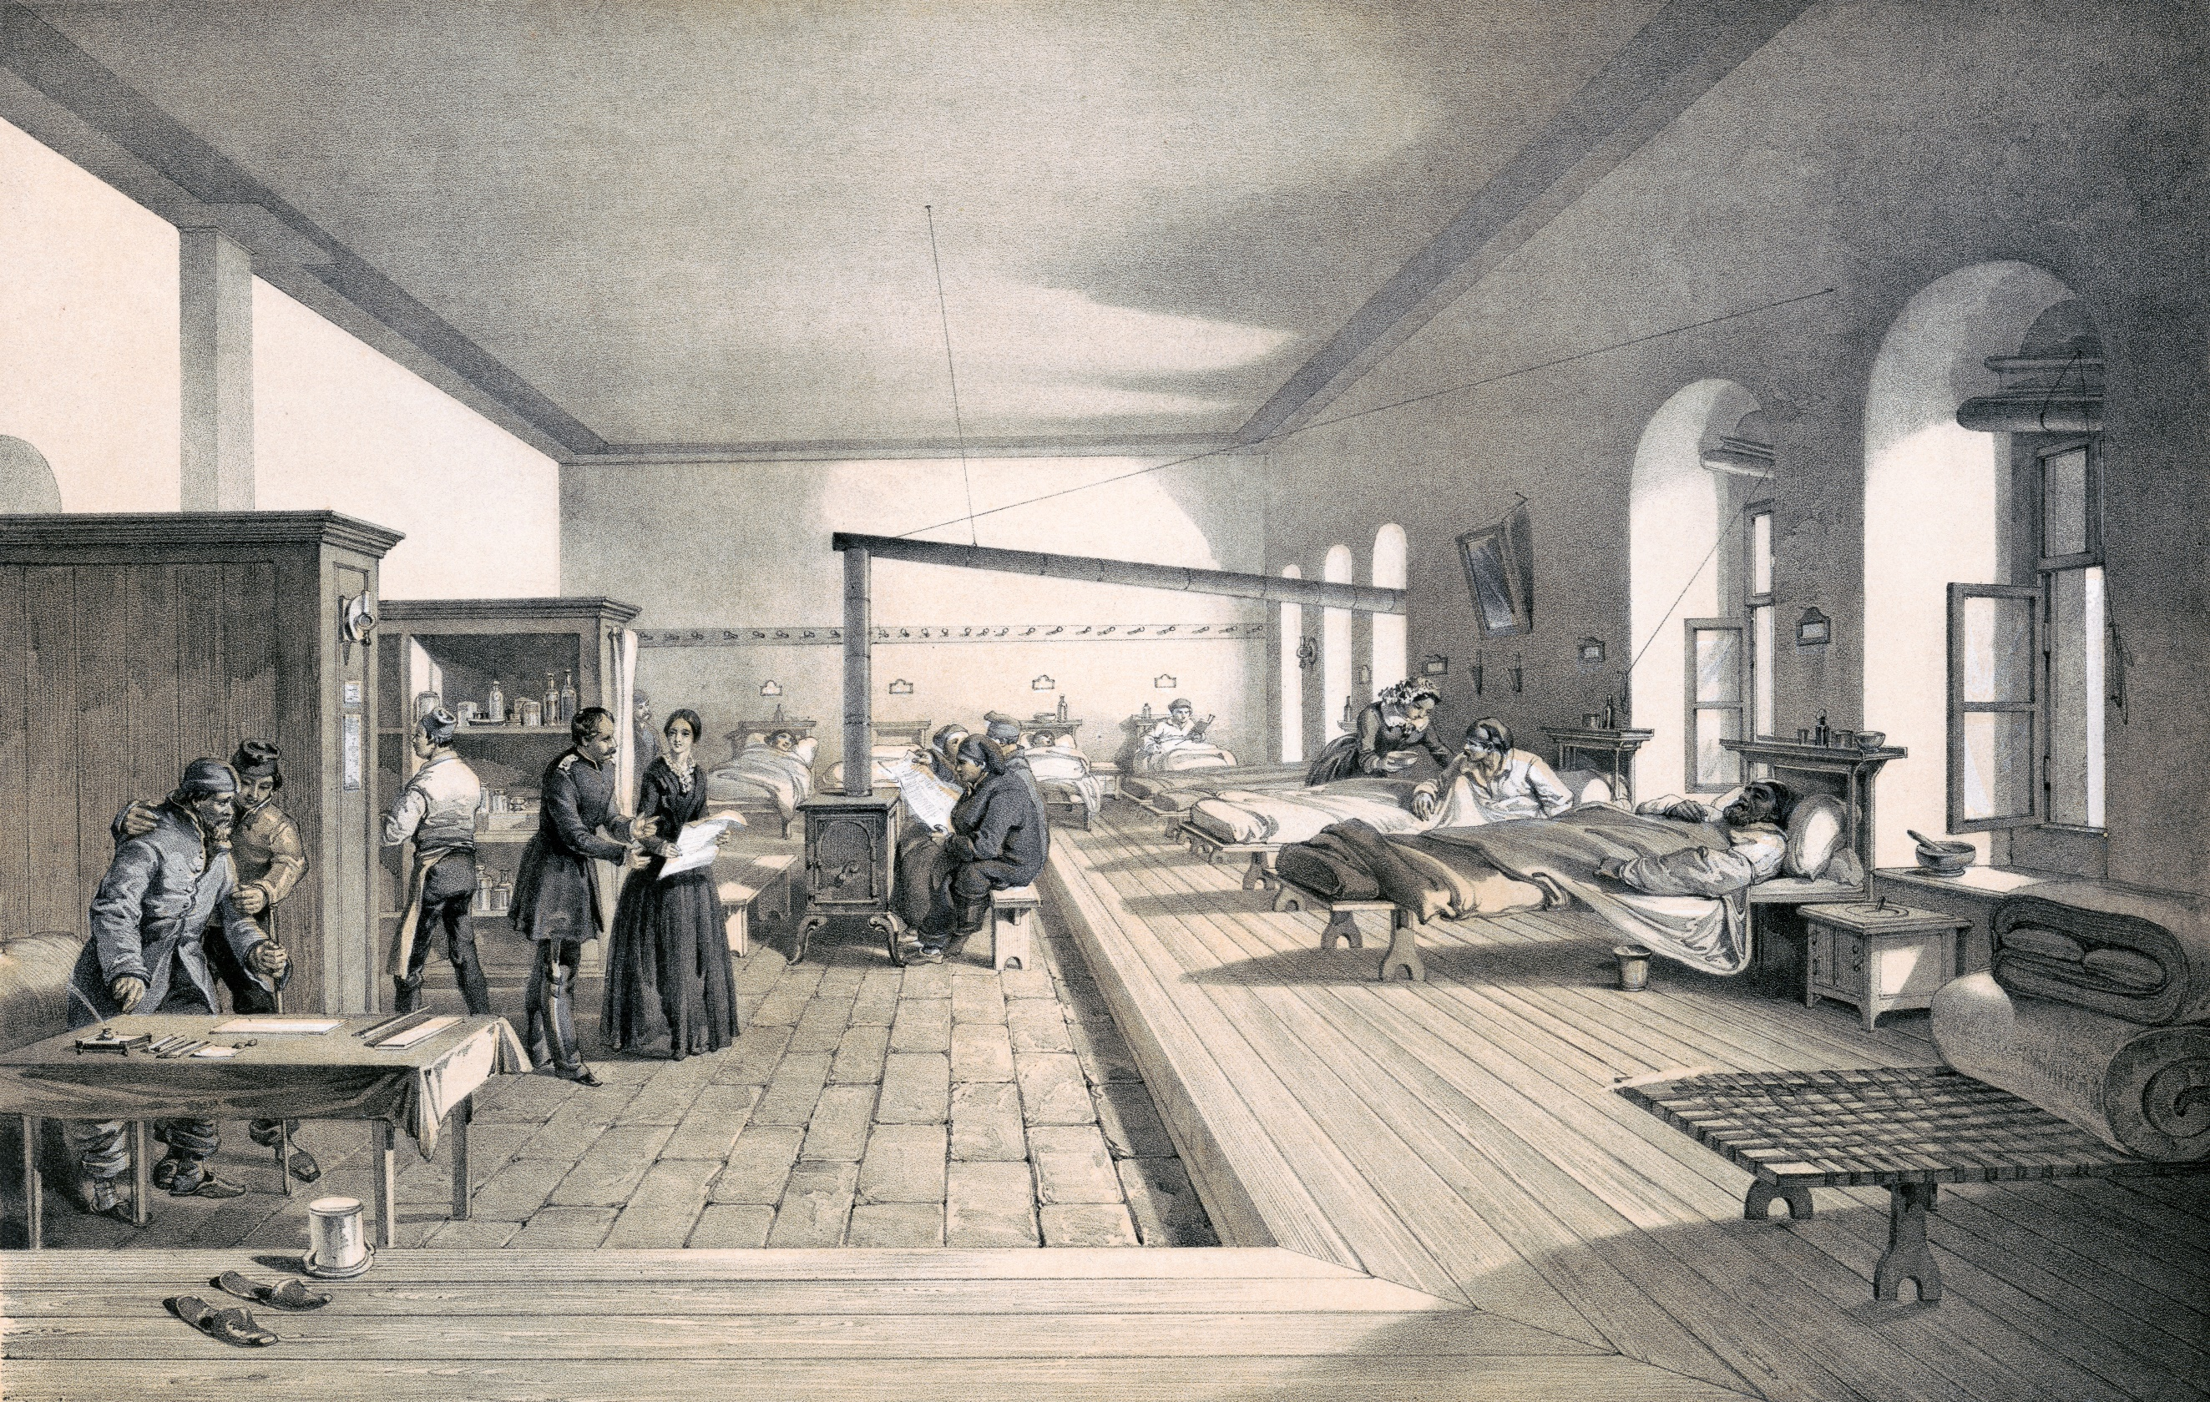

Way back in 1853, in the Crimean war, Florence Nightingale was convinced that stale air, amongst other things, was contributing to the high death rate amongst soldiers. She realised that increasing natural ventilation on hospital wards led to a sharp reduction in death rates. Nowadays we understand the importance not only of all the healthcare staff but also healthcare design on both the physical health and mental health and well-being of patients.

IHEEM, the Institute of Healthcare Engineering and Estate Management, represent the thousands of people, including engineers, who design, build and service our healthcare environments. The work of their members is integral to future NHS policy development and the commitment to develop hospitals which meet the needs of patients well into the 22nd Century.

They are particularly interested in the views of young people and children in developing future hospitals. They recognise that their needs and those of their families, carers and friends may be different to those of adults. Your contributions to this Faraday Challenge really will make a difference to future hospital design and, more importantly, to the physical and mental health and wellbeing of young people who have to spend time in hospital.

You will need to think carefully about your design. The NHS has a target of working net zero by 2050 and you need to contribute to that so look carefully at the considerations in the brief.

Remember, engineering is about people. Today is your chance to make a difference, could you be our engineer...?
- 4 -

2. The Brief

The team from IHEEM wants you to:

- Design and engineer ONE prototype which could be used in a children’s hospital to make a stay in hospital more comfortable and relaxing for our young patients and their families, carers and friends. Your design MUST include at least one electronic circuit.

- Complete the planning and events log to show how you have designed your idea, and solved problems and worked as a team throughout the project.

- Present your prototype to the IHEEM judge(s).

You will need to demonstrate the skills and attitudes we are looking for so:

- be creative;
- plan carefully;
- work within the resources and the budget available;
- be realistic about what is achievable in the time available;
- be resilient and persevere with problems;
- record your thinking;
- keep to strict deadlines.

Considerations:
- Sustainability – what materials can we use to minimize our impact on the environment?
- Energy – how can we decrease the amount used and what sources do we have available to us?
- Waste management – how can we re-use resources rather than adding to the growing pile of waste?
- 5 -

Challenge schedule

09:15 | Register your team
09:30 | Welcome and introduction
09:50 | Project brief: Introduction to the Faraday Challenge
10:10 | Planning: Identifying the problems and generating initial ideas
10:25 | Team role selection: team decides on which roles they need
10:30 | Engineering apprenticeship: teams complete a short engineering task
10:40 | Development  - Shop opens  - Agree on final product designs
11:00 | Break
11:10 | Development continues  - Continue to design and modify where necessary  - Record progress in event log
12.20 | Teams are briefed on the content of the presentation and the engineering priorities.
12:30 | Lunch – Tools down
13:00 | Development: Final preparations  - Finalise product  - Prepare presentation with notes
13:30 | - Shop closes  - Submit accounting sheet to the shop keeper  - Practise presentation
13:50 | Presentation  - Teams present their designs to the judge(s)
14:45 | Award ceremony with final feedback and evaluation of the day
15:00 | Engineering teams depart

- 6 -
4. Engineering apprenticeship

In this circuit you are going to make a light dimmer or brighter depending on the level of resistance in a circuit.

Connect the circuit as shown below.

Crocodile lead
Crocodile lead
Battery pack

Crocodile lead

Light Dependent Resistor (LDR)
Piezo buzzer

Top tips:

- The LDR must be connected to the positive terminal of the battery (red wire).
- The red wire of the piezo buzzer must be connected next in the circuit on the positive terminal side of the battery pack.

Your LED may light up if you are working in a light room but, if not, try shining a torch on to the LDR. Ask your challenge leader if you do not have one.

Hold your hand over the Light Dependent Resistor (LDR) and listen to what happens to the buzzer.

Questions:

- What happens when you vary the light level on the Light Dependent Resistor?

- How could you vary or manage the resistance in your circuit(s)?

5. Shop resource sheet
- 7 -

Items to buy

Electrical components
Item | Description |  | Unit | Cost
Crocodile leads | 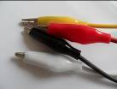 | Lead with crocodile clips at each end | Each | 4 Faradays
Piezo buzzer | 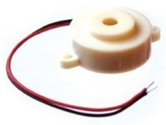 | Connect in a circuit to give a sound output | Each | 6 Faradays
LED – various colours | 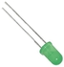 | Light Emitting Diode which lights up when connected in a circuit. Choose from red, orange, green or blue. | Each | 6 Faradays
Motor | 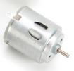 | Connect in a circuit to create clockwise or anti-clockwise movement. Will not work with a solar panel or an LDR. | Each | 6 Faradays
Solar motor | 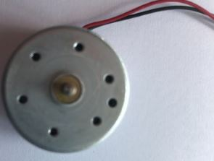 | Connect to a solar panel to create clockwise or anti-clockwise movement. | Each | 6 Faradays
Servo motor  (0 to 90 degrees) | 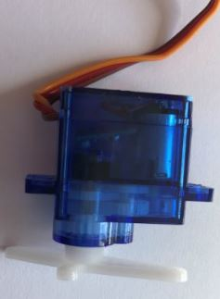 | Use with a servo motor control unit to control movement from 0º to 90º | Each | 6 Faradays
Servo motor (continuous) |  | Use with a servo motor control unit to control continuous movement through 360º | Each | 6 Faradays
Light Dependent Resistor (LDR) | 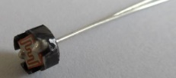 | Component that detects the light level and changes resistance in a circuit. | Each | 8 Faradays
Push to make switch | 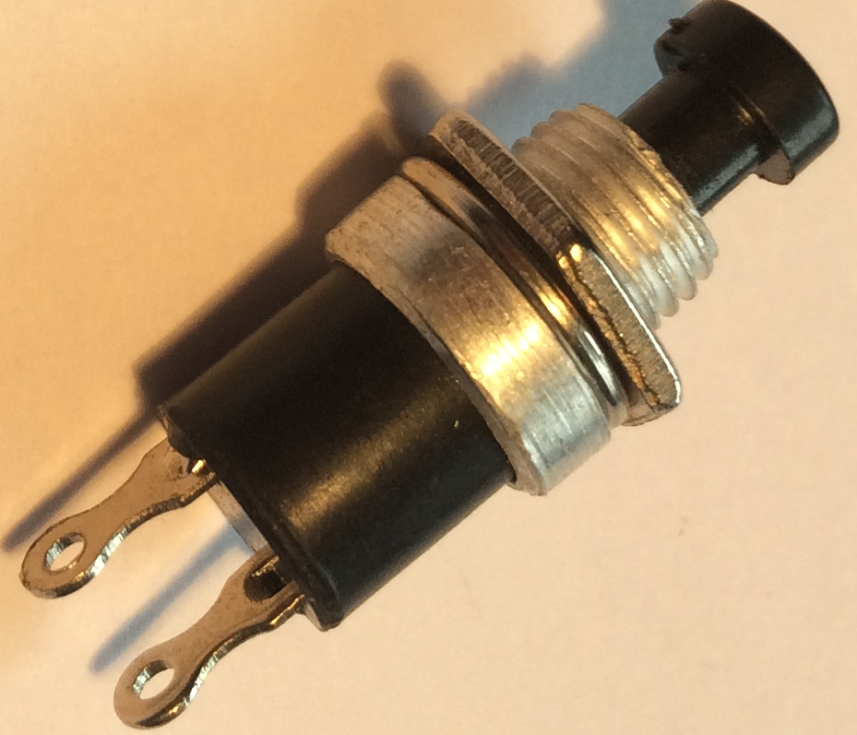 | Connects a circuit when pushed down and breaks the circuit when released. | Each | 6 Faradays
- 8 -

Servo motor control unit | 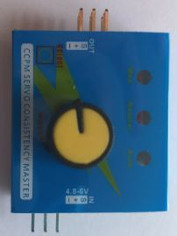 | Use this to control a servo motor. You MUST read the ‘How to …’ sheet before connecting this component. | Each | 8 Faradays
Motor holder | 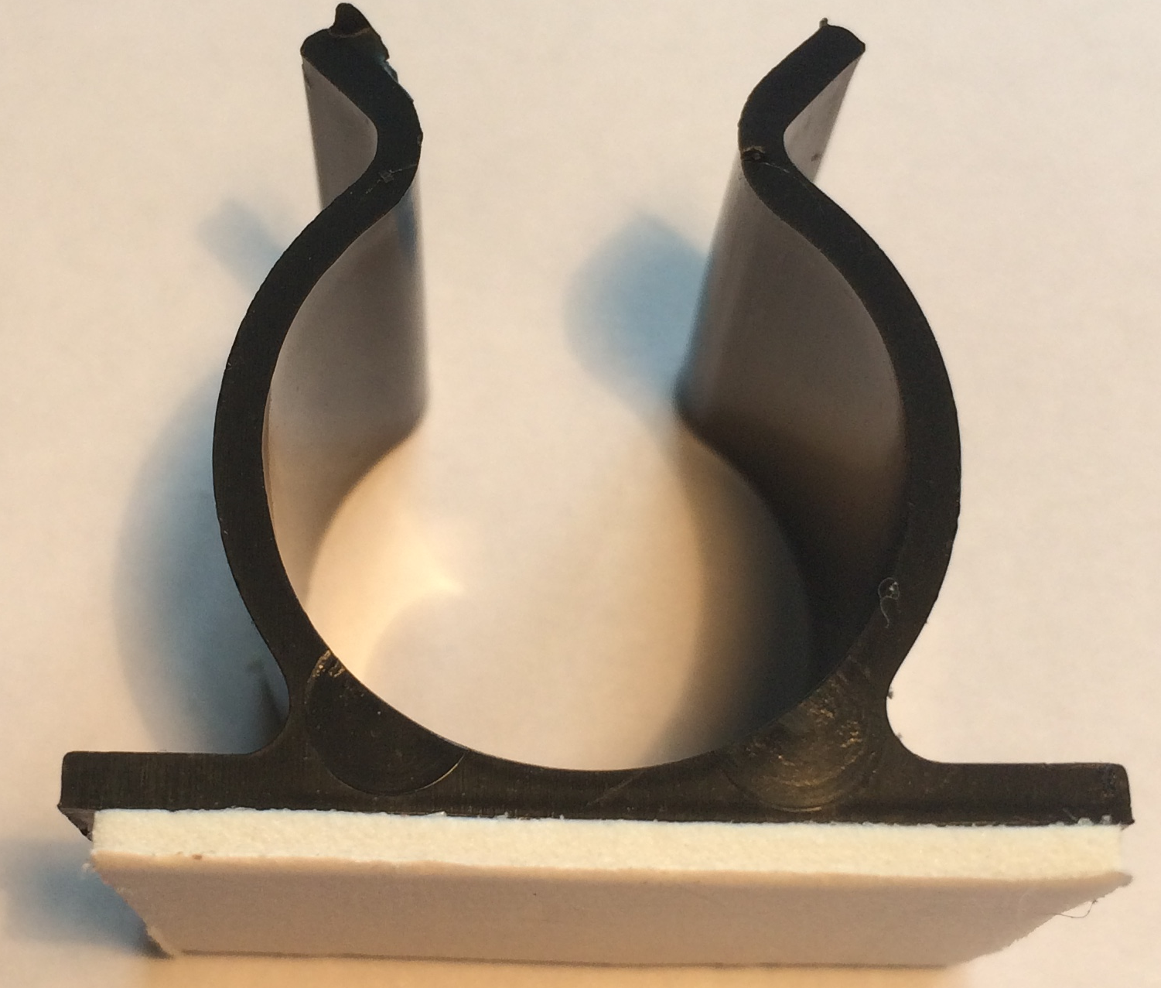 | Used to fix a motor or a syringe in position. NOTE: you will need the insert to connect a syringe. | Each | 4 Faradays
Gear attachment for motor |  | Used to connect a motor to a cog. | Each | 2 Faradays
Pulley attachment for motor | 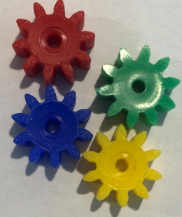  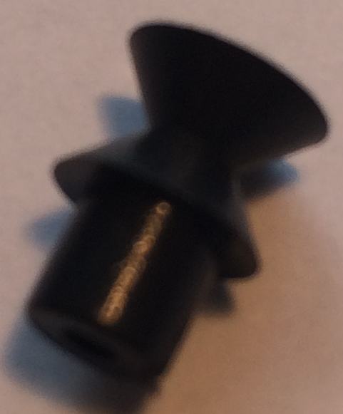 | Used to connect a motor to a pulley wheel – will need connector (e.g. elastic band) | Each | 2 Faradays
Solar panel | 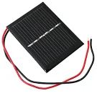  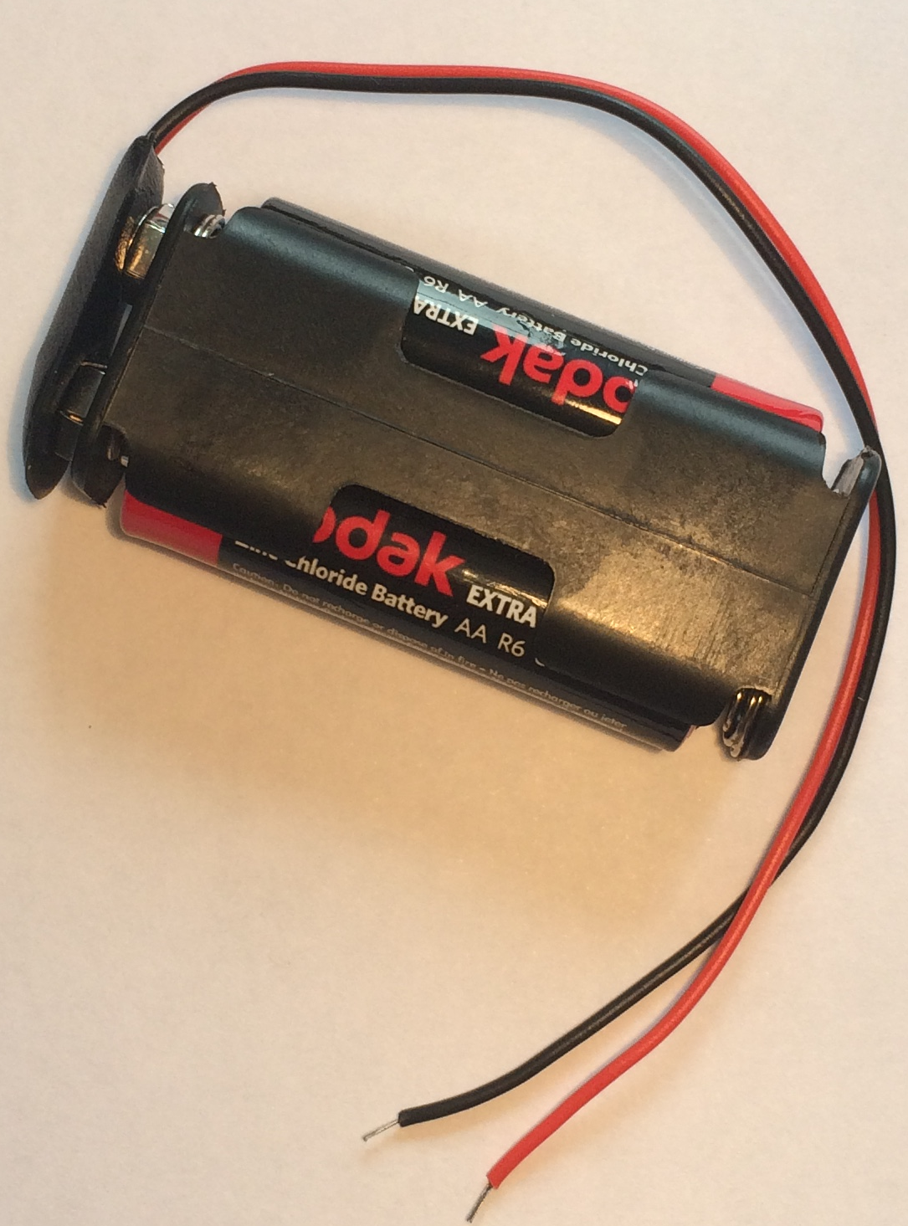 | Used to power components using the power of the sun. You MUST read the ‘How to …’ sheet before using. | Each | 6 Faradays
2AA cells in battery holder with battery snap |  | Used to provide power for your circuit | Each | 4 Faradays
4 AA cells in battery holder with jumper leads | 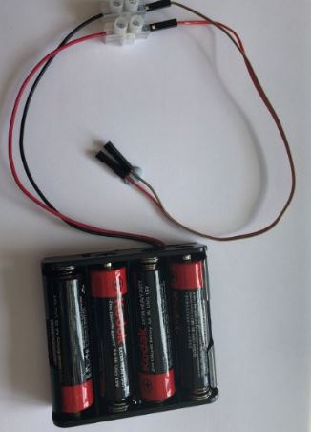 | ONLY to be used with servo motor control unit. | Each | 6 Faradays

Construction materials
Item | Description | Unit |  | Cost
Correx | Used to create structures | Piece |  | 6 Faradays
Plastic syringes with tube | Used to develop pneumatic system | Pair of syringes with plastic tube | 6 Faradays
Small cog | Used in gear systems with motors | Each | 2 Faradays
Medium cog | Used in gear systems with motors | Each | 2 Faradays
- 9 -

Large cog | Used in gear systems with motors | Each | 4 Faradays
Nail | Used for making moisture sensor | Pair | 2 Faradays
Dowel | Piece of solid cylindrical wooden rod used to create structures | Each | 4 Faradays
Pulley wheel | Used to connect to pulley attachments on motor | Each | 6 Faradays
Wooden wheel | Used with motors to drive something | Each | 4 Faradays
Plastic reel | Used in construction | Each | 4 Faradays
Coloured card | A4 sheet of card – assorted colours | Each | 4 Faradays
Aluminium foil | A conductive material which can be used to make pressure pads or switches (MUST NOT be used in place of connecting wires) | 10cm strip | 6 Faradays
Masking tape | Can be used to secure light parts in your design. NOTE: excessive use of tape will result in an additional charge | Roll | 6 Faradays
Sponge | Can be used to make pressure switches or enhance your design. | Each | 6 Faradays
Polyfoam | Can be used as part of your product design | Piece | 4 Faradays
Paperclip | Used to create switches or in construction | Each | 1 Faraday
Paper fastener | Used to create switches or in construction | Each | 1 Faraday
Elastic bands | Used to hold or create working parts, including driving pulley wheels | Each | 1 Faraday
Cable ties | Can be used to hold your structures in place | Each | 2 Faradays
String | Can be used as part of your product design | 30cm piece | 4 Faradays
Baking parchment | Can be used as part of your product design | 30cm strip | 6 Faradays
Wooden lolly sticks | Can be used as part of your product design | Each | 4 Faradays
Hire Centre Trade Card | Use this to hire various items from the hire section of the shop – see next page for details | One per team | 6 Faradays
- 10 -

Available with your Hire Centre Trade Card

These items can be hired from the shop if you buy a Hire Centre Trade Card.

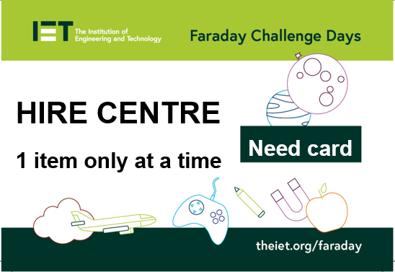

You will need to take it to the shop and show the shopkeeper each time you want to use of one of these items. You may only get one item at a time.

Stapler | Used to staple soft materials only
Hole punch | Used to make small holes in soft materials
Ruler | Used to measure any part of your product or additional items
Scissors | Used for soft materials only

Free to use

The cutting station may be used at any point BUT only 3 people will be allowed at this station at any one time. Please take care when using this equipment.

- 11 -

- 12 -

6. Assessment information and criteria

Criteria | Marks
- Planning | 13 marks
- Development of product | 20 marks
- Use of budget | 8 marks
- Product engineering | 30 marks
- The presentation | 15 marks
- Teamwork | 14 marks
Total | 100 marks
- Planning (13 marks)
Using the planning section of the Planning and Event Log, marks will be awarded as follows:
- Did they explain how their idea might help IHEEM make hospital stays more comfortable and relaxing? (3 marks)
- Does the planning diagram detail how the prototype will be constructed? (5 marks)
- Have the electronics for the prototype been detailed? (5 marks)

- Development of product (20 marks)

Using the Engineering Event Log and observations of the team, marks will be awarded as follows:

- Event log 1 - Have they provided an accurate and informative record of development beyond a simple description including any problems and solutions? (5 marks)
- Event log 2 - Have they provided an accurate and informative record of development beyond a simple description including any problems and solutions? (5 marks)
- Event log 3 - Have they provided an accurate and informative record of development beyond a simple description including any problems and solutions? (5 marks)
- Have they listed realistic and appropriate engineering priorities for the last 30 minutes and allocated tasks to team members? (5 marks)

- Use of budget (8 marks)
Using the accountancy sheet and the prototype, marks will be awarded as follows:
- Was there an accurate record of spending? (3 marks)
- Was the budget used effectively? (5 marks)
4. Product engineering (30 marks)
Using the presentation of your prototype and what we have seen during the development period, marks will be awarded for:

- Did their final prototype meet the brief from IHEEM? (4 marks)
- Was the choice of electronic components appropriate for their intended design?
(4 marks)
- Was the choice of materials appropriate for the structure and/or mechanics of their intended design? (4 marks)
- Was the final prototype engineered well with all elements coming together in a well-structured and fit for intended purpose product? (6 marks)
- Did the judge(s) see the electronics and structure work together effectively as intended? (6 marks)
- Did the team push themselves beyond the minimum brief and incorporate at least two processes? (6 marks)

5. The presentation (15 marks)
Using the presentation of your prototype, marks will be awarded as follows:

- Did the team explain how their prototype works, including details of how and why they used the electronics and the mechanics in their design? (6 marks)
- Did the team identify the most challenging engineering aspect they faced during their development and how they overcame this challenge? (3 marks)
- Did the team explain what they did well in their teamwork and what aspects they could have improved? (4 marks)
- Did the team effectively demonstrate their prototype? (2 marks)

- Teamwork (14 marks)
Using the judges’ observations of your team throughout the day, marks will be awarded as follows:

- Did the team work well together with all members engaged in the project and any conflicts successfully resolved? (5 marks)
- Did the team work tidily and safely within the health and safety rules? (3 marks)
- Did the team persevere to resolve issues during the project and work largely independently? (6 marks)

- 13 -

